FACULTY CONTRACT



BETWEEN SAGINAW VALLEY STATE UNIVERSITY AND THE SVSU FACULTY ASSOCIATION

2023 – 2026

THIS CONTRACT IS ALSO AVAILABLE AT www.svsu.edu/hr

Table of Contents
TOPIC PAGE

ARTICLE A - RECOGNITION 9
A 1. UNIVERSITY RECOGNITION 9
A 2. SOLE AGENT 9
A 3. SUPERSEDES 9
A 4. CHANGES IN CURRENT POLICIES 9
A 5. CONTRARY TO LAW 9
A 6. EFFECT BY PASSAGE OF LAW 9
A 7. AMENDMENT 9
A 8. PERSONAL RIGHTS PROTECTION 10
A 9. EFFECT ON INDIVIDUAL CONTRACTS 10
A 10. DISTRIBUTIONS OF COMMUNICATIONS 10
A 11. RECLASSIFICATION OF FULL-TIME STAFF 10
A 12. FINANCIAL RESPONSIBILITY 10
A 12.1 ASSOCIATION MEMBERSHIP 10
A 12.3 ASSOCIATION MEMBERSHIP: VOLUNTARY DUES DEDUCTION 10
A 13. RELEASE TIME FOR FACULTY ASSOCIATION 11
ARTICLE B - CONSULTATION 12
B 1. BOARD CONSULTATION 12
B 2. SPECIAL CONFERENCES 12
B 3. PRESIDENTIAL CONSULTATION 12
B 4. AGENDA, PRESIDENTIAL CONSULTATION 12
B 5. NON-PROHIBITIVE 12
B 6. ADMINISTRATIVE ATTENDANCE 13
ARTICLE C – ASSOCIATION RIGHTS 13
C 1. RIGHTS OF FACULTY IN ASSOCIATION 13
C 2. ASSOCIATION BUSINESS 13
C 3. EQUAL APPLICATION 13
C 4. OFFICIAL ASSOCIATION REPRESENTATIVE AT BOARD 13
C 5. INFORMATION 13
C 6. FACILITIES 14
C 7. PRESENCE OF ASSOCIATION REPRESENTATIVE 14
ARTICLE D - ACADEMIC CONDITIONS 14
D 1. THE ACADEMIC YEAR 14
D 2. THE ACADEMIC WEEK 14
D 3. THE ACADEMIC DAY 14
D 4. TEACHER LOAD AND REQUIREMENTS 15
D 4.1 CREDIT HOUR TEACHING LOAD AND OVERLOADS 15
D 4.2 CREDIT HOUR UNDERLOAD AND CANCELLATION OF CLASSES 16
D 4.3 DEPARTMENTAL RESOURCES 17
D 4.4 STUDENT CREDIT HOUR LOAD COMPENSATION 18
D 4.5 RELEASE TIME: COMPUTATION OF STUDENT CREDIT HOURS 18
D 4.6 OPTIONAL BANKED LOAD 18
D 4.7 NOTIFICATION OF RELEASE TIME 19
D 5. SPRING-SUMMER CREDIT HOUR ASSIGNMENTS 20
D 6. SHORT TERM COURSES 20
D 7. NEW PROGRAM AND COURSE DEVELOPMENT 20
D 8. PROFESSIONAL IMPROVEMENT 20
D 8.1 FIRST-YEAR FACULTY ORIENTATION 21
D 9. TEXTBOOKS AND OTHER TEACHING MATERIALS 21
D 10. ORIENTATION 22
D 11. SPONSORSHIP OF STUDENT ACTIVITIES 22
D 12. ADMINISTRATIVE TEACHING 22
D 13. PART-TIME TEACHING 22
D 14. REGISTRATION PERIOD FACULTY MEETINGS 22
D 15. RIGHT TO OUTSIDE EMPLOYMENT 22
D 16. TEMPORARY FULL-TIME FACULTY 23
D 17. ACADEMIC FREEDOM 23
D 18. FACULTY FACILITIES 23
D 19. STUDENT EMPLOYEES 24
D 20. UNIVERSITY YEAR 24
D 20.1 BASIC APPOINTMENTS 24
D 20.2 SUPPLEMENTAL APPOINTMENTS 24
D 21. OFFICE HOURS AND STUDENT ADVISING 26
D 22. ATTENDANCE AT UNIVERSITY FUNCTIONS 26
D 23. GRANT AND RESEARCH/DEVELOPMENT RELEASE TIME 27
D 23.1 GRANTS AND FELLOWSHIPS OBTAINED BY FACULTY MEMBERS 27
D 23.2 GRANTS OBTAINED BY THE UNIVERSITY 27
D 23.3 EXTERNALLY FUNDED RESEARCH/DEVELOPMENT 27
D 23.4 INTERNALLY FUNDED RESEARCH/DEVELOPMENT RELEASE TIME 27
D 23.5 SVSU FOUNDATION FUNDED RESEARCH AND PROFESSIONAL DEVELOPMENT GRANTS 27
D 23.6 INTERNALLY FUNDED DEVELOPMENT GRANTS 28
D 23.7 FUNDS INDIVIDUALLY RAISED FROM THE PRIVATE SECTOR 28
D 24. INITIAL APPOINTMENT 28
D 25. VACANCIES 28
D 26. TRANSFERS 28
D 27. PERFORMANCE OF ADMINISTRATIVE WORK 29
D 28. OFF-CAMPUS TEACHING 29
D 29. DISTANCE LEARNING 31
D 29.1 INTERACTIVE VIDEO-BASED INSTRUCTION (INTERACTIVE TV) 31
D 29.2 ONLINE AND HYBRID INSTRUCTION 31
D 29.4 TV COURSES 32
D 30. NURSING & HEALTH SCIENCES INSTRUCTION 32
D 31. LEARNING CONTRACTS 32
D 32. ANCILLARY FACULTY 33
D 32.1 ADJUNCT FACULTY 33
D 33. LECTURERS 33
D 34 INTELLECTUAL PROPERTY 35
D 34.1 DEFINITION 35
D 34.2 OWNERSHIP 35
ARTICLE E - SERVICES, MATERIALS AND GUARANTEES 36
E 1. PARKING 36
E 2. FACULTY PASSES 36
E 3. LEGISLATIVE ACTION 36
E 4. IDENTIFICATION CARDS 36
E 5. REQUIRED EXAMINATIONS 36
E 6. KEYS & ELECTRONIC ACCESS 36
E 7. TEMPERATURE AND NOISE 36
E 8. FACULTY TRIP 36
E 9. FACULTY SECRETARIES 37
E 10. FAMILY TUITION GRANT 37
E 11. ACADEMIC REGALIA 38
ARTICLE F - COMMITTEES 38
F 1. STANDING COMMITTEES AND DISTRIBUTION OF FACULTY MEMBERS 38
F 1.1 FACULTY COMPOSITION OF STANDING COMMITTEES 38
F 1.2 TERM OF OFFICE 38
F 1.3 PROCEDURES APPLICABLE TO ALL STANDING COMMITTEES 40
F 2. PROFESSIONAL PRACTICES COMMITTEE 40
F 2.1 RESPONSIBILITIES 40
F 2.2 MEMBERSHIP 40
F 2.3 QUORUM 40
F 2.4 PROCEDURES 41
F 3. VACANT 43
F 4. CURRICULUM/ACADEMIC POLICIES COMMITTEE 43
F 4.1 RESPONSIBILITIES 43
F 4.2 MEMBERSHIP 43
F 4.3 QUORUM 43
F 4.4 PROCEDURES 44
F 5. GRADUATE COMMITTEE 44
F 5.1 COMPOSITION 44
F 5.2 RESPONSIBILITIES 44
F 5.3 QUORUM 44
F 5.4 PROCEDURES 45
F 6 GENERAL EDUCATION COMMITTEE (GEC) 45
F 6.1 PROCEDURES 45
F 6.2 COURSE TERM 46
F 6.3 ASSESSMENT OF GENERAL EDUCATION 46
F 6.4 COMMITTEE COMPOSITION 46
F 6.5 RELEASE TIME FOR COMMITTEE MEMBERS 47
F 6.6 CLASS SIZE 47
F 6.7 ADJUNCT FACULTY 47
F 6.8 SCHEDULING OF COURSES 47
F 7. CURRICULUM AND ACADEMIC POLICIES FACULTY RATIFICATION 47
F 8. COLLEGE RESEARCH AND DEVELOPMENT COMMITTEES 48
F 8.1 STEP ONE 48
F 8.2 STEP TWO 48
F 9. ADDITIONAL COMMITTEES 49
F 10. COMMITTEE MEMBER RELEASE TIME 49
ARTICLE G - PERSONNEL AND PROFESSIONAL PRACTICES COMMITTEE (PPC) FILES
. 49
G 1. PERSONNEL AND PPC FILES 49
G 2. MEMORANDUM OF APPOINTMENTS 49
G 3. PERSONNEL FILE: CONTENTS 50
G 4. PPC FILE: CONTENTS 50
G 5. PROFESSIONAL PRACTICES COMMITTEE FILES: ACCESS 51
G 6. PERSONNEL FILES: ACCESS 52
G 7. COMPUTER AND ELECTRONICALLY STORED DATA 52
ARTICLE H - FACULTY 52
H 1. CRITERIA FOR PROMOTION, TENURE AND APPOINTMENT 52
H 1.1 FORMAL DEGREE QUALIFICATIONS 53
H 1.2 CRITERIA FOR FACULTY EVALUATION FOR PURPOSES OF REAPPOINTMENT, TENURE AND PROMOTION 54
H 2. APPOINTMENT PROCEDURES AND CONDITIONS: ISSUANCE, EVALUATION, DISCHARGE, TERMINATION AND TENURE 55
H 2.1 APPOINTMENTS 55
H 2.2 EVALUATION 56
H 2.3. DISCIPLINE, DISCHARGE AND TERMINATION: PROCEDURES AND CONDITIONS 60
H 2.4 LAYOFFS 63
H 2.5 EXPERIENCE RANKINGS 64
H 2.6 CONTINUATION OF BENEFITS 64
ARTICLE I - DEPARTMENT ORGANIZATION AND DUTIES 64
I 1. CHAIRPERSON SELECTION 64
I 2. CHAIRPERSON RESPONSIBILITIES 64
I 3. ADMINISTRATION CONSULTATION 64
I 4. CONFLICT RESOLUTION 65
I 5. STAFFING NEEDS AND RECRUITMENT 65
I 6. BUDGET REQUEST 65
I 7. ESTABLISHING A DEPARTMENT 66
I 8. SELECTION OF CHAIRPERSON 66
I 9. BUDGET CHANGES 66
I 10. DEPARTMENTAL TEACHING AIDS 66
I 11. WAIVERS AND SUBSTITUTIONS 66
I 12. GRADE CHANGES 66
I 13. STUDENT COMPLAINTS AND GRIEVANCES 67
I 14. PROTECTION OF THE CLASSROOM ENVIRONMENT 67
ARTICLE J - COMPLAINT 67
ARTICLE K - GRIEVANCE PROCEDURE 67
K 1. DEFINITION 67
K 2. PRESENTING A GRIEVANCE 68
K 2.1 STEP ONE (1), OFFICE OF THE DEAN (WRITTEN) 68
K 2.2 STEP TWO (2), OFFICE OF THE VICE PRESIDENT FOR ACADEMIC AFFAIRS 68
K 2.3 STEP THREE (3), GRIEVANCE RESOLUTION COMMISSION (GRC) 69
K 2.4 MISCELLANEOUS PROVISIONS 70
ARTICLE L - MANAGEMENT RIGHTS 71
ARTICLE M - FRINGE BENEFITS 71
M 1. GROUP LIFE INSURANCE 71
M 1.1 ACCIDENTAL DEATH & DISMEMBERMENT INSURANCE 71
M 1.2 ACCELERATED DEATH BENEFIT 71
M 1.3 OPTIONAL DEPENDENT LIFE INSURANCE 72
M 2. DISABILITY INSURANCE 72
M 3. HEALTH INSURANCE 72
M 3.1 DENTAL INSURANCE 73
M 3.2 VISION INSURANCE 73
M 4. RETIREMENT 73
M 4.1 PARTICIPATION 73
M 4.2 CONTRIBUTIONS 73
M 4.3 CONTRACTS 73
M 4.4 REPURCHASE 74
M 4.5 POLICY FOR REQUIREMENTS FOR ENTRY INTO RETIREMENT PROGRAM 74
M 4.6 OPTIONAL DEFERRED COMPENSATION PLAN 75
M 4.7 POLICY FOR THOSE WHO RETIRE ON OR BEFORE JUNE 30, 2003 75
M 5. SICK LEAVE 75
M 5.1 GRANT OF SICK LEAVE UNITS 75
M 5.2 USE OF SICK LEAVE UNITS 75
M 5.3 RECORDS AND REPORTS 76
M 6. DEFINITIONS 76
M 7. FRINGE BENEFITS 76
M 8. PERSONAL AND PROFESSIONAL LEAVE 77
M 8.1 PERSONAL LEAVE 77
M 8.2 PROFESSIONAL LEAVE 77
M 9. SABBATICALS 77
M 10. LEAVE OF ABSENCE 79
M 11. JURY DUTY 80
M 12. FRINGE BENEFIT BASE 80
M 13. PRIVILEGE OF FACULTY TO CONTINUE BENEFITS 80
M 14. SALARY PLACEMENT ON RETURN 80
M 15. LEAVE EXTENSION 80
M 16. BENEFICIARY RIGHTS 80
M 17. STATE AUTOMOBILE INSURANCE 80
M 18. SUBSTITUTE PAY 81
M 19. PARENTAL AND FAMILY CARE LEAVE 81
ARTICLE N - SALARIES 81
N 1. BASE SALARY RAISES 81
N 2. MERIT BONUSES 82
N 3. MINIMUM BASE SALARIES 82
N 4. DOCTORATE RAISES 82
N 5. PROMOTION RAISES 82
N 6. EQUITY / MARKET COMMITTEE 83
N 6.1 MARKET/EQUITY SALARY ADJUSTMENTS 83
N 7. LUMP SUM PAYMENT 83
ARTICLE O - TERM OF AGREEMENT 84
MEMORANDUMS DELETED 85
MEMORANDUM OF UNDERSTANDING IV 88
MEMORANDUM OF UNDERSTANDING – ENDOWED PROFESSORS 98
MEMORANDUM OF UNDERSTANDING – TENURE TIMELINE DUE TO COVID-19 101
MEMORANDUM OF UNDERSTANDING – TEMPORARY REDUCED LOAD 102
MEMORANDUM OF UNDERSTANDING – 2020-21 PROFESSIONAL IMPROVEMENT 105
MEMORANDUM OF UNDERSTANDING – PRESCENCE OF FACULTY ASSOCIATION REPRESENTATIVE 105

ARTICLE A - RECOGNITION

A 1. UNIVERSITY RECOGNITION
Pursuant to P.A. 379 the University hereby recognizes the Association as the sole and exclusive negotiating representative for all Saginaw Valley State University faculty members specifically described herein, all of whom are collectively designated as the "faculty", defined as:
- All full-time, full-salaried (8, 10 or 12 months) Saginaw Valley State University faculty who hold faculty rank;
- All full-time, full-salaried (8, 10 or 12 months) faculty serving as department chairpersons;
- All part-time faculty who hold faculty rank carrying at least two-thirds teaching load; but excluding graduate assistants, coordinators, part-time lecturers, visiting faculty, or adjunct professors unless otherwise qualified under (a), (b), or (c) above, directors, managers, supervisors, confidential employees (as the term is used in labor relations), administrators, deans, assistant deans, vice presidents, vice provosts, the provost, the president, students, professional librarians, student counselors, and persons doing research exclusively, with respect to salary, hours, terms and conditions of employment. (also see D 32.1).

A 2. SOLE AGENT
The University agrees not to negotiate concerning wages, hours, terms, or conditions of employment with any faculty member individually or with any faculty organization other than the Association for the duration of this agreement. The salaries, hours, terms, and conditions of employment set forth in this agreement will not be changed without negotiation with the Association.

A 3. SUPERSEDES
This agreement constitutes the negotiated agreement of the University and the Association and supersedes any previous rules, regulations, or policies which may have been in effect relative to the subjects specifically covered in this agreement.

A 4. CHANGES IN CURRENT POLICIES
The University agrees to effect any changes in current University policies or bylaws which are in conflict with the specific terms of this agreement and in the event of any inconsistencies or conflict of University policies or bylaws the provisions of this agreement shall apply.

A 5. CONTRARY TO LAW
If any provisions of this agreement or any application of the agreement to any employee or group of employees shall be found contrary to law, then such provision or application shall not be deemed valid and subsisting except to the extent permitted by law, but all other provisions or applications of this agreement shall continue in full force and effect.

A 6. EFFECT BY PASSAGE OF LAW
Any provision of this contract which is contrary to law, but becomes legal during the life of this contract, shall take immediate effect upon the enactment of such legislation.

A 7. AMENDMENT
Should a mutually acceptable amendment to this agreement be negotiated by the parties it shall be reduced to writing and submitted to appropriate ratification procedures of the University

and the Association. At such time as it has been ratified by both the University and the Association, it shall become a part of the agreement.

A 8. PERSONAL RIGHTS PROTECTION
Nothing contained herein shall be construed to deny or restrict to any Saginaw Valley State University faculty member rights he or she may have under laws of the State of Michigan or other applicable regulations, unless such rights are specifically waived herein. The rights granted to faculty hereunder shall be deemed to be in addition to those provided elsewhere.

A 9. EFFECT ON INDIVIDUAL CONTRACTS
Any individual contract between the University and an individual faculty member heretofore or hereinafter executed shall be subject to and consistent with the terms and conditions of this agreement. If an individual contract contains any language inconsistent with this agreement, this agreement, during its duration, shall be controlling.

A 10. DISTRIBUTIONS OF COMMUNICATIONS
Copies of all communications related to salary, hours, and terms and conditions of employment of the bargaining unit distributed generally to members of the faculty by the University, or a school or college within the University, shall be supplied to the Association at the same time. Copies of memoranda of appointment for all new faculty members shall be supplied to the Association at the time of receipt by the University of the signed appointment from the new faculty member. In addition, the University shall send to the Association at the beginning of each term, a list stating the name of each faculty member then in the unit and shall monthly notify the Association, in writing, of any changes in such list.

A 11. RECLASSIFICATION OF FULL-TIME STAFF
The reclassification of any faculty position which results in removals from or addition to the bargaining unit shall occur only after a negotiated agreement on the terms of such reclassification has been appropriately ratified as an amendment to this contract.

A 12. FINANCIAL RESPONSIBILITY

A 12.1 ASSOCIATION MEMBERSHIP
Association membership shall be established by the filing of a signed payroll deduction authorization with the University or by direct payment by the faculty member.

A12.2
Within fifteen days after receiving any list required by Article A 10, the Association shall:

A 12.2.1
Notify the University of the names of faculty who are members of the Association, and certify the periodic dues payable by each member;

A 12.2.2
Notify the University of the names of the faculty who are nonmembers.

A 12.2.3
Provide a signed payroll deduction authorization for any faculty member for whom such an authorization is not on file.

A 12.3 ASSOCIATION MEMBERSHIP: VOLUNTARY DUES DEDUCTION
Within thirty days after receiving the initial list required by Article A 10 and biweekly thereafter during the term of this Agreement or until further notified by the Association (subject to

the requirements of any changes in the list required by Article A 10), the University will for each faculty member named on such lists who:
- has on each payroll date involved sufficient compensation due him/her from the University and

- has on a form satisfactory to the University duly authorized it to do so, deduct from such faculty member's compensation and remit to the Association voluntary dues or payment so listed as payable to the Association for his/her account. The University will have no obligation to deduct or remit the amount payable for the account of any faculty member whose withholding authorization reaches the payroll department in an untimely manner or who does not have sufficient compensation due him/her on any payroll date to pay his/her account with the Association. The Association will indemnify the University against all liability the University may incur by reason of any dues deduction or remittance pursuant to this paragraph.

A 12.4
All sums deducted by the University shall be remitted to the Association's financial officer on a timely biweekly basis together with a list showing the amount of voluntary dues or payment deducted from each current faculty member.

A 12.5
The University shall not be liable to the Association by reason of this article for the remittance or payment of any sum other than that constituting actual deductions made from the pay earned by the faculty member.

A 12.6
The Association shall have thirty days from the receipt of said list required by paragraph A
12.4 to encourage faculty members who are named on said list to file the required deduction forms.

A 12.7
The Faculty Association shall notify the faculty member that they are delinquent in not tendering the voluntary dues or payment specifying the current amount of the delinquency.

A 12.8
The Association shall protect and save the University harmless from any and all claims, demands, and other forms of liability by reason of action taken in compliance with this article for so long as the University shall cooperate with the Association in the defense of any such claims, demands, and potential liabilities. Any legal defense that is required against such claims, demands and liabilities shall be controlled by the Association.

A 12.9
In the event Section 10(3) of Public Act 349 of 2012 is repealed, otherwise found unlawful, or changed the parties agree to reopen the Faculty Contract for discussions over this provision only.

A 13. RELEASE TIME FOR FACULTY ASSOCIATION
The President of the Association shall be granted release time at full pay from normal teaching duties equivalent to twelve (12) credit hours of teaching load during each fiscal year. Six (6) additional hours of release time will be granted to other Association officers as designated by the Association president. The Association president's other rights under this contract will not be altered by this provision. Adjustments in the teaching schedule of the President of the Faculty

Association will be made with his/her approval. An additional six (6) credit hours of release time during each fiscal year may be purchased by the Association to be assigned to one (1) or more Association executive officers, other than the president, at the discretion of the president. The purchase price for this additional release time shall be $450.00 per credit hour. In the event the Association wishes to purchase such release time, advance written notification of this fact, together with identification of the individuals involved, shall be provided to the Vice President for Academic Affairs and the deans involved. The Association shall provide payment for the release time involved before the end of the relevant semester.

ARTICLE B - CONSULTATION

B 1. BOARD CONSULTATION
The Board of Control or its designee shall advise the Association of any new or modified major fiscal or budgetary programs, construction programs, or revisions of institutional direction or purpose which are proposed or under consideration and the Association shall be given opportunity to advise the board with respect to said matters ten (10) calendar days prior to their adoption and/or general publication. In the event of an emergency or special meeting, the Association will be notified of the aforementioned items at the same time that the board is notified.

B 2. SPECIAL CONFERENCES
Special conferences for important matters of mutual interest may be arranged between the President of the Faculty Association and the Vice President for Academic Affairs or their designated representatives. Such conferences will not be used to consider matters under consideration in the grievance procedure or to otherwise circumvent the grievance procedure.
Such meeting shall be between at least two representatives of the University and at least two representatives of the Association. Arrangements for such special conferences shall be made in advance and an agenda of the matters to be considered at the meeting shall be presented at the time the conference is requested. Matters considered in special conferences shall be confined to those included in the agenda.

B 3. PRESIDENTIAL CONSULTATION
The President or designee shall meet with representatives of the Association for consultation once each semester for the purpose of discussing legitimate and proper subjects of collective negotiations that may arise during the life of this agreement and to discuss those matters necessary to the implementation of this agreement which are institution-wide in nature. Other University matters may be placed on the agenda and considered at the discretion of the President or the Association.

B 4. AGENDA, PRESIDENTIAL CONSULTATION
A written agenda shall be submitted to the Association no less than five (5) days before the scheduled date of the meeting. Such agenda is to contain all items previously submitted in writing by the Association.

B 5. NON-PROHIBITIVE
Nothing contained herein shall prevent an official Association representative from consulting at the proper level at times other than those set forth above, if matters of an urgent or emergency nature arise within the area of collective negotiations, or administration of the contract.

B 6. ADMINISTRATIVE ATTENDANCE
Administrative personnel may appear before meetings of the faculty for purposes of presenting their viewpoint, but such personnel may be excluded from the meeting during elections and voting.

ARTICLE C – ASSOCIATION RIGHTS

C 1. RIGHTS OF FACULTY IN ASSOCIATION
The University hereby agrees that every professional employee of the faculty shall have the right to freely organize, join and support the Faculty Association for the purpose of engaging in collective bargaining or negotiation and other concerted activities for mutual aid and protection. As a duly elected body exercising power under color of law of the State of Michigan, the Board of Control members and President of the University undertake and agree they will not directly or indirectly deprive or coerce any faculty member in the employment of any rights conferred by act or laws of Michigan, or the Constitution of Michigan, in the United States; that they will not discriminate against any faculty member with respect to hours, wages, or any terms or conditions of employment by reason of their membership in the Faculty Association, their participation in any activities of the Faculty Association or collective negotiations with the University, or their institution of any grievance, complaint or proceeding under this agreement.

C 2. ASSOCIATION BUSINESS
Duly authorized representatives of the Association shall be permitted to transact official Association business on institution property at all reasonable times, provided that this shall not interfere with or interrupt normal institution operations, faculty member responsibilities, or incur an expense to the University.

C 3. EQUAL APPLICATION
This agreement shall be applied equally in all cases with respect to wages, hours, terms and conditions of appointment. In no case shall arbitrary, capricious or discriminatory action be taken. It shall be applied without regard to creed, age, color, disability, gender identity, genetic information, height, marital status, national origin, race, religion, sex (including pregnancy), sexual orientation, veteran status, weight, or on any other basis protected by state, federal, or other applicable law or by the stated University policy.

C 4. OFFICIAL ASSOCIATION REPRESENTATIVE AT BOARD
An officially designated Association representative or agent shall appear on the agenda of all Board of Control meetings. The Association shall receive notice of such meetings at the same time and in the same manner as given Board of Control members. Copies of the agenda shall be given to the Association at the same time as distributed to Board of Control members.

C 5. INFORMATION
The University shall make available to the Association upon reasonable request and within a reasonable time thereafter, such information as is necessary for negotiation and implementation of this agreement; provided, however, that this provision shall not be construed to require the University to prepare or develop information for the Association or to provide information in any form other than that of copies of already existing records including but not limited to: annual financial reports and audits, registry of professional personnel, agenda and minutes of all Board of Control meetings and all attachments thereto at the time of distribution to the Board of Control, the treasurer's reports, names, addresses, and position on salary schedule of all faculty members

in the bargaining unit, request budgets to the State of Michigan, the governor's recommended budget to the legislature, the Senate Appropriation Committee's recommendation to the Legislature, the approved Legislative budget and such information as will assist the Association in contract negotiations or the processing of any grievance or in support of any member against whom a complaint is filed or pending, including a complaint involving a demand for dismissal.

C 6. FACILITIES
The Association and its representatives shall have the right to meet in rooms at the University not otherwise in use. The Association will be assigned a room with appropriate equipment at a mutually agreeable location for use as the Association President's office. The size of this assigned room will be approximately 200 square feet, to permit the seating of 8-10 people. The Association shall also be able to rent available office space at the University at the normal rental rates thereof. The Association will be able to use the University's copy machine by payment of the regular charges for use thereof. The Association shall have the right to post notices of its meetings on the faculty bulletin board or boards. The Association may use the University's mail service and faculty member mailboxes for distributing notices of meetings and its regular newsletter. The Association will be assigned a mailbox. Neither the board nor the University administration will consent to the use of University bulletin boards, mailboxes or mail service during the duration of this contract by any organization which is attempting to replace the Association as the collective bargaining representative.

C 7. PRESENCE OF ASSOCIATION REPRESENTATIVE
A faculty member shall at all times be entitled to have present a representative of the Association when being reprimanded, warned, or disciplined for any infraction of rules or delinquency in professional performance, or when he/she believes that the presence of such representation may be necessary. When a request for such representation is made, no action shall be taken with respect to such faculty member until such representative of the Association is present, except in cases of dire emergency to the University, students, or individuals involved. In non-emergency cases, a representative must be available within forty-eight (48) hours or action may proceed.

ARTICLE D - ACADEMIC CONDITIONS

D 1. THE ACADEMIC YEAR
The academic year shall consist of the period of time from August 25 through August 24 of the following year. The dates established during that period including the commencing and closing dates shall be called the academic calendar

D 2. THE ACADEMIC WEEK
The academic week for purposes of this agreement will normally be Monday through Friday. Saturday and Sunday, however, may be scheduled for classes in any fashion provided the consent of the faculty member and the Association is obtained before scheduling. The Association, however, shall not deny consent against the wishes of the faculty member. Each faculty member shall have the right to two consecutive days free of all duties in each seven day period.

D 3. THE ACADEMIC DAY
The academic day shall be those hours of the day between which classes are normally

scheduled even though no classes are actually scheduled at any given hour on any given day. There shall, however, be no classes scheduled to begin before 7:30 a.m. or to end after 11:00
p.m. without the consent of the faculty member involved. The consent of the faculty member and the Faculty Association shall be required before scheduling classes that end at 11:00 p.m. The Faculty Association, however, may not refuse against the faculty member's wishes. No faculty member scheduled to teach until 11:00 p.m. shall have obligations that begin before 11:00 a.m. the following day without their prior written consent. Further, no full-time faculty member (including those on reduced load) shall be scheduled to teach during the interval from 4:00 - 5:30 p.m. on Thursdays in order that faculty meetings etc. may be scheduled without interference with classes.
There shall be at least twelve (12) hours scheduled between the end of the last class of the day for any individual faculty member and the beginning of their first class of the next day unless prior written consent of the faculty member involved is obtained. Evening classes are any classes that start at 4 p.m. or later. Evening classes which end at 6:30 p.m. or later shall be assigned to a faculty member no more than two (2) evenings per week without their prior written consent.
Further, no member shall be assigned more than three (3) evening classes in any regular two-semester appointment without their prior written consent.

D 4. TEACHER LOAD AND REQUIREMENTS

D 4.1 CREDIT HOUR TEACHING LOAD AND OVERLOADS
Each faculty member normally shall have a teaching load of not less than 24 nor more than 38 credit hours over a three semester appointment. Any teaching load in excess of the above 24 credit hour limit, during the basic two (2) semester appointment, shall be compensated for either by banking the hours as in D 4.6 or by payment at the rate of $1,025 per credit hour. Payment for any credit hour overload shall be made as soon as possible following the official winter term count. No overload shall be scheduled for any faculty member without his or her consent and advance notification to the Association; no overload in excess of three (3) credit hours will be scheduled without Association and the faculty member's consent.

D 4.1.2 CREDIT HOUR ALLOCATION
Credit hours shall be allocated for purposes of determining teaching load as follows:

D 4.1.2.1
In lecture, seminar, and recitation/discussion sections, the faculty member will be credited with one (1) hour of teaching load for each hour spent teaching said sections.

D 4.1.2.2
In Science, Technology, Engineering, English Reading, Computer and Psychology Laboratory, Art Studio, Performing Music, and Physical Education Activity sections, and Nursing Practicum and Simulated Practicum sections, the faculty member will be credited with four (4) hours of teaching load for each five (5) hours spent teaching said sections.

D 4.1.2.3
In scheduled field work courses such as in Criminal Justice, Social Work, and Public Administration, the supervising faculty member will be credited with one (1) hour of teaching load for each twenty-four (24) student credit hours generated. Each section shall not exceed twelve (12) students.

D 4.1.2.4
In courses with combinations of D 4.1.2.1 and D 4.1.2.2 or D 4.1.2.1 and D 4.1.2.3 the teaching load will be divided proportionately.

D 4.1.2.5
Three graduate credit hours shall be treated as the equivalent of four undergraduate credit hours for purposes of computing teaching load, full-time faculty equivalencies in a department or school, and student credit hour loads.

D 4.1.2.6
Four hours per week of general supervision of students and required weekly consultations with non-students in connection with same in field work shall be treated as the equivalent of one credit hour.

D 4.1.2.7
It is recognized that it is beneficial and desirable for students to have educational experiences which extend beyond the University classroom into various organizations such as business; industries; community, state and federal agencies; hospitals and other health care facilities; schools; and so forth. These experiences, when designated for academic credit, require preparation, supervision, evaluation, and coordination by an instructor and therefore must be given consideration for compensation, crediting of teaching load, and scheduling. It is recognized further that because educational objectives vary from discipline to discipline and course to course, the amount of instructor preparation, supervision, evaluation and coordination may also vary. Additionally, the number of students, the number of placement sites, and traveling time and distance must be taken into account. While it is recognized that no one policy may cover all circumstances, there shall be a good faith effort to resolve differences regarding scheduling, crediting of load and compensation in all areas not otherwise provided for in this agreement.

D 4.1.2.8 INDEPENDENT STUDY
No independent study will be scheduled without the consent of the faculty member, department chairperson, and dean or director involved, and prior notification to the Association. Compensation for directing all kinds of individual study, including tutorials, directed study or research, and credit by examination, will be uniform. Faculty members will receive compensation of one hundred thirty dollars ($130) per credit hour of independent study. The said compensation will be paid upon submission of the final grade and administration processing of same.

D 4.1.2.9
In team-teaching courses which have the written approval of the Vice President for Academic Affairs, teaching load will be multiplied by 1.5 and proportionately shared among the responsible faculty members.

D 4.1.2.10
Supervision of a graduate thesis or capstone project shall result in compensation for the assigned faculty at the rate of six hundred dollars ($600.00) upon the submission of the thesis or capstone project to the respective committee.

D 4.1.2.11
Supervision of an honors thesis shall result in compensation for the assigned faculty at the rate of six hundred dollars ($600.00) upon the submission of the thesis to and approval by the Honors Committee.

D 4.2 CREDIT HOUR UNDERLOAD AND CANCELLATION OF CLASSES
Classes at the 100 level with fewer than 9 students, at the 200 level with fewer than 8, at the

300 level with fewer than 6, and at the 400 and graduate levels with fewer than 5 students may be canceled. However, exceptions may be made for such courses required in the major, or for new courses or new programs on a one-time basis provided that they have been scheduled in a manner to achieve reasonably an expected enrollment of 10 students, e.g., once per year or once per two years.
If a class is canceled for any reason, or if the faculty member for any reason is under load, the department shall assign, after prior consultation with the appropriate dean, administrative or other duties to complete a full-load assignment.

D 4.3 DEPARTMENTAL RESOURCES
Department chairpersons shall be compensated for their duties as follows: (Release time shall be based on an annual credit load of twenty-four hours.) Calculations for full-time equivalency shall include one-half (1/2) of the in-load release time for committees and Faculty Association with the release time added to the load last.

FTEF | Release Hrs.
24 or more | 15
18-23 | 12
13-17 | 9
6-12 | 6
3-5 | 3
The number of FTEF will be rounded to the nearest whole number for department chairpersons. Any department chairperson of a department with twelve (12) or more full time equivalent faculty, with the approval of the department and dean involved, may distribute all or a portion of such chairperson's release time in excess of six (6) hours to other members of the department as compensation for duties undertaken on behalf of the department, with a corresponding reduction in such department chairperson's release time. Departments with 13 FTEF or more may distribute up to 3 hours as release time taken as a Spring/Summer supplemental appointment.
In addition to the above, supplemental release time shall be allocated to departments for specific duties defined by agreement between the department and the relevant dean. Such duties would include a clearly stated written job description and timeline for completion of the assigned task(s), and the signatures of the department chair, dean and the person who is assigned the supplemental release time. Disagreement on the assignment of release time and/or duties shall be resolved according to Article I-4 Conflict Resolution. This supplemental release time shall be allocated as follows:

FTEF | Release Hrs.
36 or more | 12
20-35 | 9
12-19 | 6
6-11 | 3
3-5 | 0

Departments charged with an internal self-study will be granted three (3) hours of additional release time during the year in which the report is prepared. It is understood that the self-study report will substitute for the annual department planning report in the year in which the self-study report is due. Departments with specialized accreditations may be granted up to six (6) hours of additional support in the year that precedes the accreditation site visit. The department

and dean must approve the assignment of these additional hours. Disagreement on the assignment of these hours shall be resolved according to Article I.4 Conflict Resolution.

D 4.4 STUDENT CREDIT HOUR LOAD COMPENSATION
If at the time of the official count of the second term taught by the faculty member, the faculty member taught over 600 student credit hours (600 SCH), including overload credit hours generating SCH, if any, the faculty member involved shall receive additional compensation of
$200.00; if over 720 student credit hours (720 SCH), $300.00. (If over 800 student credit hours are generated by actual teaching of the faculty member involved, as defined in D 4.6, see D
4.6 about the banking of hours rather than receiving payment.) Payment for any SCH overload shall be made as soon as possible following the official count for the appropriate term.

D 4.5 RELEASE TIME: COMPUTATION OF STUDENT CREDIT HOURS
Where faculty members are receiving release time, for any purpose, student credit hours will be computed for purposes of compensation, if any, as follows:

Student Credit Hours (SCH ) x 12 = Student Credit Hours (adjusted for release time )
Credit Hours (CH )

For example, if the faculty member has generated 450 SCH and taught nine (9) credit hours during the semester, the computation would yield an adjusted load of 600 student credit hours:

450
9
SCH x CH
12 = 600
Student
Credit
Hours
(adjusted
for
release
time).

D 4.6 OPTIONAL BANKED LOAD
D 4.6.1 OPTIONAL BANKED LOAD BASED UPON CREDIT HOUR OVERLOAD
A faculty member having a teaching load in excess of 24 credit hours during the basic two (2) semester appointment may elect to forego overload compensation set forth in Subsection D 4.1, instead banking those hours. Such hours will be used to satisfy an underload in later semesters, including eligibility for supplemental courses as in D 20.2. If a faculty member elects to bank hours, written notice of such election must be provided by such faculty member to their dean within fifteen (15) days after receiving the dean’s notice regarding the official count of the second (2nd) semester of such basic two (2) semester contract. Faculty can choose to split those hours between the bank and financial compensation. Failure to provide such timely written notification shall mean that these banked hours shall not be available for that year's basic two (2) semester contract.

D 4.6.2 OPTIONAL BANKED LOAD BASED UPON STUDENT CREDIT HOURS
A faculty member teaching over eight hundred (800) student credit hours during any basic two (2) semester contract, will use the method of measuring overload, based upon student credit hour production, for such two (2) semester contract.
For purposes of this Subsection D 4.6.2 only, seven hundred fifty (750) student credit hours will be considered a full load for a basic two (2) semester contract. (This load

measurement shall apply only over a full two (2) semester contract and only for purposes of banked load; i.e. a heavy student credit hour load the first (1st) semester of a two (2) semester contract will not justify released time in the second (2nd) semester of that contract.) Student credit hours generated (i.e. directly produced by the teaching of the faculty member involved) at greater than that level shall be banked for use toward future load calculation. Units of one hundred (100) SCH over seven hundred fifty (750) generated in a given basic two (2) semester contract shall be equivalent to one (1) credit hour of load. (Rounding shall occur to the closest one-half (1/2) unit.) The maximum SCH considered will be one thousand two hundred (1,200) SCH, so that the maximum which can be banked based on student credit hour production for any basic two (2) semester contract would be four and five tenths (4.5) units which would be equivalent to four and five tenths (4.5) credit hours. In such an instance as the faculty member’s banked hours are currently at the maximum of 6 banked hours and cannot be increased (see section D.4.6.3), the faculty member will receive compensation of $300, instead of banked hours.

Full-time temporary faculty will receive compensation in lieu of banked load.
For purposes of this subsection faculty members receiving release time for any reason will not receive student credit hour production credit under Subsection D 4.5 by reason of the release time, but will receive student credit hour production credit for hours actually taught by the faculty member involved.

D 4.6.3
Credit hour overload compensation set forth in Subsection D 4.1 and student credit hour load compensation set forth in Subsection D 4.4 will not be paid to faculty members who elect to be covered under this Section D 4.6.
The maximum overall banked accumulation which may occur based on the optional student credit hour production computation of load combined with the credit hour overload is six (6) credit hours. Subject to this maximum, banked amounts may be carried forward indefinitely.
Banked hours will be used to adjust faculty load to achieve 24 load hours in the basic two-semester appointment, as needed. At such time as a faculty member desires to request use of any banked credit as release time during the fall or winter semesters, such faculty member will provide an advance written request for release time to their dean and department chair. Such request shall be indicated on the faculty member's Course Load Form. Ordinarily such request will be accommodated, unless such accommodation would involve severe hardship (i.e. unavailability of ancillary faculty) in staffing necessary departmental courses. The Faculty Association shall be notified in such a circumstance. If such request is not accommodated, the six (6) credit hour bank maximum will be temporarily increased for such faculty member, if necessary, so that the inability to accommodate such request will not result in the loss of banked load. Notwithstanding such a temporary increase in the maximum bank, banked amounts may not thereafter be used more than six (6) credit hours per semester. Any faculty member who is using banked hours may not teach an overload in the same term, absent an emergency situation where a class needs to be staffed and no reasonable alternative staffing is possible.

D 4.7 NOTIFICATION OF RELEASE TIME
The University shall notify the Association of all faculty members receiving release for any

purpose, the purpose of the release time and the amount of said release time. Notification shall be at the beginning of Winter term for the current academic year.

D 5. SPRING-SUMMER CREDIT HOUR ASSIGNMENTS
The same limits shall apply in a pro rata manner during summer-spring sessions as apply during the normal semester periods.

D 6. SHORT TERM COURSES
All short term courses, (less than the regular semester in length, but during the semester period) may be considered as part of the faculty member's regular load using the regular formula equated for credit and contact hours.

D 7. NEW PROGRAM AND COURSE DEVELOPMENT
In the event the University desires to have a faculty member take the responsibility for developing a new program, and it is contemplated that this responsibility will involve substantial additional work, over and above normal faculty advice and input regarding the University curriculum, the individual faculty member must first agree in writing to accept such additional work and to the amount of compensation or reduced teaching load, if any, proposed by the University for such work.
Similarly, if the University desires to assign a faculty member to develop a totally new course or series of such courses, (with "totally new courses" being defined as a new course which will involve an unusually large degree of self-education and research preparation on the part of the faculty member), the individual faculty member must first agree in writing to accept such additional work and to the amount of compensation or reduced teaching load, if any, proposed by the University for such work.
In either instance, the Association will first be notified.

D 8. PROFESSIONAL IMPROVEMENT
Each faculty member will be able to attend at least one professional meeting in each year. However, the faculty member involved shall arrange for coverage of his or her classes by a qualified substitute or reschedule classes at a time convenient to students, and at no expense to the University. The University will pay the reasonable expenses of attending one such professional meeting up to $1,450.00 per year per faculty member. It is understood that the conference attended will be related to the faculty member's area of expertise and will be on the list of professional meetings approved by the University. It is further understood that the Professional Improvement allocation will be paid on a reimbursement basis and will only cover conference registration fees, reasonable travel bills, and food and lodging expense. Dues in a recognized professional society related to the faculty member’s discipline may be drawn from this total. If any of the yearly allocation to a faculty member is not spent by that faculty member in that year on conference expense, up to $400 of any such faculty member’s unspent funds for that year may be used by such faculty member for developmental materials in the faculty member’s discipline, such as books, DVDs, and software or periodicals, dues in a recognized professional society related to the faculty member’s discipline, or for approved research expenses.

The respective faculty member's dean may authorize additional payment of expenses for the above purposes. For such additional expenses a Professional Improvement Pool of $25,000.00 shall be established and disbursed respectively for each year by the Vice President for Academic Affairs upon the recommendation of the appropriate dean and department chairperson, provided

that no individual faculty member shall normally receive more than $1,500.00 in addition to the individual allotment and any additional sum authorized by the Vice President for Academic Affairs. Authorization of such additional payment of expenses will give priority to those on programs and professional conferences. Thirty days prior to the end of each fiscal year, any sums allocated in the University for professional improvement to individual faculty members or to the Professional Improvement Pool which may be unexpended or unencumbered may be placed in the general budget to be used as needed and shall be reported to the Faculty Association.
Since both the Administration and the Association have a common interest in maintaining the professional vitality of the faculty, faculty members who have not expended their professional improvement funds shall be so notified not later than 90 days prior to the end of the fiscal year. The Association shall be notified at the same time as the members and shall encourage the members to use the funds for their professional development.

D 8.1 FIRST-YEAR FACULTY ORIENTATION
It is agreed to create a formal first-year faculty experience intended to socialize new faculty into the academic community. All first-year full-time faculty members hired in tenure track and lecturer positions will be encouraged to complete the First-Year Faculty Orientation during their first year of employment.
The First-Year Faculty Orientation will include participation in the following events: New Faculty Institute (July/August)
University and College Meetings (August, Wednesday/Thursday prior to fall semester) Evaluation Methods and Schedules and PPC File Workshop (September)
Fall Curriculum Ratification (November/December) Standing Committee Elections (January)
State of the University Address (January/February) Evaluation Team Response Workshop (January/February) Winter Curriculum Ratification (March/April)
One admissions event or the University Open House (across the year) One pedagogical event sponsored by the CETL (across the year)
Fall (December) and/or winter commencement (May)
Upon completion of the First-Year Faculty Orientation, the participating faculty will be issued a certificate that they may place in their PPC file. In an instance where the first-year faculty member is not able to attend a given event, it can be made up during the second year of service. Participation in the First-Year Faculty Orientation will be specified in the new hire’s letter of appointment. Failure to complete the First-Year Faculty Orientation will not be grounds for disciplinary action, denial of reappointment, or denial of any PPC decision. Members who complete the orientation will have $500 added to their professional improvement account (#5620) in the academic year following completion (one-time basis).

D 9. TEXTBOOKS AND OTHER TEACHING MATERIALS
All textbooks and other teaching materials to be purchased by the student shall be selected by the faculty member except for multiple section courses. In multiple section courses all faculty members who teach the course shall have the responsibility for the selection of the texts to be

used. The only limitation on such freedom of selection shall be that the textbooks and materials so selected shall not result in an unreasonable financial burden on the students involved.

D 10. ORIENTATION
Any materials which the administration will present at faculty orientation meetings shall be supplied to the Association ten (10) days prior to the commencement of each academic period.

D 11. SPONSORSHIP OF STUDENT ACTIVITIES
Sponsorship of all student clubs and organizations by a faculty member shall be on a voluntary basis. The Association shall be notified if any payments for such work are to be made by the University.

D 12. ADMINISTRATIVE TEACHING
Administrative personnel of the institution who wish to develop an opportunity to teach may do so in coordination with the department involved. In no event shall such teaching be for extra compensation when done by academic administrators. In areas where departments have not yet been developed, such teaching will be coordinated with the curriculum committee.

D 13. PART-TIME TEACHING
The part-time faculty to full-time faculty ratio based on credit hours taught will not exceed a 1:4 ratio on an annual basis. All teaching performed by full-time faculty shall be counted as full-time. In addition, those hours scheduled specifically for the replacement of full-time faculty caused by sabbatical leave, department chair, committee assignments, and Faculty Association President shall be counted as full-time teaching hours. However, off campus clinical positions in the medical technology and nursing programs, and positions in the non-credit continuing education programs shall not be counted in determining these ratios.
Whenever the part-time to full-time ratio in a department exceeds 1:3, the department, the dean, and the Vice President for Academic Affairs will meet to address the excessive reliance upon part-time faculty and to design a plan to rectify this excessive reliance.

D 14. REGISTRATION PERIOD FACULTY MEETINGS
General faculty meetings during any registration period shall be scheduled in consultation with the Association.

D 15. RIGHT TO OUTSIDE EMPLOYMENT
Faculty members’ primary professional responsibility is to perform satisfactorily all of their University assignments and duties; therefore the University expects that no faculty member will engage in any outside employment or consultation for pay which may prevent them from fulfilling that obligation. Faculty members will refrain from teaching credit courses for another public or private institution online or at any institution located in the State of Michigan when such teaching involves courses, classes and/or subjects which are in direct competition with similar courses, classes and/or subjects offered by the University. This restriction shall not preclude appointments jointly entered with the University.

D 15.1
Prior to accepting any outside work assignment or consultation, during a term in which the faculty member is scheduled to teach, a faculty member shall advise the department chairperson and dean in writing of the scope and duration of the assignment to be undertaken and the employer or agency to be served. Such notification shall be provided on an annual basis for assignments or work agreements which exceed one year.

D 15.2
No University facilities or services shall be used in connection with any outside employment unless prior approval has been received or reimbursement to the University for such use has been arranged.

D 15.3
If outside work involves more than one day per academic week, prior approval of the respective dean is required. If outside consulting or outside work demonstrably interferes with the regular University duties of the faculty member, said faculty member may be instructed by the Vice President for Academic Affairs to terminate or substantially modify such work or to accept a reduced appointment or to accept a leave of absence without pay for the specified period of such outside work.

D 16. TEMPORARY FULL-TIME FACULTY
Full-time faculty members may be hired on a temporary basis only as temporary replacements for regular faculty members on leave from the University, for experimental new programs, or for such special limited purposes as deemed necessary by the Vice President for Academic Affairs after consultation with the Association. So long as these special conditions are part of the written understanding reached prior to employment, it is agreed that when the special conditions which brought about the need for such employment cease, the said temporary faculty member's employment may be terminated immediately, without resort to any other provision of this agreement. The letter of appointment for any temporary full-time faculty member shall designate the beginning and ending dates of such appointment and shall serve as official notice of termination at the end of the one year. During such period of employment, however, other terms of this agreement shall apply to such faculty member if such faculty member meets the other tests set forth in the recognition clause of this agreement, except for the following: serving on search committees, voting in election of department chairpersons, or voting on matters of tenure and promotion or other PPC related issues. Temporary faculty members may vote in faculty ratification of CAPC, General Education and Graduate Committee recommendations. No person may be hired under this provision for an established program for more than one year, nor may any person having served under such a one year temporary full-time contract be continued for additional employment, nor may a temporary full-time appointment be replaced by a second faculty member on a temporary full-time appointment under this provision without prior approval by the Association unless such person is offered a regular full-time contract. Persons hired to implement a new program may be placed on a two-year temporary full-time contract upon initial appointment and additional years of such an appointment may be granted with prior approval of the Association.

D 17. ACADEMIC FREEDOM
Faculty members shall have the freedom to report the truth in their disciplines as they see it in the classroom, in publication, in reports of research activities, and all other professional and academic forums. Faculty members’ rights as citizens shall not be abridged because of their relationship with the institution.

D 18. FACULTY FACILITIES
The University shall make available rooms which shall be reserved for use as faculty lounges (said lounges to be furnished with tables, chairs, lounge furniture, a refrigerator and a coffee machine, carpeting, and draperies suitable to exclude sunlight). It is recognized that members of the administration will also have access to the lounges. The facilities shall be lockable and a key made available to every faculty member and administration member.

D 19. STUDENT EMPLOYEES
Each Department shall have at least one student employee. Additional student employees or funded time shall be based on documented needs related to the instructional process.

D 20. UNIVERSITY YEAR
The University year shall be divided into three (3) semesters: Fall, Winter, and Spring-Summer from August 25 through August 24.

D 20.1 BASIC APPOINTMENTS
Appointments for two semesters: Faculty members will be assigned to teach two (2) semesters in the three (3) semester year; provided that no faculty member will be assigned to the spring-summer semester as one semester in the basic two (2) semester appointment, without the involved faculty member's consent. The basic two (2) semester contract will be for thirty-two (32) weeks of teaching and associated duties. Payment for the performance of duties under the basic two (2) semester appointment will be spread over twelve (12) months in twenty-six (26) bi-weekly payments; provided that a faculty member must refund any money paid in advance of duties performed under such arrangement if duties under such two (2) semester appointment are not performed, and provided further that upon completion of all teaching duties full payment of the remaining balance due under said contract will be available to the faculty member upon request.
For fiscal years containing twenty seven (27) bi-weekly pay days, the parties are in agreement that the twelve (12) months of payments referenced above will be divided into twenty seven (27) bi-weekly payments during the fiscal year, rather than twenty six (26) bi-weekly payments.
In addition to the above duties, the faculty member should be available on the campus for those functions which are basic to the organization and orderly completion of each semester as follows:
Academic advising and administering final examinations during the final examination period, if such exams are given. If final exams are not given, the faculty member will be available in his/her office during the scheduled examination times and will keep regularly scheduled office hours during the final examination period. In addition, the University will have the right to require each department to have a representative available during the open registration periods to answer student questions about that department's courses. Further, faculty members will submit semester grades and grades which replace incompletes by the deadlines published by the registrar. For semester grades, this deadline will be no earlier than 72 hours after the end of the final examination period, and for grades replacing incompletes, no earlier than 72 hours after the four week period allowed for students to submit remaining course work.

D 20.2 SUPPLEMENTAL APPOINTMENTS D 20.2.1
The offering of a supplemental appointment beyond the contract for two semesters will follow the following guidelines and procedures.

D 20.2.1.1
Emphasis on departments rather than individual faculty members;

D 20.2.1.2
Attempt to avoid all-or-none extremes of full or no appointments. The aim is not

only to give additional employment to faculty but to increase student credit hour productivity for the University. To do this will require cooperative planning and flexibility in the assignment of faculty members in and outside of their usual areas;

D 20.2.1.3
Attempt to balance courses scheduled for both spring and summer halves of a calendar year;

D 20.2.1.4
Course scheduling shall follow the procedure established in Article I, Sections 3 and 4. The Office of the Vice President for Academic Affairs will provide information about previous enrollments and other data, and shall coordinate the overall plan for the Spring/Summer terms. Expansion of enrollments during the Summer term will require imagination and innovation in the design of programs to attract additional students, i.e. seminars in residence, language or cultural institutes, travel programs, field programs, workshops for teachers, theatre presentations, writing seminars, ethnic or area studies, field work and clinical studies, or some other combination. The aim should be to present not only a solid core of courses useful for the University students and for transfer purposes by students from other colleges and universities but a program which will offer unique opportunities.

D 20.2.1.5 Additional Criteria: D 20.2.1.5.1
Departmental productivity - average departmental student credit hour production.

D 20.2.1.5.2
Individual student credit hour production - if basic two-semester contract student credit hour production is below 350 student credit hours, no full load supplemental appointments will be awarded, but a 1/2 load Spring or Summer contract may be awarded.

D 20.2.1.5.3
Student enrollment - A course scheduled as a supplemental appointment which ends up after open registration with nine (9) or fewer students may be canceled, but no such class will be canceled unless all of the same size and smaller classes are also canceled. Alternatively, the formula as stated in D.4.2 may be applied. If just one (1) of a faculty member's courses is so canceled, the faculty member involved will be paid on a pro rata basis or may elect not to teach the remaining class if a qualified substitute is available. Full-time faculty whose classes are canceled because of low enrollment shall at their option displace part-time faculty teaching classes for which the full-time faculty is qualified.
At the option of the faculty member, he/she may elect to teach a course in which three to nine students have registered. In such cases, the rate of pay shall be according to the schedule shown below:

Rank | Pay per SCH
Lecturer/Instructor | $100
Assistant Professor | $120
Associate Professor | $140

Full Professor | $160

The University shall not make any retirement contributions on said pay.

D 20.2.1.5.4
In general, the aim should be to offer courses which have a reasonable basis of attracting at least fifteen (15) students or more, especially the courses for both Spring and Summer terms. Maximum total credit hour production consistent with student need in both Spring and Summer terms shall be a goal for both faculty and administration.

D 20.2.1.5.5
One member of the bargaining unit will not receive a full teaching assignment in each of the Spring and Summer terms of the same calendar year, while another member of the bargaining unit who desires to teach in either the Spring or Summer terms has not been provided the opportunity to receive any such additional teaching contract subject to the enrollment provisions of D 20.2.1.5.3.
Faculty who accept assignment to teach during the Spring/Summer combined session as part of their regular two semester appointment shall not displace faculty eligible for additional appointment for the Spring and/or Summer term, and shall be eligible for additional appointment during the Fall or Winter semester, or any portion thereof, on the same basis as otherwise provided in this article for Spring/Summer appointment.

D 20.2.2
Pay for a full teaching load of six (6) credit hours during either the Spring or Summer semester will be at the rate of one-fifth the faculty member's salary for the regular appointment; payment for a lesser load will be on a pro rata basis on the one-fifth scale. Payment for work performed on additional appointment will be in bi-weekly payment over the term of such work, or in a lump sum at the end of such work, at the option of the faculty member involved.

D 21. OFFICE HOURS AND STUDENT ADVISING
During semesters in which they are scheduled to teach, faculty will hold office hours for students and members of the academic community. Scheduled hours will be posted on office doors. Faculty will be available for a minimum of five hours a week (reasonably calculated to provide availability). Four hours a week will be definite and posted and one hour can be set by appointment. Of the four posted hours, at least two hours will require availability in-person on campus at a posted location (office, classroom, lab, library, etc). The other two posted hours can be in-person or synchronously online (meaning immediately available).
Department chair shall receive complaints regarding the availability, as posted, of departmental faculty members.

D 22. ATTENDANCE AT UNIVERSITY FUNCTIONS
Faculty member attendance at University functions shall be voluntary unless 1) stated as part of regular job duties elsewhere in this contract or 2) a specific institutional function has been designated as required. The President of the University may designate one (1) such required function per academic year.

D 23. GRANT AND RESEARCH/DEVELOPMENT RELEASE TIME

D 23.1 GRANTS AND FELLOWSHIPS OBTAINED BY FACULTY MEMBERS
Individual faculty members who desire to apply for outside grant funds and/or fellowships shall develop such applications in coordination and agreement with the University administration, and the University administration shall have the responsibility for specifying on such applications any financial arrangements or protections necessary for the interest of the University. If such grants are later received, the faculty member who developed the application shall direct the spending of the funds within the guidelines established by the application.

D 23.2 GRANTS OBTAINED BY THE UNIVERSITY
In the event that the University obtains grant money for the purpose of conducting scholarly work or research (exclusive of any funds allocated to any full-time research personnel employed by the University), it will notify the teaching staff of the availability of such funds, the nature of the work, and the compensation available under said grant. The teaching staff with the required expertise will be given first consideration for research opportunities afforded by the grant. In the event that the University submitted the grant with an individual faculty member designated as the individual to be involved with the research, that faculty member will be given a right to first refusal as to the research opportunity.

D 23.3 EXTERNALLY FUNDED RESEARCH/DEVELOPMENT
In the event that research funds are available from any source other than the general fund or the SVSU Foundation to enable faculty research, the faculty member involved may request to be relieved of the equivalent teaching responsibilities and the University will make every effort to comply with this request. Compensation for full-time faculty doing research work on a temporary basis will be negotiated on an individual basis with Association involvement in such negotiations.

D 23.4 INTERNALLY FUNDED RESEARCH/DEVELOPMENT RELEASE TIME
After consultation between the President of the Faculty Association and the Vice President for Academic Affairs, each year the University may assign a number of hours to be used by faculty to support their individual research and professional development.
Faculty requesting release time for research and/or development must deliver their proposals to the appropriate Faculty Research & Development Committee (Unit committee) (See F.8) on the form distributed by the committee by no later than the due date and the time the Vice President for Academic Affairs establishes.
Proposals will be considered by the Unit committee for support in accord with Article
F.8. Awards will be based on the quality of the proposal, the service record of the faculty member and the proposed benefit to the individual and the University. The Vice President for Academic Affairs or the Unit committee may reduce the numbers of hours requested in a proposal.
Awards or the lack of an award shall not be grievable nor appealable.

D 23.5 SVSU FOUNDATION FUNDED RESEARCH AND PROFESSIONAL DEVELOPMENT GRANTS
With the support from the SVSU Foundation, each year the University may award funds to be used by the faculty to support their individual research and professional development. Financial limitations on the use of these funds may be established by the Vice President for

Academic Affairs.
Faculty requesting support for research and/or development must deliver their proposals to the appropriate unit committee (See F 8) on the form distributed by the committee by no later than the due date and time the Vice President for Academic Affairs establishes.
Awards will be based on the quality of the proposal, the service record of the faculty member and the proposed benefits to the individual and the University. The Vice President for Academic Affairs or the unit committee may reduce the amount of funds requested in a proposal.
Proposals will be considered by the unit committee for support in accord with Article
F.4. After receipt of the unit committee's rankings, the Vice President for Academic Affairs will submit the proposals to the SVSU Foundation for possible funding. The foundation reserves the right to make individual decisions.
Awards or the lack of an award shall not be grievable nor appealable.

D 23.6 INTERNALLY FUNDED DEVELOPMENT GRANTS
Out of the general fund, the Vice President for Academic Affairs and/or academic deans may award funds to support faculty attendance at workshops and similar activities that would prove beneficial to the individual and the University. The service record of the faculty member will be considered in such awards.
Awards or the lack of an award shall not be grievable nor appealable.

D 23.7 FUNDS INDIVIDUALLY RAISED FROM THE PRIVATE SECTOR
Unrestricted funds raised from the private sector by administrators with the authorization of the president may be used for purposes consistent with University policy. To the extent that such funds are used to provide additional support for faculty research, program development, attendance at professional meetings, and similar activities, the allocation of these funds will be performed by the unit committees (See F 4).
Individual administrators who raise restricted funds from the private sector shall retain the right to allocate these funds as stipulated in the restriction.
Awards or the lack of an award shall not be grievable nor appealable.

D 24. INITIAL APPOINTMENT
The rank of appointment, and any credit for years in rank and experience credit in the faculty (being ranks of instructor, assistant professor, associate professor, and professor) shall be established and included in the individual's initial contract of employment and handled as set forth in Articles G 2 and H 2.5.

D 25. VACANCIES
Notice of any professional position vacancy, administrative or faculty, shall be circulated to the members of the faculty at least ten (10) days prior to its general publication. All applicants for such openings shall be notified of the disposition of their application prior to the publication of the name of a successful applicant.

D 26. TRANSFERS
With the consent of the University administration, a faculty member may transfer from one college or department to another without loss of rights, provided he/she meets all of the necessary qualifications for the position to which he/she is transferring. Under no circumstances will any

faculty member be transferred to another college, division or department against his/her will. When a change in title or function occurs through such a transfer, the faculty member shall retain all rights and benefits and privileges of his/her previous status. The vacancy created by the transfer of one or more individual faculty members must be filled if the original department would suffer a substantial loss in student credit hour productivity or diminution in the viability of the academic major as a result of such transfer, except in cases of transfer made necessary by layoff for financial exigency.

D 27. PERFORMANCE OF ADMINISTRATIVE WORK
With the consent of the faculty member, the University may appoint a faculty member to hold an administrative position on an acting basis. His/her title in the administrative position will include the word acting. During the time he or she holds the administrative position while at the same time remaining a full-time teaching member of the Saginaw Valley State University faculty, he or she will remain a member of the bargaining unit and he or she will have the right to the grievance procedure and such other rights and benefits as conferred by this master contract. With the consent of the faculty member involved, the University may also appoint the faculty member to a permanent position as an administrator, with a resulting loss of full-time teaching duties. This action will remove the individual involved from the faculty, but if the individual later returns to a position within the faculty, (1) he or she shall be considered in terms of seniority, for purposes of Section H 2.4 (Layoffs) as having continued in the faculty during the time he or she held the administrative position; and (2) for purposes of eligibility for promotion and tenure, or any other purpose, he or she shall be considered as not having continued in the faculty during the time he or she held the administrative position, but instead the status of such individual with respect to promotion and tenure shall be reinstated exactly as it was immediately prior to taking the administrative position. In the event that the faculty member so promoted does not satisfactorily perform the said administrative duties, the individual involved will be returned to teaching duties at Saginaw Valley State University rather than discharged. In the event that an administrator who has never been a faculty member is to be transferred to faculty status, he/she shall begin such faculty appointment under Article H 2.2.1.1 (Probationary) with consideration for prior experience credit as described in Article H 2.5.

D 28. OFF-CAMPUS TEACHING D 28.1
Off-campus teaching shall be defined as any teaching taking place beyond a thirty (30) mile radius of the campus proper.

D 28.2
It is recognized that academic programs which have off-campus delivery sites are part of the on-campus program, and that the academic integrity of such programs, including both on-campus and off-campus delivery sites, depends upon maintaining the unitary structure of said academic programs. Off-campus teaching may be included as part of a faculty member's regular teaching load subject to the prior written approval of the faculty member, the department and the Faculty Association. However, the Association shall not withhold its approval where the faculty member and the department have given prior written consent. Scheduling of such courses shall occur in the office of the Vice President for Academic Affairs. Off-campus student credit hours shall be included in productivity measures. Classes the day following off-campus teaching shall begin no earlier than twelve (12) hours from the end of the off-campus class (plus driving time to the faculty member's home) without the faculty member's prior written consent.

Part-time faculty shall not be originally assigned to teach off-campus courses without written approval of the department. Further, for any department, assignment of faculty in any semester shall be on a basis whereby the number of off-campus courses assigned to part-time faculty shall not exceed the number of off-campus courses assigned to full-time faculty by more than one off-campus course; provided, however, that exceptions to the foregoing may be made with the written approval of the department and the Faculty Association.
Faculty teaching off-campus classes shall be paid two hundred ($200) dollars per credit hour above the regular salary when the credit hours are within regular load. When off-campus teaching is overload, the faculty member involved shall be paid one hundred ($100) dollars per credit hour in addition to the overload compensation established in Article D.4.1. Mileage for off-campus teaching shall be paid according to university policy and the rates in effect at the time of the class. State cars may be used; however, a faculty member may use their personal car and still receive the established University mileage rate per mile for each round trip actually completed to the site. Faculty shall be compensated for trips on days cancelled by SVSU. The round trip distance ordinarily will be measured from the faculty member’s home or the campus proper, whichever is the lesser. In the event that a faculty member has more than 50% of their load off campus, said faculty shall designate which destination shall be the basis for the compensation under this provision. This request must be made in writing on a semester by semester basis.
For faculty who teach more than half their load at campuses more than 30 miles from the main campus, mileage for conducting official University business (department meetings, service on evaluation teams, meetings of standing committees, and other approved business) at the main campus is also compensated according to University policy and the rates in effect at the time of the travel if the faculty member must travel more than 30 miles (one-way) to conduct said business. Such trips normally will not exceed 20 per academic year; additional trips may be supported with approval from the dean.
The actual cost of necessary meals will be paid according to University policy.
Ordinarily, faculty members will be expected to return to their homes after off-campus teaching; but if weather or special conditions make overnight lodging necessary, actual reasonable cost will be reimbursed.

D 28.3
Classes taught within the thirty (30) mile radius, but not on the main campus, may be a part of a faculty member's regular teaching load subject to the prior written approval of the faculty member, the department and the Faculty Association. However, the Association shall not withhold its approval where the faculty member and the department have given prior written consent. Scheduling of such courses shall occur in the Office of the Vice President for Academic Affairs. Except as herein provided, such classes shall be regarded as classes taught on the main campus. Faculty teaching such classes shall be compensated for any actual mileage (round trip distance from the faculty member's home to the instruction site) which exceeds the distance from the faculty member's home to the SVSU main campus site according to University policy and the rates in effect at the time of the class. State cars may be used; however, a faculty member may use his/her personal car and receive mileage as provided under the University travel policy. Additionally, faculty members shall be compensated for any actual mileage required by the assignment and approved by the dean.

D 29. DISTANCE LEARNING

D 29.1 INTERACTIVE VIDEO-BASED INSTRUCTION (INTERACTIVE TV)
Interactive video based instruction shall be defined as multiple two-way audio/video based classrooms wherein instruction is delivered in real time at two or more sites simultaneously. Interactive video instruction will be compensated using the teleconferencing rates below.
For faculty members teaching regular load:
Combined Enrollment Compensation per Credit Hour
Fewer than 30 students | $200
30-45 students | $250
46 or more students | $300

For faculty members teaching overload:

Combined Enrollment Compensation per Credit Hour

Fewer than 30 students | $100*
30-45 students | $125*
46 or more students | $150*

*This compensation is in addition to the contractual overload payments established in Article D 4.2.

D 29.2 ONLINE AND HYBRID INSTRUCTION
In all cases, faculty must be certified through CETL (per training or waiver) to teach an online or hybrid course. Property rights for the course will be retained by the faculty member(s) consistent with Article D.34. Decisions regarding class size, approval, and scheduling of online and hybrid course offerings and other related matters will be determined through Articles I.3 and I.4 of the Collective Bargaining Agreement between the SVSUFA and SVSU.
No faculty member shall be required to teach through the use of online or hybrid instruction and compensation for online and hybrid courses will be at the same rate as traditional face-to-face courses.

D 29.2.1 ONLINE INSTRUCTION
Online courses shall be defined as those wherein all the course activity is delivered via a computer, in an asynchronous and/or synchronous environment, in lieu of face-to-face instruction. Such courses have no face-to-face meetings. These courses will be identified as “online” in the University Course Schedule.

D 29.2.2 HYBRID INSTRUCTION
Hybrid courses are those that blend traditional face-to-face instruction with substantial (more than 5 contact hours, as defined D 29.2.3) online instruction. Course activities not covered in the face-to-face meetings will be presented online in an asynchronous and/or synchronous environment.
All faculty teaching hybrid courses will specify in their course syllabus the dates that

the class will meet face-to-face. These courses will be identified as “hybrid” in the University Course Schedule. Scheduling for hybrid courses will be based on room availability, with preference, when possible, given to times recommended by the departments.

D 29.2.3 SUPPLEMENTAL ONLINE INSTRUCTION
Faculty may substitute up to 5 contact hours of instruction in any 3 or 4 credit face-to-face course with online instruction at their discretion without the course being designated as being hybrid.

D 29.3
Reimbursement for mileage and other travel expenses shall be made as provided in paragraph D 29.2 and E 8.

D 29.4 TV COURSES
No TV course will be offered without the approval of the appropriate department, academic dean, curriculum committee and Vice-President for Academic Affairs. Compensation shall be based upon the credit hours of the TV offering plus an amount determined as follows:
Up to 119 SCH -No Compensation 120 to 179 SCH -$330.00
180 to 239 SCH -$660.00
240 to 300 SCH -$990.00
The maximum enrollment for any TV course shall be one hundred (100) students

D 30. NURSING & HEALTH SCIENCES INSTRUCTION
Nursing & Health Sciences instruction occurring off the campus proper may be a part of a faculty member's regular teaching load. Except as herein provided, such instruction shall be regarded as classes taught on the campus proper. Faculty teaching such classes shall be compensated for any actual mileage (round trip distance from the faculty member's home to the instruction site) which exceeds the distance from the faculty member's home to the SVSU main campus site at the official mileage rate. If this excess round trip mileage is greater than thirty (30) miles, the faculty member shall receive additional compensation of twenty-five ($25) dollars per credit hour. Additionally, faculty members shall be compensated for any actual mileage required by the assignment and approved by the dean/director at the official mileage rate.

D 31. LEARNING CONTRACTS
A learning contract may arise when a student has an opportunity to obtain credit, under a faculty member's supervision, for such off campus experiences as curriculum related employment, public service, or internships. Any learning contract may be entered into only with the specific approval of the faculty member's dean. Six (6) learning contracts (at an average of three (3) student credit hours each) in any one term will constitute the equivalent of one (1) teaching credit hour of faculty work load. No faculty member may engage in more than twelve (12) learning contracts for an average of three (3) student credit hours each in faculty travel to the learning contract off campus site. Travel expenses will be absorbed by the Cooperative Education Office under the following terms:

D 31.1
State cars must be used for travel if available; if unavailable and a faculty member's personal car is used, compensation will be paid under the provisions of Article E 8.

D 31.2
The actual cost of necessary meals will be paid according to University policy provided that meal reimbursement will not be made if the learning contract site is in Saginaw, Midland or Bay County.

D 32. ANCILLARY FACULTY
Ancillary faculty are persons employed for instructional purposes under conditions specified herein but who are not regular faculty members and do not hold regular faculty rank and/or tenure.

D 32.1 ADJUNCT FACULTY
Adjunct faculty are qualified persons appointed according to established practice to teach, or assist in teaching, courses on a part-time basis during the Fall and/or Winter terms. Adjunct faculty may be appointed to teach in the Spring-Summer terms only in cases of clear need and only if such appointment does not displace a full-time faculty member from desired supplemental teaching. The maximum credit hour teaching load of an adjunct faculty appointee is eight (8) hours in any given semester and fifteen (15) hours in any given year. (July 1 through June 30 of the following year).
For the purpose of defining part-time faculty, holding faculty rank, to be included in the bargaining unit:
“Two-thirds teaching load” shall mean at least sixteen (16) credit hours taught by the faculty member during any two (2) of the fall, winter or spring-summer semesters of a given academic year (July 1 through June 30 of the following year).
Prior written consent of the Association shall be required where a part-time teaching assignment exceeds eight (8) credit hours for either fall or winter semesters or for either of the spring or summer terms.

D 33. LECTURERS
Lecturers are appointed initially for one year with duties consisting of teaching and departmental service. Subsequent to the first year, a lecturer, if reappointed, will be appointed for two years at a time for up to two additional appointments. Any appointments after five consecutive years of service as a lecturer will be for five years at a time. The letter of appointment shall designate the beginning and ending dates of such appointment and shall serve as an official notice of termination at the end of the term of appointment. Appointments are renewable at the discretion of the President of the University, or designee, following receipt of recommendations thereon by the appropriate dean and department. If a notice of reappointment is issued, it shall be issued at least 60 days before the ending date of the prior letter of appointment.
When the Vice President for Academic Affairs has authorized a lecturer position, the procedure set forth in I 5, "staffing needs and recruitment" will be followed. Lecturers will be evaluated in relation to teaching and service in the first year of service and prior to subsequent appointment renewals, as prescribed in Article H1.2.1 and H1.2.3. Evaluation teams will be assigned to lecturers in the first, third and fifth year of service. Lecturers on five year contracts will be evaluated by their respective department using the departmental IER during the last year of the given lecturer’s five-year contract (service years 10, 15, 20 and so on). The dean’s office will notify
st
department chairs of the need for the evaluation by October 1 of the year wherein the IER is
th
due. The department chair will deliver the IER to the respective dean by January 30 of that same academic year.

Lecturers, if reappointed, will receive the same percentage salary increase during the years of appointment as tenure-track faculty members, as covered in N 1. The second two-year appointment shall include a bonus payment ranging from $500 to $1,500. Each five-year appointment shall include a bonus payment ranging from $1,500 to $3,000. Said lump payment (one time payment) shall be made in the first pay period following the effective date of the given reappointment. The University retains the right to determine the amount of the bonus payment within the given ranges provided above. These decisions are final and binding and not grievable.
Lecturers do not accumulate time toward tenure and cannot be tenured. A lecturer cannot be promoted to another rank. However, an individual employed as a lecturer may be an internal candidate for a tenure-track position, for which the lecturer is qualified, as a vacancy occurs.
The standard teaching load for lecturers is 24 credit hours per two semesters plus up to 6 credit hours of overload with the approval of the department. Lecturers are restricted to teach selected remedial courses (credit or non-credit below 100 level) and 100 and 200 level courses. No lecturer may be assigned to any course without the approval of the department; provided, however, that once a lecturer has been approved for a course or courses, the department may not rescind approval except in a situation of a demonstrated lessening of teaching effectiveness or a substantial curriculum change.
Lecturers are expected to remain current in their teaching area and are eligible for professional improvement funds as specified in D 8. With the exception of the General Education Committee, lecturers may not serve on major standing elected committees; nor vote in departmental issues of tenure, promotion or other PPC related issues; nor serve on evaluation teams of non-lecturers. They may, however, serve on evaluation teams of temporary full-time faculty. They may vote in faculty ratification of CAPC, General Education and Graduate Committee recommendations.
Minimum qualifications for the position of lecturer include the possession of an appropriate Master's Degree or its equivalent (see H 1.1.6).
Lecturers are eligible for Spring-Summer teaching appointments with priority equal to tenure-track faculty, for courses lecturers are contractually permitted to teach.
The number of lecturer positions available University wide for any given year shall not exceed 25 full time equivalent faculty positions. Employment of lecturers shall not result in the layoff of any tenure-track faculty members, and in the event of layoffs, all lecturers shall be laid off before any tenure-track faculty members who are qualified to teach courses for which lecturers are employed. Except where restricted by these provisions, full time lecturers (with a teaching load of 16 hours or more per two semesters) will be treated as tenure-track faculty under this Agreement.
The number of lecturer positions in any given department shall not exceed 25% of the tenure-track faculty lines in that department (rounded to the nearest whole position). If the number of tenure-track faculty is at least 25, however, the number of lecturer positions may be increased to 30% of that number (rounded to the nearest whole position). Departments with fewer than four tenure-track faculty, however, may be allocated one lecturer position if requested. Any department not in compliance with the foregoing in the Fall, 1993 semester will be grandfathered and not expected to achieve compliance with the foregoing except as the department grows; i.e. if any such grandfathered department adds new faculty lines after the Fall, 1993 semester, such added lines must be tenure-track positions until such time as such department is in compliance with the foregoing.
The base salary of a lecturer shall not be less than the minimum base salary for Instructors set forth in Article N 3.

As their current terms of appointment expire, lecturers now under four-year contracts will be eligible for reappointment for five-year terms.

D 34 INTELLECTUAL PROPERTY
Both parties recognize that an understanding on intellectual property rights is intended to encourage research, academic curriculum development, professional growth, inventions, artistic innovations authored and utilized by faculty. Furthermore, both parties recognize the need to develop a contractual agreement that is intended to be consistent with the Digital Millennium Copyright Act of 1998 and subsequent revisions (2001). It is also understood that all provisions of this memorandum are subject to and subordinate to the faculty contract.

D 34.1 DEFINITION
It is recognized that intellectual property rights are normally defined to include works such as copyrights, patents, trademarks and trade secrets and that this article speaks to these in general. The “intellectual property” referred to above shall be defined as works of scholarly activity and materials incident to their creation, including but not limited to the following: inventions, lecture notes, examination questions, course assignments, essays, books, articles, study guides, syllabi, workbooks or manuals, bibliographies, video or audio recordings, films, slides, transparencies, charts, other graphic materials, photographic or similar visual materials, multi-media materials, art work, three dimensional materials, exhibits, scientific experiments, psycho-therapeutic techniques, computer software, CD-ROMs, web courseware and distance learning materials. This article is intended to apply to intellectual property in both electronic and non-electronic forms.

D 34.2 OWNERSHIP
The rights to intellectual property between any SVSU faculty member and the University shall be governed by the applicable provisions of state and federal law. It is agreed by the parties that, as a general matter, intellectual property developed by SVSU faculty while employed at the institution are the property of faculty.
In the event the University wishes to make use of the intellectual property of a faculty member in ways other than for courses taught by that faculty member, the permission of that faculty member is required.
It is further acknowledged that “works for hire” are separately contracted commissioned projects which are the result of the faculty member and the University knowingly and voluntarily entering into a written agreement to create an intellectual property; such efforts are not in fulfillment of the faculty member’s normal duties and responsibilities.
“Joint efforts” occur when the faculty member and the University knowingly and voluntarily enter into a written agreement to create an intellectual property as part of the fulfillment of the faculty member’s normal duties and responsibilities. The signing of a specific contract with SVSU for such projects cannot be a stipulated condition of employment. In the event a faculty member develops or prepares materials which are required to be purchased by students in a class taught at SVSU, no part of the revenue for that sale shall be retained as the personal income of that faculty member. If such a sale to students yields a royalty or other payment to the faculty member he/she shall remit the entire amount to the SVSU Foundation. All such revenue will be deposited into one of the SVSU Faculty Association scholarship funds as designated by the faculty member.

ARTICLE E - SERVICES, MATERIALS AND GUARANTEES

E 1. PARKING
The University will provide parking as a fringe benefit for faculty, specially marked, reserved parking areas will be posted. Faculty who wish to park in reserved areas will pay $20.00 toward the annual cost of a reserved area parking permit.
Any changes in the regulations concerning faculty parking will be submitted to the Association for review and appropriate comment. Changes will not be implemented until after ten days of their receipt by the Association.

E 2. FACULTY PASSES
Upon request, two passes to a concert or musical performance, lecture series, theatrical performance, or athletic event will be provided free of charge to faculty members. This excludes performances or speaking engagements sponsored by non-academic units and/or subsidized partially or fully by student fees and/or non-University funding sources.

E 3. LEGISLATIVE ACTION
The University and the Association agree that neither will attempt to influence or support changes in existing statutes or legislation which would change the terms of this agreement, without prior notification to the other party.

E 4. IDENTIFICATION CARDS
All faculty members are to be supplied with University identification cards designating their faculty status within a reasonable time after assuming duties at the University.

E 5. REQUIRED EXAMINATIONS
Physical examinations required by the University, or by law in connection with University job activities, shall be paid for by the University, and shall be made by a physician chosen by the member and acceptable to the University.

E 6. KEYS & ELECTRONIC ACCESS
The Board of Control or its stated designee shall be responsible for all keys to office files and all duplicate keys to offices and files and shall make adequate provision for preventing access to duplicate keys by all unauthorized parties. In no event shall a faculty member's files be entered by the University administration or staff without the faculty member's consent. Faculty who terminate their employment with the University shall surrender all keys issued to them, or certify that they have been lost, prior to receiving their last paycheck. Keys and/or electronic access (e.g. swipe cards and key pads) to classroom buildings shall be available if necessary to faculty members at the lowest deposit rate currently paid by other University staff.

E 7. TEMPERATURE AND NOISE
If classroom temperatures become so hot or so cold or noise becomes so loud as to preclude the possibility of meaningful academic discourse, the faculty member involved shall first attempt to locate a suitable alternate location for class, and if none is available, the said faculty member may dismiss class.

E 8. FACULTY TRIP
A faculty trip shall be defined as any educational activity which requires faculty members to leave campus. Any faculty trip must first be approved by the individual faculty member's dean;

after such approval is obtained, the University shall attempt to provide transportation for such field trip and shall pay other expenses, including meals and parking expense, if any, authorized by the dean in connection with the trip.
The faculty member involved may elect to use his/her own or other transportation on said faculty trip, and in such case the University will reimburse said faculty member according to established University policy.

E 9. FACULTY SECRETARIES
At or about the time the West Complex building is placed into substantially full operational status (January, 1997), the University will be adding two additional 12 month full-time faculty secretarial employees, making a total at that time of 15.2 full-time equivalent faculty secretarial employees. The University will be maintaining at least this number of such employees in the future, absent unforeseen future circumstances such as significant enrollment/faculty member decreases, or financial difficulties.
The faculty may select, in consultation with the Director of Human Resources and Contract Administrator, one or more of its members to coordinate the said secretaries' workload, settle questions of work priority, and communicate with the administration in the event of problems with the secretarial personnel involved. Coordination is defined for the purposes of the preceding sentence as a process to resolve problems involving supervision or budgetary support of faculty secretaries. A problem situation requiring “coordination” would include the following: (a) When a secretary perceives a problem and has not been able to resolve it with the faculty coordinator alone, or when the two of them agree that there is a need for “coordination”. (b) When a faculty coordinator(s) perceives there is a problem and is unable to resolve it without “coordination”. (c) When a faculty member or group of faculty perceives there is a problem and is unable to resolve it with the faculty coordinator and secretary. When a dean perceives there is a problem, he or she will consult the faculty coordinator for assistance in resolving it. When any of these circumstances occur, a joint problem-solving meeting will include the relevant dean, the faculty coordinator(s) and the relevant secretary(ies). Any other faculty members who are principals in the matter should also be included. It will be faculty members' responsibility to submit their work as early as possible in order to allow for necessary coordination. For purposes of supervisory and budgetary coordination, each faculty secretary will be assigned to an academic dean. This assignment will be based on the primary faculty to which each secretary is assigned.
In making its decisions as to assignments of such secretaries, the University administration agrees to consider assigning secretaries to single departments or specific combinations of departments when reasonably possible after consideration of space availability, departmental member location and equality of work load issues. When a secretary is assigned to one (1) specific department, that department chairperson will be the faculty coordinator with respect to such secretary. A department or combination of departments may initiate a request for such assignments.
A minimum of eighty (80) hours per week of assistance during each said semester will be provided to the secretaries. The Association and the administration will periodically review the workload assignment and the budget for additional secretaries.

E 10. FAMILY TUITION GRANT
Spouses, children and stepchildren (children and stepchildren only so long as they are under the age of 30 during the entire academic term involved) of faculty members will be granted one-half of tuition and general service fees provided they meet admissions requirements. Faculty and

faculty retirees shall be granted seventy-five percent (75%) of University tuition and general service fees.

E 11. ACADEMIC REGALIA
Appropriate academic regalia will be provided at the expense of the University for those faculty so desiring it in order to attend University functions requiring the same.

ARTICLE F - COMMITTEES

F 1. STANDING COMMITTEES AND DISTRIBUTION OF FACULTY MEMBERS F 1.1 FACULTY COMPOSITION OF STANDING COMMITTEES
Six (6) faculty will be members of each of the four standing committees to be described below (Professional Practices, Curriculum/Academic Policies, General Education, and Graduate). One (1) faculty member shall be from each of the six (6) areas below, unless no candidate(s) from a given area come(s) forward for election. In that case, the member(s) may be elected from any other area, provided that no more than two (2) faculty members shall be elected from any one area.

Area | Departments
Arts/Humanities | Art, Communication, English, Modern Foreign Languages, Music, Philosophy, Rhetoric and Professional Writing, Theatre
Social Sciences | Criminal Justice, Geography, History, Political Science, Psychology, Sociology
Business | Accounting, Law and Finance, Economics, Management and Marketing
Education | Teacher Education: Elementary, Early Childhood, Special Education and Educational Technology & Development, Teacher Education: Middle/Secondary & Educational Leadership
Health and Human Services | Health Sciences, Kinesiology, Nursing, Occupational Therapy, Social Work
Science, Engineering and Technology | Biology, Chemistry, Computer Science & Information Systems, Electrical and Computer Engineering, Mathematical Sciences, Mechanical Engineering, and Physics

F 1.2 TERM OF OFFICE F 1.2.1
Each area shall nominate not more than two (2) of its faculty members to each standing committee at a meeting chaired by the SVSUFA President or their designee. If fewer than two individuals are nominated from any area, other nominations shall be taken from the floor at the standing committee election meeting of the faculty at large. Committee members shall be elected by the faculty at large at the beginning of the winter

semester of each year and shall serve from September 1 next through the end of August two (2) years thence according to the following schedule:
For Professional Practices Committee:
Elected in even-numbered years:
Arts/Humanities
Health and Human Services
Science, Engineering and Technology

Elected in odd-numbered years:
Social Sciences Business Education

For Curriculum Academic Policies Committee and Graduate Committee: Elected in even-numbered years:
Social Sciences Business Education

Elected in odd-numbered years:
Arts/Humanities
Health and Human Services
Science, Engineering and Technology

F 1.2.2
The General Education Committee shall be elected by the faculty at large at the beginning of the winter semester of each year and shall serve from September 1 next through the end of August three (3) years thence according to the following schedule:
Elected in 2017, (2020, 2023, 2026, 2029, 2032, 2035, 2038, etc.)
Social Sciences and Health and Human Services
Elected in 2018, (2021, 2024, 2027, 2030, 2033, 2036, 2039, etc.)
Education and Arts/Humanities
Elected in 2019, (2022, 2025, 2028, 2031, 2034, 2037, 2040, etc.)
Business and Science, Engineering and Technology

F 1.2.3
Committees shall meet as frequently as may be necessary to complete action as required by this agreement. Any member of a standing committee who is absent from more than three consecutive meetings, for any reason, or who resigns shall be replaced, if a faculty member, by a faculty member from the appropriate unit appointed by the President of the Faculty Association or, if an administrator, by an administrator appointed by the Vice President for Academic Affairs.
If there is an appeal regarding a committee decision pending, the term of the committee will be extended a sufficient period of time to complete any necessary actions

related to that matter.

F 1.3 PROCEDURES APPLICABLE TO ALL STANDING COMMITTEES F 1.3.1
All committee decisions shall be by majority vote of the total number of voting members on the committee. Proxy (including electronic) votes shall not be used to achieve a quorum, but may be counted in the vote for all matters before the committees.

F 1.3.2
The schedule of meetings should be established so that it does not conflict with teaching responsibilities of members.

F 1.3.3
The committees shall treat such matters as are assigned to them by this agreement according to such procedures as are provided.

F 1.3.4
The committees may request any academic officers and/or faculty member to submit additional written recommendations and/or information regarding any matter on which they are deliberating.

F 1.3.5
The Vice President for Academic Affairs shall provide such information, services and secretarial and clerical assistance as may be required by this agreement and necessary to the operation of the committees.

F 1.3.6
At the end of the academic year, the committee chairperson will issue a brief report of a summary of actions taken. This report is to be reviewed and signed by all committee members, and retained by the Vice President for Academic Affairs.

F 2. PROFESSIONAL PRACTICES COMMITTEE F 2.1 RESPONSIBILITIES
The Professional Practices Committee (PPC) shall be responsible for reviewing and recommending on matters of tenure, promotion, sabbatical leaves, serious discipline (as defined in H 2.3.8), discharge, termination, and evaluation of faculty and such other matters as set forth in this agreement.

F 2.2 MEMBERSHIP
The PPC shall consist of six (6) faculty members elected by the faculty as indicated in F 1.1 and F 1.2 above, of which at least five (5) shall be tenured, two (2) academic deans (one of these deans may be replaced by the Associate Vice President for Academic Affairs) and one dean or other administrator appointed by the Vice President for Academic Affairs, and the Vice President for Academic Affairs or his/her designee, who shall serve as chairperson and be non-voting. No one eligible for tenure consideration shall be eligible for membership on this committee. No one eligible for promotion and/or sabbatical leave shall be eligible for membership on this committee without waiving such eligibility for promotion and/or sabbatical leave.

F 2.3 QUORUM
The quorum shall consist of eight of the nine voting members and the non-voting Vice President for Academic Affairs or the VPAA’s designee except when discussing tenure and

taking final votes for promotion, tenure, sabbatical leave, serious discipline, discharge, and/or termination or on conducting hearings regarding serious discipline, discharge and/or termination, the quorum shall be nine voting members and the Vice President for Academic Affairs or the VPAA’s designee.

F 2.4 PROCEDURES
F 2.4.1
Any vacancy from the committee, temporary or other, may be replaced, in the case of a faculty member, by an alternate faculty member from the appropriate unit to be appointed by the President of the Faculty Association or, in the case of an administrator, by an alternate administrator to be appointed by the Vice President for Academic Affairs, to assume the chair of the absent member until such member's return.

F 2.4.2
For consideration for promotion and sabbatical leave, an application on a form designed by the committee and distributed by the VPAA will be required. Failure to submit the form to the committee chair by the due date and time established by the committee may constitute sufficient grounds for denial of promotion and/or sabbatical leave.

F 2.4.3
Candidates for tenure will be considered automatically in accord with the dates established by this contract. An application on a form designed by the committee and distributed by the VPAA will be expected.

F 2.4.4
The committee, through its chairperson, shall request that each candidate eligible for promotion and/or tenure provide an Information Summary and shall request the completion of Individual Evaluation Reports (IERs) from the respective dean, from the department (reflecting a vote of the department, and signed by the department members acknowledging that the contents of the IER represent the position of the department), and from one tenured faculty member outside of the department (chosen by the evaluee). One additional IER from a non-probationary faculty can be submitted but is not required. The parties agree to use the designated IER forms.
- In the case of candidates for tenure, the members of the pre-tenure evaluation team collectively will have completed one (1) form and placed it in the team report.
- In the case of candidates for Full Professor, two of the IERs shall include evaluations based on classroom visitation in two or more courses within the last three years.
- Separate IERs are required for each separate application for promotion and/or tenure
The Individual Evaluation Reports shall be sent to the VPAA’s office for review by PPC. At the same time, a copy of each report shall be sent by the evaluator(s) to the individual faculty member for review and comment (if any) to be added to the PPC file. It is the applicant's responsibility to meet the deadlines for these submissions with an appeal possible to the next higher level if the responsible party does not meet the deadline. The candidate shall have a week after the deadline for IERs to be submitted to respond to any IER before any action is taken by the PPC. A request for an IER shall include a written consent for the evaluator to review the candidate’s PPC file.

F 2.4.5 PPC PROCEDURE
The three evaluation criteria set forth in Article H 1.2 shall be used in the following way:
- Each candidate's performance first will be evaluated on each criterion by each committee member according to the following 10 point scale:
10 = Outstanding
9 = Superior
8 = Very Good
7 = Good
6 = Acceptable (Marginal)
5 = Unacceptable (Marginal) 1 - 4 = Unacceptable
0 = Insufficient Data
(Fractional scores to one decimal place may be used.)

Scoring is relative to which decision is being considered (that is, promotion to the different ranks, tenure, or sabbatical). Different decisions made regarding the same faculty member might result in different scores.
- The committee will then discuss each candidate’s evaluation on each criterion and attempt to reconcile differences among their evaluation on each criterion.
- The score for each of the criteria will then be weighted and combined for each candidate by each committee member as shown below. The teaching performance score shall be weighted .5; the scholarly activity score shall be weighted .2 to .3 and the University service, student leadership and community service score shall be weighted .2 to .3 at the option of the faculty member. It is understood that PPC members will be blind to the chosen weights until their score has been recorded. The sum of the weights selected must equal 1.00. Each of the weights selected shall be multiplied by the scores on the corresponding criterion and added to the other two criteria.
Total score = .5 (teaching) + .2-.3 (scholarly activity) + .2-.3 (University service, student leadership and community service)
For example: a candidate rated 8.0 on teaching, 8.5 on scholarly activity and 9.0 on service on the ten-point scale and selecting weights of .3 and .2 on the latter two items would receive an overall score calculated as follows:
Total score = .5(8.0) + .3(8.5) + .2(9.0) = 8.35
- Each committee member's weighted total score for each candidate shall be recorded.
- The committee will then proceed to vote on its final recommendation and each committee member’s vote in accordance with their weighted total score shall be recorded as described in H.1.2.
- The records of scores and votes will be held confidential except for their use in any grievance procedures related to promotion or tenure denials.
- PPC, through the chair shall communicate any negative decision, in writing, to the applicant. This communication shall include a list of the reasons for denial. The PPC shall approve with a recorded vote, the list of reasons before notification to the applicant. The reasons shall represent the majority opinion of the committee.

F 2.4.6
Any negative decision regarding tenure, sabbatical leave or promotion made by. PPC may be grieved by the Association Committee on Contract Grievances directly to the GRC as provided in K 2.3 within sixty (60) days after the Association Committee for Contract Grievances has received written notification of the negative decision from the Vice President for Academic Affairs.

F 2.4.7
If the University Administration overrides the PPC on any of the above matters, it shall be grievable by the Association Committee on Contract Grievances directly to the GRC as provided in K 2.3 within sixty (60) days after the Association Committee for Contract Grievances has received written notification of the override from the Vice President for Academic Affairs.

F 3. VACANT
F 4. CURRICULUM/ACADEMIC POLICIES COMMITTEE F 4.1 RESPONSIBILITIES
F 4.1.1 CURRICULUM
Except for those on the graduate level, the Curriculum/Academic Policies Committee (CAPC) shall review and make recommendations on all proposals dealing with any change in existing curriculum, new courses, new academic programs and the academic calendar.

F 4.1.2 ACADEMIC POLICIES
Except for those on the graduate level, the CAPC shall annually review existing policies and/or procedures and recommended changes related to the following areas:
  - Academic admissions, retention, probation and dismissal standards in all programs.
  - Standards for academic honors (graduation, etc.)
  - Academic policies of financial aid.
  - Other student academic regulations.
The committee may also review and make recommendations on proposals dealing with any of the above areas.

F 4.1.3 PROPOSALS
Except for those at the graduate level, proposals dealing with any of the above areas (F 4.1.1, F 4.1.2) may originate with one or more faculty members, one or more students, and/or one or more administrative officers.

F 4.2 MEMBERSHIP
The CAPC shall consist of six (6) faculty members elected as indicated above (F 1.1 and F 1.2); one (1) student selected by the duly constituted student government; the Vice President for Academic Affairs or his/her Academic designee; and one (1) Dean, Associate Dean, VPAA, or Associate VPAA, who shall serve as chair with vote.

F 4.3 QUORUM
For all meetings, a quorum shall consist of seven (7) members.

F 4.4 PROCEDURES
F 4.4.1
Curriculum proposals and recommendations shall be submitted to and reviewed by the appropriate department(s) which shall forward them with a recommendation to the appropriate dean(s) within 30 days. The dean(s) shall forward them with a recommendation to the chairperson of the CAPC within 15 days.

F 4.4.2
In most cases where the relationship of a given proposal to one or more departments is not evident, such proposals may be submitted directly to the committee. If the committee determines that such proposal should be submitted to one or more departments for review and recommendations, it may send the same to the relevant departments.

F 4.4.3
Matters submitted after the relevant deadlines established by the committee will be considered in the next round of committee deliberations.

F 4.4.4
All matters recommended for approval by the CAPC shall be submitted to the faculty for ratification (See F 7).

F 4.4.5
In cases of denial, the committee shall, in writing, inform the originator(s) of the proposal of the reason(s) for the denial when requested in writing by the originator(s).

F 4.4.6
All recommended changes in general University policy approved by this committee shall be submitted to the faculty for ratification. Matters approved by the faculty shall be forwarded to the administration for timely review and written answer.

F 5. GRADUATE COMMITTEE F 5.1 COMPOSITION
The Graduate Committee (GC) shall consist of six (6) faculty members elected as indicated above (F 1.1 and 1.2); one (1) graduate student appointed by the Vice President for Academic Affairs; the Vice President for Academic Affairs or his/her Academic designee; and one (1) Dean, Associate Dean, VPAA, or Associate VPAA, who shall serve as chair with vote.

F 5.2 RESPONSIBILITIES
The Graduate Committee shall be responsible for curriculum and academic policies/procedures pertaining to the graduate programs only, including financial aid and graduate assistantships; monitoring the quality of graduate programs; granting approval for faculty to teach graduate courses; deciding on appeals from students with regards to admission and dismissal decisions; and such other matters as set forth in this agreement.

F 5.2.1 PROPOSALS
Proposals dealing with any of the above areas may originate with one or more faculty members, one or more students, and/or one or more administrative officers.

F 5.3 QUORUM
A quorum of the GC shall consist of seven members.

F 5.4 PROCEDURES
F5.4.1
The procedures, rights, and responsibilities with respect to curriculum and academic policy/procedure matters at the graduate level shall be identical to those specified for the Curriculum/Academic Policies Committee (F 4.1 and F 4.4).

F 5.4.2
The members of the GC shall abstain from deliberations or votes concerning themselves with respect to student appeals and/or permission to teach graduate courses.

F 5.4.3
Upon the recommendation of the appropriate department and dean, the GC may grant approval for faculty to teach graduate courses.

F 5.4.4
The GC, through its chairperson, will require a written recommendation and justification from the respective department and dean for any adjunct faculty member who is to be scheduled for a graduate course.

F 5.4.5
The GC will consider written appeals from students with respect to admissions and dismissals after an appropriate response from the department and dean and render a final decision.

F 6 GENERAL EDUCATION COMMITTEE (GEC) F 6.1 PROCEDURES
The GEC shall have overall responsibility for the General Education Program, and for maintaining the quality of the program. This includes but is not limited to the approval (within the overall curriculum process), implementation and ongoing evaluation of courses to be offered for General Education credit; and the assessment of the overall program. Proposals for GE courses will need to be submitted to either or both GEC and CAPC as per the following five paragraphs. CAPC and GEC will work together closely to resolve any differences of jurisdiction and procedure.
All proposals for new courses, revisions of courses and other changes in the catalog not concerning General Education will be submitted to CAPC. Such proposals will be forwarded to the Faculty without referral to the GEC according to established procedure and practice.
All proposals concerning General Education, but not contingent upon GEC approval for effect in non-General Education, will be submitted concurrently to both CAPC and GEC. CAPC will consider only those elements concerning non-General Education matters. Related proposals approved by both committees will be jointly forwarded to the Faculty for action. The committee chairpersons will coordinate this process. All proposals affecting other areas, but also concerning General Education and contingent for effect on inclusion in the General Education program, will also be submitted concurrently to both CAPC and GEC and considered according to their respective purviews. Related proposals approved by both committees will be jointly forwarded to the faculty for action.
Where the actions and/or recommendations of the two committees are inconsistent, the chairs of the committees and three members of each will meet, and as conference committee, consider and try to resolve the inconsistency within thirty days. If the matter is not resolved, the

VPAA or designee will meet with the conference committee to attempt to find a resolution. If that fails, the VPAA will decide the specific matter in dispute between the two committees, reducing such decision to a reasoned, written statement addressed to both Committees, and such decision will be final.
Proposals for the inclusion in General Education of any existing courses otherwise unchanged in catalog course description, title, and number will be submitted to GEC only. Such proposals will be considered, and if approved, forwarded to the Faculty for consideration without referral to CAPC. All non-course proposals concerning General Education will also be submitted to GEC. Such proposals will be considered, and if approved, forwarded to the Faculty for consideration without referral to CAPC.
CAPC will not consider the appropriateness of a proposal for General Education, nor will GEC consider elements of any proposal not of concern to the General Education Program. Further, no course may be offered for General Education credit without the prior approval of the GEC, and the ratification of the faculty.
GEC shall follow all procedures set forth above in the CAPC procedures (Articles F 4.4.1 through Article F 4.4.6) as they apply to General Education proposals.

F 6.2 COURSE TERM
Courses approved by GEC, ratified by the faculty, and approved by the University for inclusion in the General Education program will be included in the program for a maximum term of five years unless the originators of the course proposal or other appropriate parties request, and are granted, deletion from the Program before the end of that period by action of GEC and approved by the faculty. At the end of its term, a course will be removed from the General Education program. Each year GEC will send to the faculty a list of all GE courses whose terms will expire within two years. A faculty member(s) can then propose that a course be granted another term using the same procedure used to propose a course’s initial inclusion in the General Education program. There will be no limit to the number of terms a course may have as long as the above procedures are followed.

F 6.3 ASSESSMENT OF GENERAL EDUCATION
GEC is responsible for developing and conducting ongoing assessment of the performance of the General Education program. The aim of the program assessment is to measure the success of the overall program and not the performance of any individual instructors; assessment will not deal with, and will not reflect upon the standing and record of any individual faculty member teaching a section of a General Education course. However, the proportionate involvement of part-time faculty in teaching General Education courses will be given attention. Program assessment will focus on the impact of the program on student learning and development. Assessment means will be both qualitative and quantitative. On-going assessment of the program will shape GEC’s consideration of proposals. GEC has the authority to establish one or more ad hoc working groups under the leadership of the GEC chair for the purposes of developing program assessment instruments and procedures and proposing such to the GEC for implementation.

F 6.4 COMMITTEE COMPOSITION
The GEC shall consist of nine (9) members. The structure of the committee shall be the same as that for CAPC as specified in Article F 4 That is, there shall be six faculty members elected from the faculty at large with two from ABS (one each from Arts and Humanities and one from Social Science), and one from each of the other colleges; two appointees of the Vice-

President for Academic Affairs, (who may be faculty members) one of which will be the chair of the committee; and one student appointed by the Student Association. Faculty members are elected for a three (3) year term. Said terms are to be staggered terms to allow for continuity on the Committee. No one may serve on both CAPC and GEC at the same time. The persons appointed by the Vice President for Academic Affairs serve at will.

F 6.5 RELEASE TIME FOR COMMITTEE MEMBERS
Each faculty member who is a member of the GEC shall receive three (3) hours release time per year. If the chairperson of the committee is a faculty member, that faculty member shall receive twelve (12) hours release time per year.

F 6.6 CLASS SIZE
Whereas effective learning of communication abilities depends upon close interaction between students and teachers which is feasible only in small classes; and because they involve extensive evaluated work in written and oral communication, course sections in Categories 9 (Oral Communication) and 10 (Written Communication) will have category-specific maximum enrollments agreed upon by the GEC and the VPAA (with input from provider departments). All communication-intensive courses in other categories will also have a maximum enrollment provided that
- such courses meet the criteria for communication-intensive courses;
- such courses are approved by the GEC as being communication-intensive;
- all sections of such courses are communication-intensive;
- all sections of such courses are assigned the same maximum enrollment.

F 6.7 ADJUNCT FACULTY
Whereas, the goal of the General Education program is to promote a coherent communication and critical thinking intensive educational experience, in order to maintain the integrity of the General Education Program, the GEC will give attention to the proportionate involvement of part-time faculty in the approval and assessment of General Education courses.

F 6.8 SCHEDULING OF COURSES
The chairperson of the GEC will advise the VPAA on the number of sections of General Education courses needed prior to the issuance of scheduling directives. The GEC chair will also review the schedule of all courses recommended by departments and colleges to be offered for General Education for the purpose of advising the VPAA, when necessary to maintain the integrity of the General Education program.

F 7. CURRICULUM AND ACADEMIC POLICIES FACULTY RATIFICATION
All matters recommended for approval by the Curriculum/Academic Policies Committee, the General Education Committee, and the Graduate Committee shall be sent to the faculty for action (see Articles F 4, F 5 and F 6). The quorum for the faculty meeting shall be 75. Each resolution before the faculty must be either approved or rejected, as a whole, or returned to the respective committee with specific recommendations for alterations. If in any year, a resolution unanimously recommended by either committee is submitted to the faculty no later than April 1, and such resolution has not been acted upon by the faculty by May 1, such resolutions shall be considered ratified by the faculty. Those matters not so unanimously recommended shall not be considered ratified. Abstentions shall not deny unanimity. After ratification by the faculty the curriculum recommendations, in writing, shall be submitted to the University administration. Within fourteen
(14) days after receipt of said recommendations, the University administration will advise the

faculty and the committee in writing of their ratification/rejection as a whole of each of the individual resolutions. If a resolution is rejected the reasons for this rejection must be submitted in writing to the faculty and the committee within 14 days.

Two (2) curriculum ratification meetings shall be scheduled between October 1 and no later than the first Thursday in April. If ratification is not possible (e.g., campus closed because of weather), ratification shall take place at the next opportunity, but in all cases will be completed by May 1.
The University administration's decision in the following areas (number of courses to be offered in each department and program, adoption of new programs and the ending of old ones, and the academic calendar) shall be grievable directly to the GRC of the grievance procedure, Article K.
If the University administration overrides the recommendations of the Curriculum/Academic Policies Committee, or the Graduate Committee, as ratified by the faculty, in the following areas: course descriptions, requirements for majors for continuing programs (and for new programs, after full-time faculty have been hired for same), or course requirements for interdisciplinary programs such overriding shall be grievable directly to the GRC of the grievance procedure, Article K.

F 8. COLLEGE RESEARCH AND DEVELOPMENT COMMITTEES
Each of the six units defined in F 1.1 shall establish a Faculty Research and Development Committee consisting of the dean and the department chairpersons in the unit. No committee shall consist of fewer than three chairpersons. In units where there are fewer than three chairpersons, the additional member(s) of the committee required to reach the minimum of three faculty on each committee will be elected by the unit faculty. In the event that a chairperson serving on the committee applies for a grant a substitute from among the other members of the same department will be selected by the department to serve for the entire process.
The Faculty Research and Development Committee shall be responsible for allocating funds for research and development as specified in D 23.5 and for allocating release time as specified in D 23.4 in a two-step process as described below.

F 8.1 STEP ONE
The Faculty Research and Development Committee shall consider all proposals in each of the three categories (research, professional development, and release time), make adjustments in hours and/or funds where deemed appropriate, and forward all approved proposals to the Vice President for Academic Affairs.
Proposals which are not approved will be returned to the respective faculty member(s) with the reasons for their disapproval. The Vice President for Academic Affairs will allocate hours/funds to the six Unit Committees.

F 8.2 STEP TWO
The Faculty Research and Development Committee shall then rank order the proposals from its unit, make further adjustments in hours and/or funds where deemed appropriate, and approve proposals in the rank order to the extent funds/hours have been allocated by the Vice President for Academic Affairs. Approved, but not funded, proposals will be forwarded to the Vice President for Academic Affairs for consideration for support at his/her discretion from sources other than the SVSU Foundation. Names of recipients, titles of projects, abstracts, and amount of release time or money awarded will be published and communicated to the faculty

as a whole, by the Vice President for Academic Affairs by March 1 each year unless the President of the Faculty Association is so notified.

F 9. ADDITIONAL COMMITTEES
Both parties hereto agree that they will cooperate in setting up such additional committees as both sides agree would be helpful in operations of the University. If other committees (with committee being defined as any group formed to study a question over a period of time) are formed which will decide on matters concerning wages, hours and working conditions of the faculty, the manner of selecting the representative or representatives of the faculty for these committees will be decided by the Association. The selection of faculty members for other committees not specifically established by this contract shall be made in consultation with the Faculty Association.

F 10. COMMITTEE MEMBER RELEASE TIME
Faculty members serving on the following committees shall receive, based on an annual teaching load of twenty-four (24) hours, the following load hours of release time during the year of service on such committee(s):

Committee | Load Hours of Released Time
Professional Practices Committee | Six (6)
Curriculum/Academic Policies | Four (4)
General Education Committee | Three (3)
Graduate | Two (2)

In order to receive the release time, the faculty member must attend committee meetings, unless excused, and participate in preparation and deliberations.

ARTICLE G - PERSONNEL AND PROFESSIONAL PRACTICES COMMITTEE (PPC)
FILES

G 1. PERSONNEL AND PPC FILES
Each member of the faculty will have two files, the Professional Practices Committee (PPC) file and a separate personnel file. The dean of the faculty member's college shall be responsible for the safekeeping of the PPC file. The personnel file shall be maintained in the Office of Human Resources. No other files of personnel matters shall be established or maintained, except that each dean may maintain a file for each faculty member of their respective college. Such files, maintained by the dean shall be expressly restricted to the following documents: 1) curriculum vitae as provided at the option of the faculty member; 2) copies of off-campus, spring, and/or summer memorandum of appointments; and 3) external letters of recommendation the dean has written, provided that copies have been furnished to the faculty member. Said file shall be available to the faculty member for review at all reasonable times.

G 2. MEMORANDUM OF APPOINTMENTS
Each memorandum of appointment shall contain:

G 2.1
The effective date of employment.

G 2.2
The rank at time of hire and eligibility for tenure, including experience credit, if any.

G 2.3
Placement on salary level.

G 2.4
A list of the field or fields in which the faculty member will be expected to work.

G 2.5
The primary assignment.

G 2.6
Any specific duties for which the faculty member will be responsible in addition to the primary assignment.

G 2.7
A clause indicating that the memorandum is subject to all terms and conditions of the Faculty Contract.

G 3. PERSONNEL FILE: CONTENTS
The personnel file shall contain only letters of reference, the curriculum vitae, academic transcripts and copies of all memoranda of appointment. Individual faculty members may request in writing that additional documents be inserted in their personnel file.

G 4. PPC FILE: CONTENTS
The PPC file shall contain:

G 4.1
Documents supporting the claim to professional and academic training.

G 4.2
Letters or records establishing the claim to prior work experience.

G 4.3
All documents relating to the evaluation conducted for said faculty member.

G 4.4
All documents relating to final resignation or discharge.

G 4.5
All records, academic assignments and transcripts supporting the faculty member's claim to continued professional development after initial appointment.

G 4.6
Information of a positive nature, indicating special competence; achievements; scholarly research; academic, professional or other contributions.

G 4.7
Any statements that the faculty member wishes to have entered in response to or in elaboration of any other item in the file.

G 4.8
All intra-administrative memoranda dealing with the member, provided, however, that notification of the insertion of such materials must be made by the responsible dean or director in writing to the faculty member involved accompanied by copies of same at the time of said insertion.

G 4.9
A table of contents of all documents contained within the file. To the extent practicable, the contents should be arranged according to the three criteria of evaluation identified in H 1.2. The first main item listed in the table of contents should be the information summary identified in G 4.10.

G 4.10
The following organizational format is suggested, but it is not a mandatory format for the organization of the PPC file. Failure to reference or include items in the information summary (items I and II below) does not constitute insufficient data as referenced in Article F 2.4.5. The PPC file shall include:
- Summary of history at SVSU (time of hire, dates of tenure, promotion and sabbaticals, etc.) and a copy of your current vita.
- Statement of current goals and objectives with respect to teaching activities, scholarly activities, and University service. (It is helpful to include explanations of the relationships between various activities and the major categories of activity as set forth below and by Article H 1.2, where such relationships overlap various categories or where the relationships are not clear.)
- Documentation of teaching activities and performance (such as courses taught, syllabi, sample assignments, innovations in curriculum, new course development, participation in CETL or other teaching development activities, summaries of and optional responses to student class evaluation surveys, other statements from students or colleagues related to teaching, etc.)
- Documentation of scholarly and creative achievements and activities (research, performances, exhibitions completed or in progress, publications, book reviews, paper or workshop presentations, community activities related to expertise in discipline which required new research or learning, continuing education in discipline or related areas, honors and awards received, grant applications, grants obtained, etc.)
- Documentation of service to the university and the community (university, college,
Faculty Association, departmental committees, evaluation teams, leadership related to student organizations, student advising, community activities related to established expertise in discipline, etc.)
- Student class evaluation surveys (it is recommended that originals of student class evaluation surveys be included in the file for all years since date of hire, or the most recent seven (7) years, whichever is less.) Normally, a minimum of 75% of evaluation sets should be submitted in each academic year. The administration may provide a list of classes taught to the PPC.
The recommended time interval for removal of non-germane, old material from the PPC file is after seven years. It is also recommended that the information summary be updated annually. The PPC file shall be up to date for any PPC action. See also sections H 1.2 and H 2.2.

G 5. PROFESSIONAL PRACTICES COMMITTEE FILES: ACCESS G 5.1
Files may be removed from the safekeeping of the dean's office only for the purposes of Professional Practices Committee action, in which case the files shall be retained in the office of the Vice President for Academic Affairs for the duration of such action, or for review and updating by the faculty member. Normally, the faculty member shall not retain the file for longer

than one week at a time.

G 5.2
A faculty member or his/her designee with written authorization by the faculty member shall have access to and review the file at all reasonable times. Should a problem be experienced in obtaining the file because of the continued absence of administrative personnel from the dean's, director's or Academic Vice President's office, the file shall be made available to the faculty member involved on twenty-four (24) hours notice to the office of the Vice President for Academic Affairs. The faculty member may obtain copies of the material in the file at his or her own expense.

G 5.3
The Association shall have access to the files if the examination relates to a filed grievance, a grievance in preparation, a written charge against a unit member, including a demand for dismissal, or verification of data for negotiations, or for such other purposes as may be allowed by this agreement.

G 5.4
Upon the written authorization by the faculty member, duly constituted evaluation teams shall have access to the faculty member's PPC file for the purpose of preparing evaluation reports and recommendations.

G 6. PERSONNEL FILES: ACCESS G 6.1
A faculty member shall have access to and review the file at all reasonable times. Should a problem be experienced in obtaining the file because of the continued absence of administrative personnel from the Office of Human Resources, the file shall be made available to the faculty member involved on twenty-four (24) hours notice to the office of the Vice President for Academic Affairs. The faculty member may obtain copies of the material in the file at his or her own expense. It is understood, however, that letters of reference relating to initial employment shall not be open to the inspection of the faculty member involved except as provided by the Privacy Acts.

G 6.2
The Association shall have access to the files if the examination relates to a filed grievance, a grievance in preparation, a written charge against a faculty member, including a demand for dismissal, or verification of data for negotiations, or for such other purposes as may be allowed by this agreement.

G 7. COMPUTER AND ELECTRONICALLY STORED DATA
The member and/or the Association shall have access to all computer files relevant to the faculty member. No computerized or electronically stored data (including e-mail, voice-mail, Internet, medical information, etc.) which relates to faculty member personnel matters shall be maintained except as same substitutes for written information contemplated by this agreement.

ARTICLE H - FACULTY

H 1. CRITERIA FOR PROMOTION, TENURE AND APPOINTMENT
Criteria for promotion, tenure and appointment for the normal full-time faculty are:
- demonstrated ability for teaching, and

- formal degree qualifications and exceptions as set forth below:

H 1.1 FORMAL DEGREE QUALIFICATIONS H 1.1.1
Normally, the formal degree qualification for promotion or appointment to the rank of professor shall be possession of an appropriate terminal degree such as Ph.D, Ed.D, D.A., D.Ed, D.B.A., D.N.S., Sc.D., D.N.P., M.F.A., or a combination of both a J.D. and an M.B.A., or their equivalent.

H 1.1.2
Normally, the formal degree qualification for promotion or appointment to the rank of associate professor shall require possession of a master's degree plus thirty (30) semester hours of appropriate course work beyond the master's degree or its equivalent. Appointment may be made upon specification that a terminal degree will be obtained within three years following the effective date of employment for purposes of (1) continued employment or (2) promotion.

H 1.1.3
Normally, the formal degree qualification for promotion or appointment to the rank of Assistant Professor shall require possession of a master's degree plus fifteen (15) semester hours of appropriate course work beyond the master's degree or its equivalent. Appointment may be made upon specification that a terminal degree will be obtained within four years following the effective date of employment for purposes of (1) continued employment or (2) promotion.

H 1.1.4
Normally, the formal degree qualification for the rank of instructor shall require possession of an appropriate master's degree or its equivalent.

H 1.1.5
Except for current instructors who are tenured, tenure may be granted at the rank of Assistant Professor or above.

H 1.1.6
It is understood that all faculty appointments will be made to ranks appropriate to their formal degree qualifications and experience.

H 1.1.7
It is recognized, however, that the above criteria are not all inclusive and that under special circumstances or in special fields, the formal degree qualification requirements are unrealistic and inapplicable. In such cases, outstanding professional achievement or experience directly related to the teaching or the study of the subject matter to be taught can serve as a substitute for a terminal degree. (Areas of outstanding professional achievement are exemplified by, but not limited to the obtaining of licenses, honors, awards, and meaningful professional contributions, inventions, innovations, or employment in the professional field of the subject being taught. However, employment in the professional field involved does not necessarily establish meaningful professional achievement; such employment must have demonstrably shown depth of knowledge of the field involved and innovative ability on the part of the individual involved in relation to the teaching position at Saginaw Valley State University.)
Exceptions from the formal degree qualification requirements as allowed herein must be specified in initial letters of appointment. The above formal degree qualification

requirement is waived for all faculty members employed by the University as faculty before January 1, 1985 unless the said member's initial memorandum of appointment specifically required the obtaining of a terminal degree as a condition of continuing employment and/or promotion. Any special provision(s) not related to promotion and/or continued employment for a potential appointee must be reviewed by the Association prior to the appointment.

H 1.2 CRITERIA FOR FACULTY EVALUATION FOR PURPOSES OF REAPPOINTMENT, TENURE AND PROMOTION
The following criteria provide guidelines for evaluating faculty performance. It is recognized, however, that precision is very difficult in this area and that in many cases outstanding achievement in one or more areas set forth below may justify lesser achievement in other areas. Only the criterion of teaching performance must be satisfied in all cases; and the failure to satisfy said criterion shall, by itself, serve as a bar to tenure or promotion. If the criterion of teaching performance is met, promotion and tenure votes are determined by the weighted total score described in F.2.4.5, with a positive vote indicated for a weighted total score of 6.0 Acceptable (Marginal) or better. Except where specifically limited by this agreement, these criteria shall apply to any evaluation of faculty members.
The criteria are as follows:

H 1.2.1
Teaching Performance is to be evaluated based on classroom visits, student class evaluation surveys, peer evaluations, and other materials submitted relevant to teaching performance. All materials related to teaching which are included in the PPC file must be evaluated for the information they provide concerning innovation, creativity, organizational skills and other aspects of instructional performance. If necessary and desirable, other procedures shall be developed by agreement between the FA and the University. (See also F 2.4.4.)

H 1.2.2
Scholarly and creative activities such as, but not limited to, publishing, developing or conducting workshops, research, presentations of papers or of posters in poster sessions, exhibitions, performances, or participating in educational or teaching research or artistic activity relevant to the discipline; and discipline-related activities of a scholarly and/or community service nature which reflect specialized knowledge of the faculty member, require new learning or research, and which bring credit to the University.

H 1.2.3
University service, leadership in student activities and community service are defined as service on standing or ad hoc committees, either elective or appointive; participation in departmental activities; Faculty Association leadership functions; sponsorship of student functions; activities relevant to the discipline in the community outside the campus which do not require new learning or research; significant community leadership roles; and other meaningful university-related or discipline-related activities.
See also Sections G 4.10 and H 2.2.2.

H 1.2.4 YEARS OF SERVICE
Tenure
An individual shall be considered automatically for tenure after accumulating five (5)

years of service at SVSU (less experience credit at initial appointment). Promotion
After serving the normal minimum years in rank (less experience credit at initial appointment), a person may apply to be considered for promotion. The minimum number of years for each rank shall be as follows:
  - Five (5) years in the rank of Instructor before promotion to the rank of Assistant Professor.
  - Five (5) years in the rank of Assistant Professor before promotion to the rank of Associate Professor.
  - Five (5) years in the rank of Associate Professor before promotion to the rank of Professor.
Accelerated Promotion
Alternatively, an individual may be considered for accelerated promotion before serving the minimum number of years upon nomination and recommendation by the individuals department and dean or director. Consideration for accelerated promotion shall occur no more than one year early.

2. APPOINTMENT PROCEDURES AND CONDITIONS: ISSUANCE, EVALUATION, DISCHARGE, TERMINATION AND TENURE

H 2.1 APPOINTMENTS
Regular faculty appointments shall consist of probationary appointments, pre-tenure appointments and tenure appointments.

H 2.1.1 PROBATIONARY APPOINTMENTS
A new appointee to the University falling within the bargaining unit will be given a one year probationary contract, and such yearly probationary contracts will be continued until the individual involved either proceeds to pre-tenure status or his or her employment relationship with the University is severed. Such yearly contracts will be issued by April 15 of the fiscal year.

H 2.1.2 PRE-TENURE APPOINTMENTS
Pre-tenure status is achieved when a faculty member on probationary status is granted a fourth consecutive yearly appointment or is given an appointment which includes experience credit sufficient to allow the achievement of pre-tenure status prior to the fourth yearly appointment. Pre-tenure faculty shall receive yearly appointments for a maximum of three years. A faculty member is considered for tenure in the second pre-tenure year, and in the event of tenure denial, may resubmit his/her credentials in the third pre-tenure year. Pre-tenure appointments shall be issued by April 15 of each fiscal year. A pre-tenure faculty member shall be given written notice, in the letter of appointment for the third pre-tenure year, of tenure granted or the extension of pre-tenure status through the third year. If the faculty member is not granted tenure or pre-tenure status is not extended through the third year, written notice shall be given by January 1 of the second pre-tenure year. If a faculty member is not granted tenure in or before the third pre-tenure year, written notice of termination will be given by January 1 of the third pre-tenure year.

H 2.1.3 TENURED APPOINTMENTS
Tenure means continuous employment of a faculty member on at least a basic two

semester appointment during each fiscal year, with discharge or termination only for just cause. Tenure may be achieved when: (1) a faculty member has completed at least two, but not more than three, years in pre-tenure status; (2) a faculty member has been approved for tenure by the Professional Practices Committee and the Board of Control; or by the GRC as provided in H 1., H 2.3.5, and H 2.3.9.8.

H 2.2 EVALUATION
A written evaluation shall be completed in each of the first two years of probationary faculty. It is understood that the main purpose of this evaluation shall be (1) to aid such new faculty member in solving any problems that may exist in connection with the performance of teaching duties at SVSU and (2) to introduce said member to the standards for later evaluation of performance. The criterion of primary importance for a probationary member shall be teaching performance. A written evaluation shall be completed for pre-tenure faculty in their first pre-tenure year (and second pre-tenure year if tenure is not achieved in the first consideration) by an Evaluation Team as provided below. The primary purpose of pre-tenure evaluation shall be to evaluate teaching performance for input to the tenure evaluation of PPC All faculty shall be evaluated in each of the first two years of teaching at SVSU in addition to any other provisions herein.
Temporary full-time faculty on a one-year appointment may choose a limited evaluation rather than the regular evaluation as in H 2.2. This limited evaluation will consist of the letter normally produced for evaluation teams by the department, based primarily upon teaching and service, including, at the department’s discretion, classroom visits. The limited evaluation is to be forwarded to the dean, following the timetable established for evaluation team reports in H 2.2.3.
Faculty who chose a limited evaluation during the temporary one-year appointment, who subsequently accept a tenure-track/lecturer position, will be considered to be in their first probationary year. Experience credit for the temporary one-year appointment will be granted to faculty who choose a full evaluation team if the tenure track position/lecturer begins immediately following the last semester of their one-year appointment and the full evaluation report completed in the year of the temporary appointment will serve as the first year evaluation record.
This provision does not apply to one-semester full time faculty or to any temporary appointment that is less than one-year.

H 2.2.1 EVALUATION TEAM COMPOSITION
Each school or division having probationary or pre-tenure faculty members shall establish at least one evaluation team. No team shall evaluate more than four faculty members in any single year, nor may any faculty member be evaluated by more than one team in any given academic year. The exact number of teams in a school or division shall be determined by the dean or director in consultation with departmental chairpersons and the F A President. Each team shall be composed of three faculty members, at least two of whom shall be tenured and all three shall have at least two years of service at SVSU. The first of the three shall be appointed by the appropriate dean or director after consultation with the departmental chairperson; the second shall be appointed by the Association; and, the third shall be selected and agreed upon by the first two appointees.
Each team shall be selected during September of each year (January for mid-year appointments) and shall serve from October 1, next, (February 10 for mid-year

appointments), through the end of the succeeding September. The appropriate dean or director shall convene the team(s) for a school or division by October 15 (February 15 for mid-year appointments) and the team chairperson shall then be chosen by the team from among its members. The team chairperson will be responsible for the team's meeting its deadline.
Deans or directors shall forward a list of all probationary or pre-tenure faculty to be evaluated to the Vice President for Academic Affairs, the Association President and the individual faculty member on or before September 15 of each year. A list of all tenured faculty in each school and division shall be forwarded to the Association President at the same time.

H 2.2.2 SUBJECT OF EVALUATION
Probationary and Pre-Tenure Faculty: Each evaluation team shall compose a written evaluation record which may measure each faculty member being evaluated according to the following criteria:
  - effectiveness of classroom teaching, including student class evaluation surveys and other materials which provide information concerning innovation, creativity, organizational skills and other aspects of instructional performance.
  - scholarly or creative achievement, including contributions to the discipline and research or new learning in support of community service;
  - service to the institution and/or the community, including committee work, on-campus leadership roles, contributions to the department, activities relevant to the discipline in the community outside the campus, and special contributions to the institution.
In the case of probationary faculty, the record shall also consider any special assignments or conditions contained in the initial letter of appointment.
See also Sections H 1.2 and G 4.10.

H 2.2.3 METHODS AND SCHEDULES
At the first meeting the evaluation team will agree upon the methods and time schedules to be used. The methods and time schedule for carrying out the evaluation shall be reduced to writing and shall become an initial record of the work of the team. The initial record plus a record of all subsequent work by the team shall be preserved in writing and shall be included with its final appraisal of the professional effectiveness of the faculty member being evaluated. The evaluation record shall then be forwarded to the evaluee and dean for review.
The dean may then add such written comments, any recommendation for action regarding the evaluee, and/or pertinent material as they deem necessary. The record shall then be returned to the team and evaluee. The evaluee shall then be given the opportunity to review the record again, and respond in writing, if any negative material has been added and return the record to the team. The team may then add further comments or materials, if it so desires, and shall compile a brief outline of the record and its specific recommendations, an index of the complete record and a dated cover entitled "EVALUATION RECORD" and place the whole in the faculty member's PPC file. The evaluation team shall forward its recommendation to the evaluee. All evaluees may request PPC review of the evaluation record and such record shall reflect the findings of the PPC.

The closing time schedule for the yearly evaluations shall be as follows:

Full Year | Mid-Year
Jan. 30 | June 1 | Evaluation team forwards preliminary record to evaluee and dean, including, if necessary, a recommendation that the evaluee formulate a correction plan
Feb. 15 | June 12 | The dean forwards preliminary record, with additions, to evaluee and evaluation team
Feb. 22 | June 18 | Evaluee forwards response, if any, to evaluation team
Mar. 10 | July 8 | If required, evaluee submits correction plan to the evaluation team, the respective department chairperson, and respective dean (probationary faculty only)
Mar. 31 | July 29 | Evaluation team places complete record in the PPC file (including, if required, a correction plan including the evaluation as described in the section H 2.2.5.1 and H 2.2.5.2) and forwards its final recommendation to the evaluee
Apr. 3 | Aug. 1 | Evaluee, if desires, appeals to PPC

H 2.2.4 EVALUATION RECORD: CONTENTS
The evaluation record shall include the following:
- A list of all persons participating, for what purpose, and when:
- A brief outline of the record and the team's recommendation regarding reappointment, termination, discharge, or tenure, as appropriate;
- An index of the complete record;
- The team's comments and findings on each of the criteria cited in H.2.2.2., where applicable, along with such supporting documents and objective evidence as are available;
- The Individual Evaluation Report completed jointly by the team (required for pre-tenure evaluation only).
- The team's comments and findings with respect to correction plans, if any;
- The team's final appraisal of the professional effectiveness of the evaluee;
- The dean's or director's comments and recommendations for action regarding the evaluee;
- The comments, responses and materials submitted by the evaluee in addition to any material requested of the evaluee by the team;
- A copy of the evaluee's vita;
- Written statement and recommendation regarding evaluee by his/her department;
- Written statements regarding the performance of the evaluee by faculty colleagues if requested by the evaluee and/or the team;
- Recommendations for improvement in the evaluee's performance; and
- The signatures of the members of the evaluation team.

H 2.2.5 PROBATIONARY FACULTY INADEQUACY
If the evaluation team for a probationary faculty member has decided that the evaluee is inadequate in some area which could lead to a desire on the part of the institution not to renew their contract, the team must communicate this concern with specific reasons, to the member evaluated and to their department chairperson and dean.

H 2.2.5.1 CORRECTION PLAN
If indicated in the evaluation record, the probationary faculty member will submit by March 10 (July 8 for mid-year evaluations) to the evaluation team, respective department chairperson, and respective dean a plan to correct the inadequacies. Failure to submit such a plan shall be sufficient cause for non-renewal of contract regardless of date. Only the evaluation team can require a correction plan. In their response, the dean or the evaluee may ask the evaluation team to consider requiring a correction plan. If such a request is made, the Evaluation Team will provide a written decision with rationale and place it in the record by March 1.

H 2.2.5.2 REVIEW MEETING
On receipt of the evaluation team's memorandum and the faculty member's plan for correction of inadequacies, the respective dean shall call a meeting which will include the evaluation team, the member evaluated, the Association representative and the department chairperson or other department representative to determine the adequacy of the plan and modify or redesign it if necessary. The evaluation team must provide a brief written disposition as to the adequacy of the plan. The final plan and this assessment will be incorporated in the evaluation record in the PPC file by the dates outlines in Section H 2.2.3.

H 2.2.5.3 NEW EVALUATION
Following this required conference in which a correction plan has been established, an evaluation team shall undertake a re-evaluation, which shall be completed by January 30 of the next appointment year. Performance with regard to the correction plan will be evaluated as part of the next year's scheduled evaluation team. If no evaluation team is normally scheduled for the next year, a special team shall be appointed as provided in H 2.2.1 and the re-evaluation shall be based solely upon the plan for correction.

H 2.2.6 PRE-TENURE FACULTY INADEQUACY
In the event a pre-tenure faculty member does not receive a positive evaluation from the faculty evaluation team and/or his/her department, another evaluation will be scheduled for this faculty member in his/her second pre-tenure year, if requested by the evaluee. This evaluation does not alter the timeline for the tenure process, but will be considered by the Professional Practices Committee in the third pre-tenure year, if tenure is denied in the first attempt. No correction plans will be issued for faculty who have obtained pre-tenure status.

H 2.2.7 REASSIGNMENT
If the faculty member has been assigned duties, which the evaluation process establishes as a contributing factor to his/her lack of success, the University administration shall cooperate, within the framework of available teaching positions, in making reassignments during the next registration period to facilitate the faculty member in making a successful contribution to the institution. The University administration will also cooperate in any other reasonable manner to aid in any plan of action aimed at correcting the faculty member's lack of success. Conditions over which the faculty member has no control which contributed to the faculty member's lack of success shall be considered as mitigating factors in any review for discipline or discharge purposes.

H 2.2.8 ADJUSTMENT OF DATES
Dates used above or other such dates used in this agreement shall be appropriately adjusted if the member joins the faculty in the winter semester, rather than in the fall

semester, or by mutual agreement between the SVSUFA and the University.

H 2.3. DISCIPLINE, DISCHARGE AND TERMINATION: PROCEDURES AND CONDITIONS H 2.3.1 BASIC CONDITIONS
Any discipline, discharge or termination shall occur in conformance with Article C 3 and just cause.

H 2.3.2 DISCHARGE OF FACULTY MEMBERS
Notice of discharge, meaning a cancellation of employment having immediate effect, shall be for just cause based upon repeated failure to comply with job requirements.
Immediate discharge with no necessity of prior warnings or repeated violations, shall be possible in extreme cases (with "extreme" being understood to mean cases of, or equivalent to, serious intentional wrongdoing, such as a theft of significant University property, or a significant physical assault on another member of the University community).
Discharge or notice of discharge without prior PPC review or any University disagreement with the findings and recommendations of the PPC is grievable by the Association Committee for Contract Grievances directly to the GRC.
Reinstatement as a result of the above GRC procedure shall be with all back salary and benefits.

H 2.3.3 TERMINATION OF PROBATIONARY FACULTY
Notice of termination, which shall mean a non-renewal of the yearly probationary appointment, shall be given on or before April 15 of the preceding academic year. If such notice is inconsistent with the findings and recommendations of the evaluation team as validated by appeal to the PPC (if requested by the evaluee and as contemplated in Article H 2.2.3), it shall be grievable by the Association Committee for Contract Grievances directly to the GRC for a final and binding decision. Reinstatement as a result of the GRC procedure may be with all back salary and benefits.
Procedures of H 2.3.8 apply to probationary faculty in the event of discharge under H 2.3.2, but H 2.2.3, not H 2.3.8, applies in the event of termination (non-renewal) of probationary faculty, as covered above.

H 2.3.4 TERMINATION OF PRE-TENURE FACULTY
Notice of termination, which means non-renewal of a yearly appointment, shall be for reasons of inadequacy or incompetence. The PPC review shall precede such notice. If such notice is inconsistent with the findings and recommendations of the PPC it shall be grievable by the Association Committee for Contract Grievances directly to the GRC for a final and binding decision. Reinstatement as a result of the GRC procedure may be with all back salary and benefits.

H 2.3.5 DENIAL OF TENURE
Any faculty member shall have two opportunities to be reviewed for tenure. If tenure is denied the first time, the faculty member may resubmit his/her credentials the following year. If tenure is denied either the first or second time, the Association Committee for Contract Grievances may grieve the decision directly to the GRC whose decision is binding. After tenure has been denied the second time, and upheld by the GRC, the contract for a faculty member cannot be renewed. If the Board of Control/Administration denies tenure against the recommendations of the PPC, such denial shall be grievable

by the Association Committee for Contract Grievances directly to the GRC for a final and binding decision. Reinstatement as a result of the GRC procedure shall be with all back salary and benefits.

H 2.3.6 TERMINATION OF TENURED FACULTY
Notice of termination, which shall mean a cancellation of continuing appointment having effect at the end of the academic year, shall be for just cause based upon factors of failure to maintain competence as a teacher and scholar or of repeated failure to comply with job requirements. Termination shall be effective at the end of the relevant academic year and notice will be given no later than November 1 of that academic year. Each notice will contain a statement setting forth in detail the cause for termination. The University must ask for review of the Professional Practices Committee prior to giving notice of termination. Copies of such notice shall be given to the faculty member and the Association at the same time. Full salary and fringe benefits shall be continued for terminated faculty through the end of the relevant academic year. Termination shall be grievable by the Association Committee for Contract Grievances directly to the GRC for a final and binding decision. In the event the decision to terminate or impose other discipline is overruled or reversed during the review or GRC process, the faculty member involved will be given full back salary and benefits accrued, but not paid, prior to reinstatement.

H 2.3.7 OTHER DISCIPLINE
The University may impose discipline less severe than discharge or termination, including warnings or suspensions, provided however: (1) that if any written record is maintained, it must be entered into the PPC file with notification to the faculty member and with opportunity to enter answering material; (2) provided further that such notification must occur within thirty (30) days of the occurrence, or within thirty (30) days of the time the administration should reasonably have had knowledge of the occurrence; and, (3) provided further that if such notification occurs for any member of the faculty, notification must be made to all members subject to similar notification by reason of similar occurrences; of which the administration knows or reasonably should have known; (4) provided further that if no such notification occurs, said occurrence shall not provide the basis for, nor be relevant to, any subsequent disciplinary or other action with respect to said member.
All such actions are subject to the grievance procedure.

H 2.3.8 PROFESSIONAL PRACTICES COMMITTEE REVIEW
The PPC shall meet to evaluate and make recommendations regarding members of the faculty who have been referred to it for review as set forth in this article. A dean, evaluation team, chairperson and/or two members of the department (or one half of the members of the same department, whichever is the greater number) may request review for serious discipline (serious discipline being defined as significant, recorded response to action(s) or behavior(s) which, if repeated, reasonably could result in discharge or termination), discharge or termination of any faculty member within their jurisdiction. A request for review under the provisions of this Article must be initiated in writing within sixty days of the incident, or most recent of a series of incidents, which is the principal cause of the request. Any member of the PPC who is involved in requesting the review, is a subject of, or becomes a party in the review shall be replaced by an alternate on the PPC. The person or persons requesting the review shall be the charging party. The charging party shall in its request for a review include the specific allegations, a full bill

of particulars for each allegation, all relevant and material evidence, and the names and addresses of all adverse witnesses. The charging party shall also provide a copy of the allegations, the full bill of particulars, all relevant and material evidence, and the names and addresses of all adverse witnesses to the accused faculty member at the same time the written request for a review is submitted to the PPC.
Surveys shall not be utilized to gather evidence nor to identify witnesses. However, this provision will not prevent competent investigation of the allegation(s).
The PPC shall determine whether the request for review is supported by sufficient evidence to warrant a review. The review of any allegation shall be limited to the original specific allegations. The original allegations shall not be added to nor modified, except that the PPC may determine that any specific allegation may not be reviewed. If a review is deemed warranted, the PPC shall consider evidence, hear testimony and conduct such additional evaluation as may be necessary in conformity with the review procedure set forth below. Any discipline, discharge or termination shall be based upon just and reasonable cause.

H 2.3.9 PROFESSIONAL PRACTICES COMMITTEE REVIEW PROCEDURE
The chairperson of the committee will address a written communication to the faculty member, with a copy to the Association Committee for Contract Grievances, informing the member of the specific allegations, the full bill of particulars, all relevant and material evidence, the names and addresses of all adverse witnesses, and that, if he/she so requests, a hearing to determine whether he/she should be disciplined, discharged or terminated on the specific allegations stated will be conducted by the committee at a mutually agreeable time and place within sixty (60) days after the Association Committee for Contract Grievances has received the written communication. In setting the date of the hearing, sufficient time must be allowed for the preparation of the defense. The faculty member will be informed, in detail or by reference to published regulations, of the procedural rights that will be accorded to him/her. The faculty member should state in reply whether he/she wishes a hearing regarding the specific allegations in the chairperson's letter.

H 2.3.9.1
The Professional Practices Committee shall proceed by considering the statement of the specific allegations for discipline, discharge or termination and the faculty member's response before the time of the hearing. If the faculty member has not requested a hearing, the committee shall consider the case on the basis of the obtainable information and decide whether he/she should be disciplined, discharged, or terminated. Otherwise, the hearing should go forward. The faculty member should exercise his/her judgment as to whether the hearing should be public or private. However, if the faculty member elects a private hearing it shall include an observer designated by the Association.

H 2.3.9.2
The Professional Practices Committee should normally conduct the questioning of witnesses, and secure the presentation of evidence important to the case in the same manner as K 2.3.2.

H 2.3.9.3
The faculty member shall have the option of assistance by counsel of his/her choice at his/her personal expense. The faculty member will have the aid of the committee in

securing the attendance of witnesses. The faculty member and/or his/her counsel will have the right to question all witnesses who testify orally. He/she will have the opportunity to be confronted by all witnesses adverse to him/her.

H 2.3.9.4
The Committee may proceed to a decision promptly, without having the record of the hearing transcribed, where it feels that a just decision can be reached by this means; or it may await the availability of a transcript of the hearing if its decision would be aided thereby. A majority of the votes of the committee is needed for discipline, discharge or termination. The committee should make explicit findings with respect to each of the specific allegations presented, and a reasoned opinion is required.

H 2.3.9.5
At the conclusion of its hearings, the committee will prepare a written report within three (3) days. A copy of the written report will be delivered immediately to the faculty member concerned, the President of the University, the President of the Association and the Chairperson of the Board of Control. This report shall be accompanied by all prior documents in this case.

H 2.3.9.6
The University will cooperate in every way in providing facilities for the above mentioned hearings, secretarial assistance for compiling a written record when required, and setting up hearing times.

H 2.3.9.7
Any decision by the PPC to recommend discipline, discharge or termination of the accused faculty member may be grieved by the Association Committee for Contract Grievances directly to the GRC as provided in K 2.3.

H 2.3.9.8 GRIEVABILITY
All grievable matters in this article not directly grievable to the GRC shall be subject to the regular grievance process detailed in Article K, below.

H 2.4 LAYOFFS
In the event of a layoff of a faculty member because of financial exigencies, insufficient enrollment in a program of the University in which the faculty member is teaching, or discontinuance of specific programs of instruction in which the faculty member is teaching, it is agreed that the member shall receive one year's notice of such termination. If the conditions which brought about the need for such termination are removed during said year, the member will not be laid off. It is also agreed that the University will cease to employ any part- time personnel in other areas of the involved faculty member's competency who are teaching courses which the faculty member(s) is/are also qualified and able to teach, prior to giving the above mentioned one year's notification to the full time faculty member (or prior to the immediate termination discussed below).
In the event that drastic cuts in state financial support to the University occur, the above mentioned one year's notice of lay off may be waived; however, failure to give the said one year's notice shall be justified only by establishing that such drastic cuts in state financial support did occur and that other areas of the University budget were reduced in a manner equivalent with the savings reflected by the reduction in bargaining unit personnel.
If a layoff of one or more faculty members is involved as set forth above, and more than one faculty member is qualified to teach the courses involved in the area of reduction, layoff will be

in order of seniority (seniority being defined as years of teaching experience at Saginaw Valley State University). Further, any person so laid off under this subsection will be recalled to employment at Saginaw Valley State University if any opening within the bargaining unit arises which the individual involved is qualified to fill within one year from the date of such layoff (or within two years from the date of such layoff, if the layoff was on the emergency basis without the one year's notice as set forth above

H 2.5 EXPERIENCE RANKINGS
Upon application any faculty member shall be evaluated by the Professional Practices Committee for experience credit. In reviewing such applications, the Professional Practices Committee shall consider as prior experience, only full-time teaching experience at the rank of instructor or above at an accredited university or college and/or equivalent professional experience related to the field of teaching to be undertaken. The maximum experience credit will be two years of such prior experience. A faculty member may rescind such experience credit so as to delay a tenure or promotion decision. Such decision may be complete or partial.
With regard to any new faculty hired by the University, the above ratings shall be established and included in the individual's initial contract of employment. If not so included these experience rankings shall be established by PPC.
In the event that the University administration and the Professional Practices Committee, or the Association, or the faculty member, disagree about any of the above rankings, it shall be a grievable matter to the GRC.

H 2.6 CONTINUATION OF BENEFITS
Discharged faculty members may continue fringe benefits at their own expense for the remaining portion of the fiscal year following notice of discharge if such option is available under insurance regulations.

ARTICLE I - DEPARTMENT ORGANIZATION AND DUTIES

1. CHAIRPERSON SELECTION
Through secret ballot, department chairpersons shall be elected by the faculty members of the respective department for a two year term, with the term to commence in the spring semester of even numbered years. On the petition of two-thirds (2/3) of the members of the department, who are eligible to vote, the appropriate dean or director will call for a new election of a department chairperson. Such an election may be petitioned for at any time, but not more than once during an academic year. If at any time the University administration is dissatisfied with the department chairperson's performance of his or her duties, the University administration will so indicate to the department, at which point a new election will be called.
In the event of a departmental reorganization, a new election will be held in the department(s) involved within thirty (30) days of the effective date of the reorganization.

I 2. CHAIRPERSON RESPONSIBILITIES
The departmental chairperson shall chair department meetings and coordinate departmental activities, including the activities of departmental clerical, laboratory and teaching assistants as mandated by the department.

I 3. ADMINISTRATION CONSULTATION
The department chairperson, at the initiative of the department, shall coordinate matters of

departmental concern including class schedules, teaching assignments of faculty members, adjunct faculty (including the departmental PT/FT ratio), number of preparations, departmental budgets and class size, and is responsible for advising the dean or director on such matters and other matters of departmental concern. The chairperson is also responsible for the performance of all departmental duties. Deans or directors will meet and confer at regular intervals with department chairpersons individually and collectively to discuss such matters as budget, class schedules, class size, hiring (including adjunct faculty and the departmental PT/FT ratio), teaching assignments of faculty members, number of preparations, and other relevant matters.

I 4. CONFLICT RESOLUTION
In the event that the department and the dean or director disagree over the resolution of the aforementioned conflicts, the department may take the matter to the office of the Vice President for Academic Affairs for final resolution.

I 5. STAFFING NEEDS AND RECRUITMENT
It shall be the responsibility of the department chairperson to present the staffing needs of the department to the appropriate dean or director. When the authorization to begin recruitment has been approved by the Vice President for Academic Affairs to fill an open position within a department, a selection committee will be established in accordance with procedures developed by the department in consultation with the appropriate dean or director. Applicants will be those applying to the Director of Human Resources and Contract Administrator and directly to the chairperson of the selection committee. The Affirmative Action Plan of the University must be followed in all cases. Any applicant who meets the established and approved qualification criteria described in the position announcement may be upgraded to the status of a "candidate" by either the departmental selection committee or the dean or director.
When forwarding a positive recommendation that a candidate shall be hired, the selection committee shall also indicate on an appropriate Affirmative Action Office form the reason for rejecting the other candidates. The dean or director may accept or reject the recommendation of the departmental selection committee, provided, however, that if the recommendation is rejected, the reasons shall be submitted in writing to the department. In the event the department and the dean or director continue to disagree over subsequent recommendations, not to exceed a total of three, the matter will be resolved by the Vice President for Academic Affairs.
A new appointee shall be made a written offer. Once any written offer has been made and accepted by the appointee, no subsequent changes of the conditions of hire shall be made that serve to reduce the salary and/or conditions of the basic appointment.
Credit shall only be given for a course taught by an individual properly affiliated with and accepted by the appropriate department and respective dean. If the department and dean do not agree with regard to faculty, the matter will be referred to the Vice President for Academic Affairs for resolution. The Vice President for Academic Affairs' decision with regard to adjunct faculty shall be final. If the department disagrees with his/her decision with regard to full-time faculty, the department shall have the right to appeal to an internal GRC. The decision of the GRC shall be final and binding.

I 6. BUDGET REQUEST
The chairperson will provide his or her dean or director with information necessary for preparing the University's annual budget request for the following fiscal year.

I 7. ESTABLISHING A DEPARTMENT
A department will not be established until there are three (3) or more full-time equivalent faculty members; further, a college will not be organized into departments until there are at least two (2) distinct departmental areas represented.
Current departments with fewer than three (3) full-time equivalent faculty members will be aligned with other existing departments during the life of this agreement.

I 8. SELECTION OF CHAIRPERSON
In the event that any department is unable to agree upon and elect a new department chairperson within two weeks after cessation of the old chairperson's holding of office, as set forth above, the University administration, after giving notice to the faculty of the department, may appoint the department chairperson involved, who shall thereafter be treated as if he or she had been elected.

I 9. BUDGET CHANGES
Each department will prepare a budget in conjunction and agreement with the appropriate dean or director. Any subsequent changes shall be explained and discussed with the department and with the meeting of department chairpersons by the appropriate dean or director.

I 10. DEPARTMENTAL TEACHING AIDS
Such teaching aids as maps, library books, laboratory equipment, films, etc. that are deemed necessary by the departments shall be budgeted and funded on an institution-wide priority basis.

I 11. WAIVERS AND SUBSTITUTIONS
The department and the dean shall have joint responsibility for the waiver of major requirements and the substitution of courses in individual cases. No waiver or course substitution shall occur without the approval of the department chairperson, as mandated by the department, and the dean. In case of disagreement, the matter shall be submitted to the Vice President for Academic Affairs whose decision shall be subject to the grievance procedure (K 2.2).

I 12. GRADE CHANGES
The normal channels for grade changes are: (1) the formal grading grievance procedure which has been adopted by the Student Association, ratified by the faculty, and approved by the University; (2) correction by faculty with the approval of the department chair and the dean due to instructor or institutional error; or (3) correction by the Registrar to enforce the rules ratified by the faculty, approved by the University, and published in the University Catalog. Notice of any grade changes other than as specified herein and any change dealing with a matter previously involved in a grade grievance will be forwarded to the faculty member(s) concerned and to the President of the SVSUFA within ten (10) days and such changes are subject to the grievance procedure (K 2). However, this notice requirement shall not be construed to sanction grade changes outside of (1) to (3) above.
All grade changes after the initial grade report shall require a notification of the faculty member who assigned the original grade. If the Vice President for Academic Affairs, or VPAA’s designee, changes a grade after a formal grade grievance hearing, written notice will be forwarded to the faculty member and the President of the Faculty Association within ten (10) days together with the reason for the change.

I 13. STUDENT COMPLAINTS AND GRIEVANCES
All student complaints regarding academic or procedural issues related to a specific course must first be presented to the faculty member involved. If discussion fails to resolve the complaint, before any administrative personnel become involved, the faculty member must receive a written complaint from the student. Failure by administrative personnel to follow the Student Grievance Procedure is grievable under Article K.

I 14. PROTECTION OF THE CLASSROOM ENVIRONMENT
In as much as safeguarding the academic environment is important to all members of the university community, faculty may act to assure protection of the classroom environment, including online environments. The Code of Student Conduct defines standards for acceptable student behavior including classroom conduct. Faculty should contact the Coordinator of Student Conduct for assistance and intervention services in those situations where student conduct may disrupt or interfere with the education activities of the classroom. If a student’s behavior in a class is disruptive to the point of impeding the educational process, the instructor has the right to ask that student to leave the class or to limit access online. In rare instances where the faculty member may feel their safety or the safety of students is being threatened, the faculty member is to contact University Police at 911, and may dismiss the class. In such an instance, the faculty member shall immediately notify their dean of the action taken and follow up with written documentation of the incident. Adjudication of the Student Code of Conduct will apply in any of the above situations and the involved faculty member will cooperate in any such adjudication, mediation, or proceeding.

ARTICLE J - COMPLAINT

A complaint is an informal claim by an employee, employees or group of employees in the faculty, or by the Association of improper, unfair, arbitrary or discriminatory treatment. Any employee in the faculty may present and discuss their complaint either with or without a representative or agent of the Association. Similarly, a representative or agent of the Association may present and discuss a complaint on behalf of any employee or group of employees with a University representative involved or the responsible institutional officer and shall be entirely informal. Any settlement, withdrawal, or disposition of a complaint at this informal stage shall not constitute a binding precedent in the settlement of similar complaints or grievances. No settlement or disposition shall be inconsistent with the terms of this agreement.

ARTICLE K - GRIEVANCE PROCEDURE

K 1. DEFINITION
A grievance is a formal alleged violation of this agreement. No reprisals of any kind shall be taken against any faculty member for participating in any grievance. Grievances shall be processed as rapidly as possible. The number of days indicated at each level shall be considered a maximum, and every effort shall be made to expedite the process in a shorter period of time. It is agreed that the aggrieved party and the Association shall be furnished with any information required in the processing of any grievance or complaint, subject to the privacy protection set forth in the section on personnel files.
If the Association Committee for Contract Grievances has determined that the grievance arises out of the agreement; that, as a matter of policy, the Association wishes to pursue the grievance;

and that the grievance procedure is the proper method to use for resolving the problem, the Association Committee for Contract Grievances shall identify the clauses in the Agreement which are the basis for the grievance, and specify remedies for the appeal or the alleged violation of this agreement.

K 2. PRESENTING A GRIEVANCE

K 2.1 STEP ONE (1), OFFICE OF THE DEAN (WRITTEN)
If the grievant and the Association wish to file a grievance, the statement prepared by the Association Committee on Contract Grievances must be presented to the office of the respective dean within sixty (60) days of the date a member of the faculty has knowledge or reasonably should have had knowledge of the occurrence of the grievance, in order for the matter to be proper for the grievance procedure.
Following submission of the written grievance, a time for meeting between the grievant and a representative from the Association and the dean shall be arranged within ten (10) days after submission of the written grievance. The meeting shall be held not later than ten (10) days after submission of the written grievance. The Association representative may fully represent the grievant in the grievant's absence. Other persons may attend to provide information.
The office of the respective dean shall answer the grievance in writing within ten (10) calendar days from the date of the meeting at which the grievance was discussed. If the dean does not so timely answer, the grievance shall be treated as granted. A grievance not appealed, as provided in Step 2 below, within ten (10) calendar days after the answer from the office of the respective dean shall be considered settled on the basis of the last answer and not subject to further review.

K 2.2 STEP TWO (2), OFFICE OF THE VICE PRESIDENT FOR ACADEMIC AFFAIRS
If the matter is not resolved at the first step, the Association Committee on Contract Grievances shall meet and reconsider the matter. If after the meeting, the Association Committee on Contract Grievances wishes to carry the matter further, it shall, within ten (10) calendar days after the first step result, submit the matter to the Office of the Vice President for Academic Affairs with a notice that the answer of the office of the respective dean with respect to the grievance is not satisfactory.
Following such submission, a time for meeting between the grievant, and a representative from the Association and the Vice President for Academic Affairs, or his/her designee, shall be arranged, to be held no later than ten (10) days from the date of submission. The Association will prepare a record which will consist of the original written grievance prepared by the Association, written answers to the grievance and other written records as there may be in connection with the matter together with any additional information and the facts the Association deems pertinent, and present the same to the office of the Vice President for Academic Affairs. Other persons, at the request of either party, may attend to provide information.
The Office of the Vice President for Academic Affairs will render a written decision on the matter within ten (10) days from said meeting. If the Office of the Vice President for Academic Affairs does not timely answer, the grievance shall be treated as granted. A grievance not appealed, as provided in Step Three (3) below, within ten (10) calendar days after the answer from the Office of the Vice President for Academic Affairs shall be considered settled on the basis of the last answer and not subject to further review.

K 2.3 STEP THREE (3), GRIEVANCE RESOLUTION COMMISSION (GRC)
A Grievance Resolution Commission shall be established to review matters brought before it by the Association Committee for Contract Grievances for matters not resolved at Step Two and any other provisions specified in this contract. The Grievance Resolution Commission shall be a five member commission which shall consist of two members selected by the Association and two members selected by the Vice President for Academic Affairs. Each member shall have full voting rights. A fifth member, who shall act as chairperson of the Grievance Resolution Commission shall be selected by agreement between the Vice President for Academic Affairs and the President of the Association. In the event they are unable to agree upon a Chairperson within thirty (30) days, either of them may request the American Arbitration Association to select a person to act as chairperson of the commission. If the grievance is a grievance under K 1, the Association Committee for Contract Grievances or the Vice President for Academic Affairs shall have the option of having the GRC consist solely of the Chairperson (Arbitrator), selected as indicated above. Any reference to the GRC shall also refer to a sole arbitrator. After the Chairperson has been selected, a hearing shall be held by the Grievance Resolution Commission and the Commission shall assemble all evidence it deems relevant to a determination of the questions raised before it by the parties. In order to reach such a decision, the majority vote of the GRC is required. The decision and award reached by the GRC on all matters shall be final and binding on all parties to this agreement, including the affected faculty member.
Necessary clerical support shall be provided by the University. The cost of an arbitrator shall be borne equally by the parties. Expenses for witnesses, however, shall be borne by the party who calls them.

K 2.3.1 GENERAL GRC PROCEDURES
A formal submission statement shall not be required; however, neither party shall be permitted to assert in such GRC proceedings any ground or to rely on any evidence not previously disclosed to the other party except in cases of newly discovered grounds or evidence. The GRC shall utilize arbitration standards and procedures. The GRC shall not have the power to alter, add to or subtract from, the terms of the agreement. Both parties agree to be bound by the award of the GRC.

K 2.3.1.1
The decision and award shall be final and binding upon the Association, the University and the employees affected thereby. The cost of arbitration shall be borne equally by the parties. Expenses for witnesses, however, shall be borne by the party who calls them.

K 2.3.2 GRC PROCEDURE ON GRIEVED PPC DECISIONS OR UNIVERSITY OVERRIDES OF PPC DECISIONS
K 2.3.2.1
The following hearing procedures and standards shall be adhered to by the commission:
- The commission may review the complete PPC record of the individual concerned, including the evaluation record, and the minutes, records, report and recommendations of the PPC. The evaluation report and recommendations of PPC must be in writing;
- The requirements of this agreement and all other documents deemed relevant to the case shall be reviewed by the commission;

- The hearing shall be public or private at the discretion of the faculty member but, if private, shall include an observer designated by the Association;
- The commission shall utilize arbitration standards and procedures. (In discipline, discharge and termination cases, the charging party shall proceed first and shall have the burden of proof);
Evidence which properly should have been part of the PPC file, but which was not included at the time the PPC decision was made, will not be considered by the GRC
- Witnesses may be questioned by the parties to the case and by the commission;
- The faculty member shall be permitted to be represented by his/her own counsel in accordance with H 2.3.9.3 throughout the hearing;
- The faculty member shall be assisted by the commission in securing the attendance of witnesses;
- The faculty member shall have the opportunity to be confronted by all witnesses adverse to him/her;
- The commission may proceed to decision promptly, without having the record of the hearing transcribed, where it determines that a just decision can be reached by this means; or it may await the availability of a transcript of the hearing if its decision would be aided thereby;
- The commission shall apply and adhere to the provision of Article C 3, Just Cause, and arbitration standards in evaluating evidence and rendering its decision;
- In a case of discipline, discharge or termination, the commission shall make explicit findings with respect to each of the specific allegations for discipline, discharge or termination presented, and write a reasoned opinion; and,
- The Commission's decision shall be forwarded to the faculty member involved, the president of the University, and the president of the Association within thirty (30) days of the close of the hearing.

K 2.4 MISCELLANEOUS PROVISIONS K 2.4.1
Grievances shall be presented and handled in such a manner as not to interfere with the day to day orderly conduct of the University. All hearings and meetings shall normally be scheduled so as to avoid any interference with scheduled classes or office hours, but, when necessary, participants will be released from other obligations.

K 2.4.2
Time limits at any step of the grievance procedure may be mutually extended if documented in writing.

K 2.4.3
Days referred to in the time limits at any step of the grievance procedure refer to calendar days only.

K 2.4.4 NO REPRISALS
No reprisals of any kind shall be taken against any faculty member for participating in any grievance.

K 2.4.5 GRIEVANCE FILE
All documents, communications and records arising as a result of a grievance shall

be filed separately from the personnel files and PPC files of participants.

K 2.4.6 AVAILABILITY OF INFORMATION
It is agreed that the aggrieved party and the Association shall be furnished with any information in the possession of the Board of Control and/or its agents necessary for the processing of any grievance or complaint. Said requested information shall be furnished to the Association within twenty (20) days from the date of the request.

K 2.4.7 IN ACCORD WITH THE CONTRACT
If a grievant has a grievance which he/she wishes to discuss with a supervisor, he/she is free to do so informally without recourse to the formal grievance procedure. However, no grievance shall be adjusted contrary to the agreement nor without prior notification to the Association and an opportunity for an Association representative to be present.

K 2.4.8 WITHDRAWAL OF GRIEVANCE
A grievant may withdraw the grievance at any level. However, if in the judgment of the grievance committee, the grievance affects the welfare of the faculty, the grievance procedure may be continued as a grievance of the Association.

K 2.4.9
The faculty member shall be permitted to be represented by his/her own counsel in accordance with H 2.3.9.3 throughout the grievance procedure.

ARTICLE L - MANAGEMENT RIGHTS

The Board of Control retains all rights, duties, powers and privileges granted it by law, including the right to operate the University, determine the scope of University operations and establish reasonable rules to maintain order and efficiency in University operations, except to the extent such rights, duties, powers and privileges are specifically abridged by this Agreement.

ARTICLE M - FRINGE BENEFITS

M 1. GROUP LIFE INSURANCE
The University will provide the following level of life insurance coverage at no cost to the faculty member: Faculty whose base annual salary is $49,999 or less will receive coverage equal to four
(4) times base annual salary (rounded up to the nearest $1,000). Faculty whose base annual salary is more than $50,000 will receive coverage equal to three (3) times base annual salary (rounded up to the nearest $1,000). Optional employee life insurance is available at group rates through payroll deduction at the faculty member’s expense. Faculty may “buy up” to a total of five
(5) times base annual salary and a maximum amount of $500,000.00. The maximum life insurance benefit combining basic and optional coverage is $500,000. Faculty may elect to receive $50,000 in group life insurance in order to avoid imputed income.

M 1.1 ACCIDENTAL DEATH & DISMEMBERMENT INSURANCE
The Group Life Insurance plan also provides faculty members with Accidental Death & Dismemberment Insurance. The principal amount of the Accidental Death & Dismemberment benefit is equal to the amount of the individual’s life insurance, except that in no event will the amount of Accident Death & Dismemberment benefits exceed $500,000.

M 1.2 ACCELERATED DEATH BENEFIT
SVSU participates in TIAA’s Living Choices program (which offers an insured person who is

diagnosed with a medical condition that results in a life expectancy of 12 months or less the opportunity to take) up to 100% of the policy’s available proceeds to deal with the sudden, unexpected financial burden that a terminal illness can create.

M 1.3 OPTIONAL DEPENDENT LIFE INSURANCE
Optional Dependent Life Insurance is available through payroll deduction at the employee’s expense as described below:
There are four spousal plans available:
$10,000 (guaranteed issue)
$25,000 (guaranteed issue)
$50,000 (requires evidence of insurability)
$100,000 (requires evidence of insurability) Coverage options for children are:
- $5,000
- $10,000
All future increases to dependent life insurance coverage require evidence of Insurability.

M 2. DISABILITY INSURANCE
The University will continue its present disability insurance program for all actively working faculty employees, after one (1) year of continuous employment, subject to the terms, definitions and conditions of eligibility of the actual insurance policy, with benefits payable under said policy of sixty-six and two-thirds percent (66 2/3%) of monthly base salary to a maximum monthly disability income of $8,000, subject to a three month eligibility period as defined in said policy. Faculty members on disability will, at the expense of such individual, be able to continue health insurance at the group rates available through the University, in accordance with the terms and conditions imposed by the insurance company involved in providing such coverage. The University shall have the right to self insure and/or change carriers to provide equivalent coverage.

M 3. HEALTH INSURANCE
Saginaw Valley State University will provide funding for health insurance coverage through the MESSA Choices II ($0 deductible in-network – Saver RX) or MESSA Choices II ($200/400 deductible, Saver RX, $10 Office, $25 Urgent, $50 Emergency) or MESSA Choices II ($500/1000 deductible in-network – Saver RX, $20 Office, $25 Urgent, $50 Emergency) for the benefit of all working faculty members and their spouses and dependent children subject to all terms, definitions and conditions of eligibility; provided, however, that the University's payment obligations shall be limited to the following maximum amounts with respect to the monthly payments for the insurance:

 |  | Monthly Payments
Caps: Effective Dates | Single | Two Party | Full Family
1/01/24 forward | $811 | $1520 | $1722
1/01/25 forward | $835 | $1566 | $1774
1/01/26 forward | $859 | $1613 | $1827

The faculty member will be responsible for the remaining cost in excess of the University contribution as covered above.
It is understood that the MESSA Choices II $0 deductible plan will sunset in December 2025.
No additional health care choices will be offered.
In the event that the University has the option of providing equivalent coverage on a cost basis to the University, which is 98%, or less of the above cap amounts, the University shall have the option to provide equivalent coverage through a mechanism other than the MESSA coverage structure referenced above. Both the Association and the University must agree that the alternative coverage is equivalent, or if the parties fail to agree, the issue will be subject to the grievance and arbitration process in Article K.
The Executive Board of the Faculty Association has the option of changing the deductible and RX of the MESSA health care plans during the life of the agreement. Said change shall be coordinated with the annual open enrollment period for the University.
If legislation is adopted during the term of this agreement which substantially affects either party's position as contemplated in this agreement with respect to health insurance, the parties agree to reopen this agreement for the sole purpose of negotiating an amendment to this agreement which will, to the maximum extent possible, restore both parties to their original position.

M 3.1 DENTAL INSURANCE
The University will pay the full cost of a single subscriber premium for a MESSA dental plan.

M 3.2 VISION INSURANCE
The University will provide the full cost of single subscriber vision insurance coverage for the MESSA VSP 3 Plus 250 CL plan.

M 4. RETIREMENT

M 4.1 PARTICIPATION
The Retirement Plan will cover all full-time actively working members of the faculty.
Participation shall be required.

M 4.2 CONTRIBUTIONS
Effective July 1, 1996, contributions, including spring/summer, to this retirement plan for all actively working members of the faculty shall be made in accordance with the following schedule:
On Calendar Year Earnings Below $12,000

By Participant | Institution
-0- | 12%
On Calendar Year Earning Above $12,000

By Participant | Institution
4% | 12%

M 4.3 CONTRACTS
Each TIAA retirement annuity contract and CREF certificate is the property of the individual participant.

M 4.4 REPURCHASE
In the event a participant in TIAA-CREF leaves the employ of Saginaw Valley State University for reasons other than retirement or disability and requests repurchase of his/her annuity, Saginaw Valley State University will approve such repurchase provided it meets the conditions under which TIAA-CREF will repurchase annuities.

M 4.5 POLICY FOR REQUIREMENTS FOR ENTRY INTO RETIREMENT PROGRAM M 4.5.1 REDUCED LOAD
On attaining the age of fifty-five (55) (with at least ten (10) years service to SVSU) or after twenty-five (25) years service to SVSU, whichever comes first, a faculty member may choose to reduce their regular teaching load while continuing to be treated as a member of the faculty for all other purposes. In such cases salary will be proportionate to load and fringe benefits will be continued. (Fringe benefits based upon a percentage of compensation, such as FICA and retirement contributions, will be reduced in accordance with the amount of salary reduction.) The following requirements will apply to the foregoing:
- The faculty member involved must give advance written notice to their dean no later than October 31, prior to implementation of any such load reduction for the following Academic Year as defined in D 1.
- Such load reduction cannot be to less than a fifty percent (50%) load. (With the written consent of the University President, which consent may be granted or not granted on a discretionary, nongrievable basis, load reduction could be reduced to a thirty-three and one-third percent (33 - 1/3%) load.) A reasonable effort will be made to accommodate the faculty member's desires in scheduling such load between the Fall and Winter semesters, recognizing that class scheduling requirements must receive first priority.
- Once having reduced load the faculty member involved may not thereafter rescind such reduction; provided, that this principle will not preclude one (1) or two (2) hour load variance from one (1) Fall/Winter combined load to the next, based on class scheduling requirements.
- A faculty member who elects reduced load after August 22 2017, can continue in such status for a maximum of five years after the implementation of such reduced load status. The voluntary election by such a faculty member to take reduced load automatically includes an agreement by the faculty member to retire from all employment at SVSU no later than the end of such five year period. However, faculty who elected reduced load status on or before January 15, 1997, will not be subject to any maximum number of years for this status and faculty who elected reduced load status after January 15, 1997 and before August 22, 2017 will be able to complete their seven year maximum in this status.

M 4.5.2 AVAILABILITY OF GROUP HEALTH INSURANCE RATES
Individuals who retire meeting either of the following criteria.
  - At least fifty-five (55) years of age and at least ten (10) years service with SVSU, or
  - At least sixty-two (62) years of age and at least five (5) years of service with SVSU will, at the expense of such individual, be able to continue health insurance at the group rates available through the University, in accordance with the terms and conditions imposed by the insurance company involved in providing such

coverage, so long as this coverage is available through such insurance company at no substantial additional cost to the University. (See M 13.2)

M 4.6 OPTIONAL DEFERRED COMPENSATION PLAN
Faculty members will be offered the opportunity to contribute a sum of money from their base pay into a deferred compensation plan. The amount of the contribution is subject to federal guidelines and tax restrictions.

M 4.7 POLICY FOR THOSE WHO RETIRE ON OR BEFORE JUNE 30, 2003.
For those faculty members who retire on or before June 30, 2003, a special provision has been made. If a faculty member qualifies under the reduced load provision of this contract (Article M 4.5.3 Reduced Load) and retires on or before June 30, 2003, the University will pay in a lump sum to the retiring faculty member $950 for each year of service for a maximum of
$21,000. The faculty member involved must give advanced written notice to his/her dean no later than January 15, 2003.

M 5. SICK LEAVE
M 5.1 GRANT OF SICK LEAVE UNITS M 5.1.1
Sick leave allowances of sixty (60) sick leave units for a basic two (2) semester contract are granted to full-time actively working faculty members. A sick leave unit is defined as covering one (1) credit hour of teaching time; for example, if a faculty member did not teach any classes for a week, and that faculty member had a twelve (12) credit hour teaching load, the faculty member would be charged with twelve (12) sick leave units. Sick leave units are granted at the commencement of a faculty member's duties during any fiscal year. All unused sick leave units granted for the basic two (2) semester contract will accumulate in the individual's sick leave bank; however, the maximum such accumulation for a carryover from fiscal year to fiscal year is one hundred eighty (180) sick leave units. Further, any faculty member who teaches the spring and/or summer one-half (2) semesters in addition to a basic two (2) semester contract will be granted ten (10) additional sick leave units for each additional one-half (2) semester taught; provided, however, that such sick leave units, if unused, will not accumulate.

M 5.1.2
Faculty members who are actively working part-time on a regular basis and permanent basis shall be entitled to sick leave benefits prorated on the basis of the proportion of the position to a regular full-time position. Faculty members who work only a portion of the contract period shall be entitled to sick leave benefits prorated on the basis of the proportion of the member's credit hour load compared to a regular credit hour load.

M 5.2 USE OF SICK LEAVE UNITS M 5.2.1
Under the conditions of the sick leave provisions, all regular or part-time faculty members may use their sick leave units in any month of the year in which they are scheduled on the payroll.

M 5.2.2
A faculty member who is absent from work because of a compensable injury (Worker's Compensation) will not be regarded as being on sick leave and will not be charged as using sick leave units.

M 5.2.3
Each faculty member desiring consideration for sick leave benefits may be required to file with the University either a physician's statement or a sworn affidavit that the claim of sick leave absence is bona fide. Until such statement is filed, if requested, each absence will be considered as lost time and the faculty member's pay will be reduced accordingly.

M 5.2.4
Disability verified by a physician's statement shall be treated as a sickness for purposes of this section, as shall a pregnancy similarly verified as disabling. The University may require an additional physician's examination, at the University's expense.

M 5.2.5
Whenever a faculty member has used up all of his/her sick leave credit and bank, (s)he will be removed from the active payroll until (s)he reports back to duty, except that such faculty member may be retained on the payroll for an additional two week period if his or her classes are covered without pay by other members of the faculty qualified to teach the classes involved.

M 5.2.6
All absences from work other than sick leave, and other approved leaves with pay, will be without pay and proper deductions will be made from the faculty member's paycheck.

M 5.2.7
Any regular or part-time faculty member will be considered absent if he or she fails to appear for his/her regularly scheduled teaching duties on any day because of illness or injury, and his/her sick leave yearly account will be debited for that day, unless the option to reschedule or have the class covered as defined in M 5.3.2 is evoked.

M 5.3 RECORDS AND REPORTS M 5.3.1
The University shall maintain a sick leave record on all faculty employees, which shall be available to faculty.

M 5.3.2
Faculty members, at the earliest opportunity, must notify their chair and faculty secretary when they will be off work because of illness. Faculty members utilizing sick leave units shall report their absence through designated administrative channels within fourteen (14) days. Although absence due to illness must be reported, sick leave will not be debited if the class is rescheduled to a time convenient to the students or if it is covered by another qualified faculty at no cost to the University.

M 5.3.3
The department in consultation with the appropriate dean/director will have the responsibility for locating a substitute teacher for any faculty member who is on sick leave for a period which is long enough to necessitate his or her absence for more than either two one-hour classes or one two-hour class.

M 6. DEFINITIONS
Working Day - Any day of the week in which the faculty member has a class scheduled.

M 7. FRINGE BENEFITS
While salary and retirement payments shall cease after expiration of sick days as set forth

above, the University's contributions toward health insurance, life insurance and disability coverage will continue for the period of sickness, pregnancy or other disability up to a maximum period of three (3) months. A leave for the period of such disability will be granted for a maximum one (1) year period. After the expiration of such year, the faculty member involved may request yearly extensions of such period of leave from the Board of Control.

M 8. PERSONAL AND PROFESSIONAL LEAVE M 8.1 PERSONAL LEAVE
Each faculty member will be provided a total of twelve (12) class hours and five (5) office hours of personal leave time during each fiscal year which he or she may use for such purposes as religious holidays, personal business, funerals, etc.; provided that twenty-four (24) hours notice will be given to the department chairperson and appropriate dean/director except in emergencies. Personal leave will not be debited if the class is rescheduled to a time convenient to the students or if it is covered by another qualified faculty member at no cost to the University. Except under circumstances of emergency, if a faculty member requires an absence which exceeds one day to conduct personal business, he/she shall submit a request to the office of the appropriate dean for approval prior to commencing such leave.

M 8.2 PROFESSIONAL LEAVE
Each faculty member may be provided with up to twelve (12) class hours of professional leave time during each academic year, subject to the approval of the Vice President for Academic Affairs. Professional leave will not be debited if the class is rescheduled to a time convenient to the students or if it is covered by another qualified faculty member at no cost to the University. Any office hours missed during the absence will be rescheduled.

M 9. SABBATICALS
The University will give due consideration to applications for sabbatical leave for full-time, salaried members of its teaching staff, such privileges being limited ordinarily to personnel of the rank of assistant professor, associate professor, and professor, subject to such general circumstances as may prevail and the following specific conditions:

M 9.1
An applicant shall have served this University continuously for six (6) years before he or she is eligible for such leave. If an individual is not granted or does not apply for or accept a sabbatical leave when eligible, the time in service in excess of six years shall apply to the period of eligibility for the subsequent sabbatical leave eligibility period.
Such an individual shall be eligible for the second sabbatical leave in his/her fourteenth year of service regardless of when the first sabbatical is taken. The applicant shall be eligible for the third sabbatical leave in the twenty-first year; and the fourth in the twenty-eighth year, and so forth, regardless of when the other sabbaticals were taken. Such sabbatical leaves, however, may not be taken or granted in consecutive years, and no more than two such leaves can be taken or granted in any seven year period.

M 9.2
Years of service, quality of service and quality of proposed activities shall be taken into account in the consideration of such applications according to the weights set forth below.

Years of Service |  | Quality of Teaching/  Research/Service | Quality of Proposal
6 yrs | .333 | .333 | .333
7 yrs | .417 | .333 | .25
8 yrs | .467 | .333 | .20
9+yrs | .50 | .300 | .20
Years of service shall be assigned a value of 10 and weighted as above. Quality of service shall be rated from 1-10 according to the guidelines for promotion and tenure set forth in Article H 1 and weighted as above. Quality of proposal shall be evaluated on a scale from 1-10 and weighted as above.
These criteria shall be applied in the following way. Each weight shall be multiplied by the value assigned to that criterion and added to the other criteria. For example, a member after six (6) years of service, with quality of service rated seven (7) on a ten-point scale and quality of proposal rated nine (9) on a ten-point scale would receive the following value for sabbatical:
.333 (10) + .333 (7) + .333 (9) = 8.658

M 9.3
Sabbatical Leave shall be granted according to the values obtained from combining the weights. The members with the highest values shall be given priority for choosing from the sabbatical arrangements specified below. At least seventy-five (75) percent of those eligible and recommended by the Professional Practices Committee shall be granted unless financial exigency (10% reduction in State appropriations) is demonstrated. In no case, however, shall more than 18% of the faculty be on such leave in any year.

M 9.4
Where practical, in the judgment of the administration, the applicant may exercise choice between requests for:

M 9.4.1
leave for two (2) trimesters at half normal salary,

M 9.4.2
leave for one (1) trimester at full salary

M 9.4.3
maintenance of half regular teaching load (with scheduling priority to allow a one or two (1-2) day per week schedule) for one academic year at regular salary.

M 9.4.4
Maintenance of regular full-time teaching load during the academic year with leave for three successive spring or summer terms with supplemental contracts issued at a pro rata basis (5/6 of full-time) not to exceed the compensation rates established in paragraph 9.4.1 and 9.4.2 above. Election of this option by the faculty member constitutes a waiver of any right to a spring/summer appointment during the three year period of leave.
In any case the total period of leave shall not exceed three trimesters.

M 9.5
The rate of compensation expressed above shall not be inflexible but considered as

maximum, subject to modifications where necessary.

M 9.6
Such sabbatical leaves of absence shall be limited distinctly to purposes that clearly promise reciprocal advantage to the University through enhancement of professional competence through study and research, writing, or cognate pursuits. Applications shall be made in writing and shall include a plan for the use of the sabbatical time.

M 9.7
No such leaves shall be granted for the purpose of taking up employment for pecuniary advantage elsewhere, academic or otherwise.

M 9.8
Such leaves shall always be conditioned upon the feasibility of local departmental arrangements, which will preclude any loss of efficiency in the department, any substantial deviation from the announced program of instruction or administrative services, or any material addition to the University budget.

M 9.9
All fringe benefits will be continued during the period of such sabbatical leave.

M 9.10
The faculty member agrees that on return from sabbatical leave they will give the University at least two additional semesters (where Spring-Summer terms are counted as one semester) of service. The faculty member will, before receiving any compensation for the sabbatical leave, sign a promissory note agreeing to repay such compensation if they do not serve for two additional semesters after completing the sabbatical leave. These additional two semesters will commence upon conclusion of the sabbatical leave, provided that if the faculty member is then unable to work because of sickness or disability, the commencement of two additional semesters shall be deferred until the faculty member recovers and is able to work.

M 10. LEAVE OF ABSENCE
Leaves of absences for a period of up to one (1) year without salary or any fringe benefits may be granted at any time at the discretion of the Board of Control.

M 10.1
A family caring leave of one (1) year may be granted without salary or any fringe benefits. A one year extension may be granted by the University. Upon the mutual agreement of the University and the Association, additional extensions shall be granted. Years of service for tenure, promotions and sabbatical leave shall not accrue during a family caring leave.

M 10.2
In certain family caring leave situations as contemplated in Section M 10.1 above, a faculty member may be covered by the provisions of the federal Family and Medical Leave legislation. As a general statement, that legislation mandates up to 12 work weeks of unpaid leave (but with paid health insurance on the same basis as active employees) in situations involving birth or adoption of a child, or a serious health condition of an employee or an employee's spouse, child or parent. If a faculty member is covered by the federal Family and Medical Leave legislation, any leave mandated by that legislation (including any applicable paid health insurance requirement) will be used first, with any leave covered by Section M 10.1 above to commence after such mandated leave is exhausted, to a total leave of one year. An extension may be granted as contemplated in Section M 10.1 above.

M 11. JURY DUTY
A faculty member required to perform jury duty will continue to be paid his or her usual salary, less jury pay received, during the period of such jury duty. Fringe benefits shall continue to be paid during the period of jury duty.

M 12. FRINGE BENEFIT BASE
The University will continue in accordance with its past practice for computing salary base for purpose of fringe benefits, in accordance with the relevant insurance regulations. Any faculty member who performs all duties under his or her basic two semester contract shall be entitled to fringe benefits for the entire fiscal year.

M 13. PRIVILEGE OF FACULTY TO CONTINUE BENEFITS M 13.1
For those unpaid leaves which do not provide for the continuation of benefits during the leave, the University shall make provision for the faculty member to continue any or all such benefits at his or her own expense, if available under insurance regulations.

M 13.2
Subject to conditions established by the carrier, faculty members may upon retirement continue to participate in group medical, dental and vision insurance plans by paying the appropriate premiums. To be eligible, a faculty member must have been employed by the University for not less than five years.

M 14. SALARY PLACEMENT ON RETURN
Upon return to active campus assignment, the faculty member who has been on full or partial pay leave shall be placed upon the salary schedule at that position which would have been occupied had the service been continuous. Time on full or partial pay leave shall be considered as continuous service for all matters in which it is a factor at the University. The above points will be negotiated with the faculty member involved, with Association involvement, in the event the faculty member is going on an unpaid leave.

M 15. LEAVE EXTENSION
Leaves granted for experience, professional service, advanced study, Fulbright, exchange teaching or by mutual consent may be extended annually by written request from the faculty member to the Board of Control. Such request for extension must be made as early as possible and at least ninety days prior to the termination of the faculty member's current leave.

M 16. BENEFICIARY RIGHTS
The University's past practice with regard to rights of beneficiaries under a deceased faculty member's life insurance, retirement benefits, etc. shall be continued.

M 17. STATE AUTOMOBILE INSURANCE
The University will continue its present insurance policy with regard to the liability coverage for faculty members operating their own or State vehicles on Institution business. Reference to the insurance policy is suggested for details; however, it is noted for explanatory purposes that in order to have liability coverage on University business while driving a personal car, the faculty member involved must have personal automobile liability insurance as required by the State of Michigan.

M 18. SUBSTITUTE PAY
Faculty members may teach classes as substitutes for faculty members on sick leave, personal leave, or parental and family care leave (PFC) as a professional courtesy. However, faculty members who have substituted for others in excess of the hours they have required substitutes will be paid for such substitute teaching at the part-time rate on a pro rata basis. (With the exception of those teaching under the provisions of Article M 5.2.5.)

M 19. PARENTAL AND FAMILY CARE LEAVE
After one year of full-time employment, faculty are eligible for 24 class hours and 10 office hours of paid Parental and Family Care Leave (PFC) per academic year. Said leave will be prorated for faculty on reduced load (M 4.5.3). PFC is available to either parent for the birth of a child, adoption of a child, or foster care of a child within the first year after the birth, adoption, or foster care placement. PFC will apply to the care of a faculty member’s spouse, child, parent, or next of kin active military service member experiencing a serious health condition that is consistent with FMLA guidelines (e.g., hospitalization, hospice). PFC leave will be in addition to sick leave related to childbirth (M.5) and to the use of personal leave (M.8.1).
PFC leave requires appropriate medical and or legal documentation and, to the extent possible, should be arranged 30 days in advance or as soon as the need for the leave is reasonably known. The PFC leave provision will only apply to Spring and Summer teaching assignments in the case where they are part of the faculty member’s basic 24 credit hour appointment (D.20.1). PFC leave can be used in conjunction with other types of teaching load modification (e.g., a heavier load in one semester in exchange for a lighter load in another semester). PFC leave renews on an annual basis (July 1 to June 30). Unused PFC leave balances do not carry over into the following year and are not paid at the time of termination.

ARTICLE N - SALARIES

N 1. BASE SALARY RAISES N 1.1
Members of the faculty who were employed under a basic two (2) semester appointment during the 2022-2023 fiscal year will receive a 4.0% increase. This across-the-board increase shall be effective July 1, 2023.

N 1.2
Members of the faculty who were employed under a basic two (2) semester appointment during the 2023-2024 fiscal year will receive a 3.0% increase. This across-the-board increase shall be effective July 1, 2024.

N 1.3
Members of the faculty who were employed under a basic two (2) semester appointment during the 2024-2025 fiscal year will receive a 3.0% increase. This across-the-board increase shall be effective July 1, 2025.

N 1.4 2023 ONE-TIME MARKET ADJUSTMENT
All Faculty at Professor rank will receive an additional base salary adjustment of 0.25% increase for each year they have been at Professor rank up to a maximum of $1,000. This adjustment will be based on the 2022-2023 base salary. It is understood this adjustment only applies to the 2023-2024 contract year.

N 2. MERIT BONUSES
N 2.1
The sum of zero ($0) dollars will be made available for Merit Bonuses for the fiscal years. The University retains the right to determine the individuals who may receive onetime merit pay bonuses.

N 2.2
To be eligible for a merit pay bonus, the faculty member must submit an application on a form provided by the University and must have regularly and consistently demonstrated:
- Excellence in teaching performance,
- Superior in scholarly and creative activities,
- Outstanding University service, leadership in student activities and community service.
The above criteria provide guidelines for the University in exercising discretion to award merit pay bonuses. It is recognized, however, that precision is very difficult to determine and, in many cases, outstanding achievement in one or more areas may justify lesser achievement in other areas. In all cases, the merit pay principle requires that a faculty member must demonstrate consistent and enduring superior performance to be eligible for merit pay bonus consideration.

N 2.3
Decisions to grant or not to grant a merit pay bonus are final and binding and not grievable.

N 3. MINIMUM BASE SALARIES
The minimum salary for full time faculty members for the basic two (2) semester appointment shall be the following, for each academic rank:

 | 2023-2024 | 2024-2025 | 2025-2026
Instructor / Lecturer | $ 51,418 | $ 52,961 | $ 54,550
Assistant Professor | $ 63,249 | $ 65,146 | $ 67,100
Associate Professor | $ 71,238 | $ 73,375 | $ 75,576
Professor | $ 83,162 | $ 85,657 | $ 88,227

The base salary for Lecturers on two-year contracts will be no less than $2,000 dollars above the minimum base wage for Instructor/Lecturer. The base salary for Lecturers on five-year contracts will be no less than $4,000 above the minimum base salary for Instructor/Lecturer.

N 4. DOCTORATE RAISES
Any member of the faculty who obtains a recognized doctorate shall receive an automatic
$2000 increase, prorated from the time in the year that the faculty member obtains said doctorate. The obtaining of the doctorate will not result in automatic promotion, but the experience requirement for years in rank as instructor will be reduced to one year for persons who hold a doctorate.

N 5. PROMOTION RAISES
Faculty members who are promoted in rank during the term of this agreement shall receive raises in addition to any other increments detailed herein according to the following schedule:

Promotion in Rank:
From Instructor to Assistant Professor | $2,000
From Assistant Professor to Associate Professor | $3,000
From Associate Professor to Professor | $4,500

N 6. EQUITY / MARKET COMMITTEE

N 6.1 MARKET/EQUITY SALARY ADJUSTMENTS
For the term of the contract, $20,000 shall be allocated for market and equity adjustments to faculty salaries. The Administration shall determine the procedures for such adjustments. The granting or failure to grant such adjustments are non-grievable. In each year, the Administration shall provide to the Faculty Association a list of faculty members who receive such adjustments and the amounts of such adjustments.

N 7. LUMP SUM PAYMENT
Members of the faculty who are employed under a basic two (2) semester appointment during the 2020-2021 fiscal year will receive two payments. The first one-time payment of $750 will occur in the pay period after ratification by both parties. The second one-time payment of $750 will occur during the last pay period of March 2021. Faculty working a reduced load in the 2020-2021 fiscal year will receive a payment amount in proportion to the load reduction. Faculty taking a full-time, one-year leave for the 2020-2021 fiscal year will not be eligible to receive a payment. These payments shall not increase base salary.

ARTICLE O - TERM OF AGREEMENT

This Agreement shall continue in full force and effect until July 1, 2026.
If either party desires to terminate this agreement, it shall give written notice to the other party by May 1 prior to the termination date. If either party desires to modify one or more provisions of this agreement or desires to add provisions, it shall by May 1 prior to the termination date give written notice to the other party.
If notice as provided above is not given, this contract shall continue in full force and effect from year to year thereafter subject to notice of termination or modification after sixty (60) days written notice by either party to the other party.

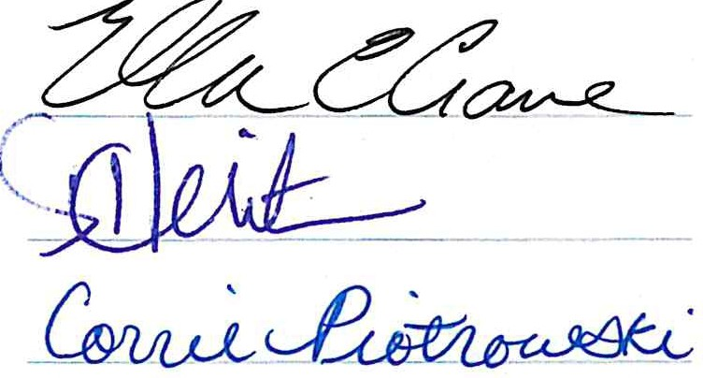
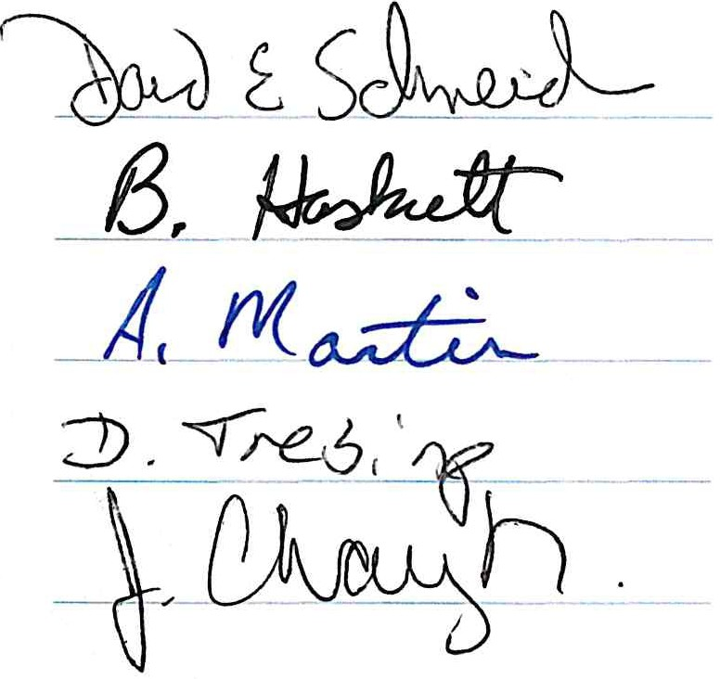
SVSU Board of Control SVSU Faculty Association

MEMORANDUMS DELETED

As part of the 2020-2023 contractual agreement, the following six memorandums of understandings were deleted from the contract. In some cases, relevant language was integrated into the contract proper. In other cases, the MOU had simply become dated and was removed:

MOU I MOU II MOU VI MOU VIII MOU X MOU XI

MEMORANDUM OF UNDERSTANDING III
Effective the Fall, 1993 semester, lower-division instruction in French which is partially or totally taught through an individualized approach will be compensated in accord with the following guidelines.
- The load generated by classroom sections of French 111 will be that of regular 3 hour lecture/1 hour laboratory courses.
- The load generated by individualized sections of French 111 and that of all other lower-division French courses (112, 211, 212), whether taught as classroom sections or as individualized sections, will be figured according to the table below. These courses will be treated as a unit for purposes of scheduling, with the department chairperson arranging the schedule in consultation with the dean.
- Compute the "total" of all students enrolled in French 111 (excluding classroom sections of French 111), and all students enrolled in French 112, 211, and 212, whether enrolled in classroom or individualized sections, as of the day after the official count. Cancel all French lower division classes (excluding classroom sections of French 111) if the total does not reach the minimum for single 200-level courses established in accord with the contract. Regular classes of French 111 will be run or canceled according to the contract.

- During the fall-winter semesters only, there will be one-half (.5) hours of instructional load generated for each different course taught from French 111 (excluding classroom sections of French 111), 112, 211, and 212.

- Total student enrollment (from No. 3 above) shall be converted to instructional load as follows:

1 to 12 | = | 3 | 34 to 38 | = | 9 | 70 to 76 | = | 15
13 to 16 | = | 4 | 39 to 43 | = | 10 | 77 to 84 | = | 16
17 to 20 | = | 5 | 44 to 49 | = | 11 | 85 to 92 | = | 17
21 to 24 | = | 6 | 50 to 55 | = | 12 | 93 to 100 | = | 18
25 to 28 | = | 7 | 56 to 62 | = | 13 | 101 to 108 | = | 19
29 to 33 | = | 8 | 63 to 69 | = | 14 | 109 to 116 | = | 20

- During the academic year, 75 hours of student assistant time will be provided by the university each semester, but none will be provided in the summer. Additional student assistant time will be provided as deemed appropriate by the faculty and dean in units of 75 hours at a charge of 1/3 hour of instructional load per unit, to be used in any semester in the same year at faculty discretion. It is recognized that student assistants qualified in French would rarely be eligible for work/study funds.

- The faculty in French, in consultation with the dean, shall decide how the instructional load generated by the formula will be divided among faculty and student assistants.

- The above agreement assumes that the department will schedule a minimum of 20 (twenty) hours weekly of lower division French courses each fall and winter semester including classroom and individualized sections of 111, 112, 211, and 212. If, after following the above-mentioned

guidelines, one or more of the full-time faculty members is underload for the academic year, then for the semester(s) which create the underload situation, regular sections of 111 will be removed from ordinary load, the enrollments added back into the total for this agreement, and the following table of figures used to compute the load:

Up to 12 | = | 3 | 30 to 34 | = | 9 | 66 to 72 | = | 15
13 to 15 | = | 4 | 35 to 39 | = | 10 | 73 to 80 | = | 16
16 to 18 | = | 5 | 40 to 45 | = | 11 | 81 to 88 | = | 17
19 to 21 | = | 6 | 46 to 51 | = | 12 | 89 to 96 | = | 18
22 to 25 | = | 7 | 52 to 58 | = | 13 | 97 to 104 | = | 19
26 to 29 | = | 8 | 59 to 65 | = | 14 | 105 to 112 | = | 20

This memorandum of understanding will continue in effect with either side having the right to cancel it (or renegotiate its terms) prior to the preparation of the class schedule for any semester, and subject to the provisions of the SVSU-SVSUFA Contract.

S/ Janet Robinson S/ Morton E. Weldy
S/ George A. Corser S/ Judith B. Kerman
S/ Larry Kickham S/ James G. Muladore
S/ Bradley Miller S/ Larry Fitzpatrick S/ David Schneider

MEMORANDUM OF UNDERSTANDING IV BETWEEN
SAGINAW VALLEY STATE UNIVERSITY AND THE
SVSU FACULTY ASSOCIATION

The University agrees to continue its practice of providing secretarial services to the SVSU Faculty Association as needed by the Association.

FOR THE UNIVERSITY | FOR THE ASSOCIATION
S/ Lawrence K. Fitzpatrick December 4, 1984 | S/ Edwin N. Shimabukuro

MEMORANDUM OF UNDERSTANDING V BETWEEN
SAGINAW VALLEY STATE UNIVERSITY AND THE
SVSU FACULTY ASSOCIATION

When a faculty member who is tenured resigns from the faculty and wishes to return to the faculty, such prior faculty member may return to the faculty without being subject to normal recruitment and hiring processes by mutual agreement of the Faculty Association and the Administration.

Effective January 1, 1998
Agreed for the University | Agreed for the Association
S/ Eric R. Gilbertson | S/ Ervin F. Sparapani

MEMORANDUM OF UNDERSTANDING VII BETWEEN
SAGINAW VALLEY STATE UNIVERSITY AND THE
SVSU FACULTY ASSOCIATION

The parties agree to consult with the objective of mutual agreement concerning the formation of a joint Faculty-Administration Budget Committee as recommended in the North Central Association Report.

FOR THE UNIVERSITY | FOR THE ASSOCIATION
S/ Jack M. Ryder | S/ John R. Willertz

MEMORANDUM OF UNDERSTANDING IX BETWEEN
SAGINAW VALLEY STATE UNIVERSITY AND THE
SVSU FACULTY ASSOCIATION

It is the intent and wish of the parties to create and foster an environment in which creativity, innovation and achievement is encouraged and promoted. This is most likely to occur where both subjective and material incentives and rewards are provided and where faculty and staff employees alike need not fear adverse consequences from projects or experiments that are not successful.
Specifically, the parties intend to promote innovations in instructional and organizational methodology and delivery that will, or may result in benefits to the University, its faculty, staff and the community which it serves. Such benefits may include:
- the creation of new courses, learning modules, and/or other teaching and learning systems, or the modification of existing ones, so as to organize and deliver subjects or materials while serving program and/or educational goals;
- the more effective use of the energies and talents of personnel and resources;
- the search for, acquisition and provision of personal and professional development opportunities for faculty and staff;
- the enhancement of instructional delivery with a controlling focus upon the quality of content and learning effectiveness;
- fostering increased efficiency and effectiveness in the use of human or material resources;
- improving upon the use of available technology or helping to determine needs for additional technology;
- creating models for such improvements that could be useful to others within the University and elsewhere;

For these purposes, the parties agree that:

  - the University will create a special Program, to be called "The Special Initiatives Program," to support and encourage the activities described above;
  - this program will continue through the life of the master contract between the University and the Faculty Association;
  - faculty who choose to participate in this Program through the submission of proposals or involvement in experimental or other innovative efforts may submit such endeavors as evidence of teaching, research or service activities for purposes of promotion or tenure consideration, but no such efforts or the results thereof may be considered for these purposes without noting the intent of the first paragraph of this Understanding and without the express consent of the faculty member in question;
  - the University, at its discretion, will provide necessary administrative support services and will seek financial support for this Program from sources other than the University General Fund, which support may be used to provide release time from teaching or other duties, special compensation, or direct financial support for travel or equipment and/or expenses associated with proposals submitted under this Program; and

  - no individual agreements relative to workload or compensation that are reached in pursuance of a proposal under this Program shall be considered binding or precedent setting on any party thereto beyond the life of that specific proposal; nor may they conflict with any provision of the master contract between the parties hereto.

AGREED
FOR THE UNIVERSITY FOR THE ASSOCIATION
S/ Morton E. Weldy S/ David R. Weaver

MEMORANDUM OF UNDERSTANDING XII

For 2007-2008 the English department has 29 tenure-track faculty and seven lecturers, the maximum permitted by contract (D33). It is the intent of the parties to allow a variance in the number of lecturers permitted by contract so as to allow the English department to hire additional faculty up to a total of nine lecturers for 2008-2009.

The total number of lecturers allowed for all departments university-wide is to remain capped at 20.

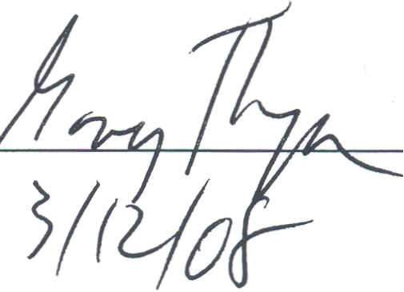
FOR THE UNIVERSITY FOR THE ASSOCIATION

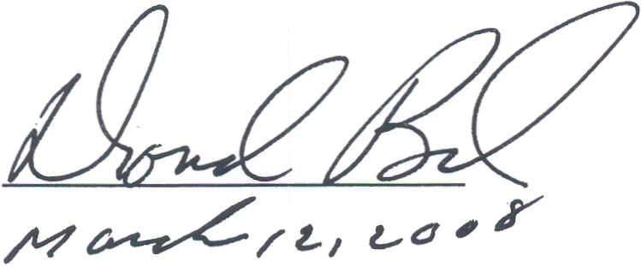

MEMORANDUM OF UNDERSTANDING XIII

The Faculty Contract stipulates that faculty members are required to teach "not less than 24 .
. . credit hours over a three semester appointment." Section D4.1. The teaching load for any faculty members below the 24-hour requirement ordinarily would have their 2008 Spring or Summer semester supplemental appointment reduced to satisfy the 24 credit hour rule. For the purposes of the 2008 Spring and Summer semesters only, the University will not reduce the faculty members' Spring and Summer load assignments to meet the 24-hour requirement. This practice is not precedent setting and will not have any effect on future years. It is agreed that in the future any faculty member who does not meet the 24-hour requirement of D4.1 will have any deficiency reduced from the Spring/Summer semester to meet the 24-hour requirement. As provided in the Faculty Contract, once the 24-hour requirement has been met, the remaining credit hours will be compensated at the appropriate contractual rate.

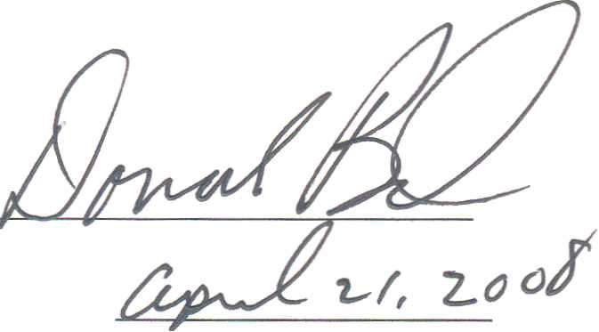
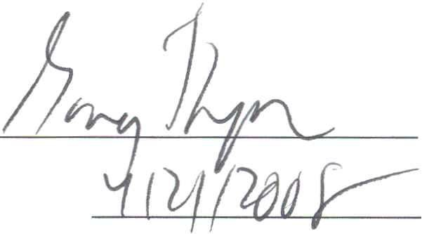
In addition, the Faculty Contract stipulates that "if basic two-semester contract student credit hour production is below 350 student credit hours, no full load supplemental appointments will be awarded, but ½ load Spring or Summer contract may be awarded." D 20.2.1.5.1. For the purposes of the 2008 Spring and Summer semesters only, the University will permit faculty members who have not met the requirements of D 20.2.1.5.1 to keep full load supplemental appointments. This practice is not precedent setting and will not have any effect on future years. It is agreed that in the future any faculty member who does not meet the requirements of D.20.2.1.5.1 will not be eligible for a full supplemental teaching load.

FOR THE UNIVERSITY
FOR THE ASSOCIATION

MEMORANDUM OF UNDERSTANDING XIV
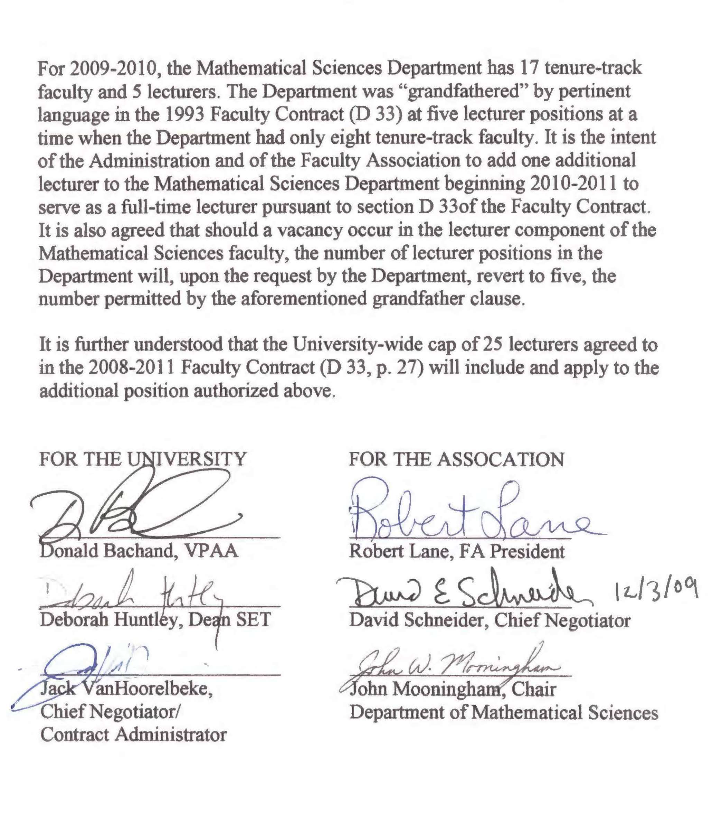

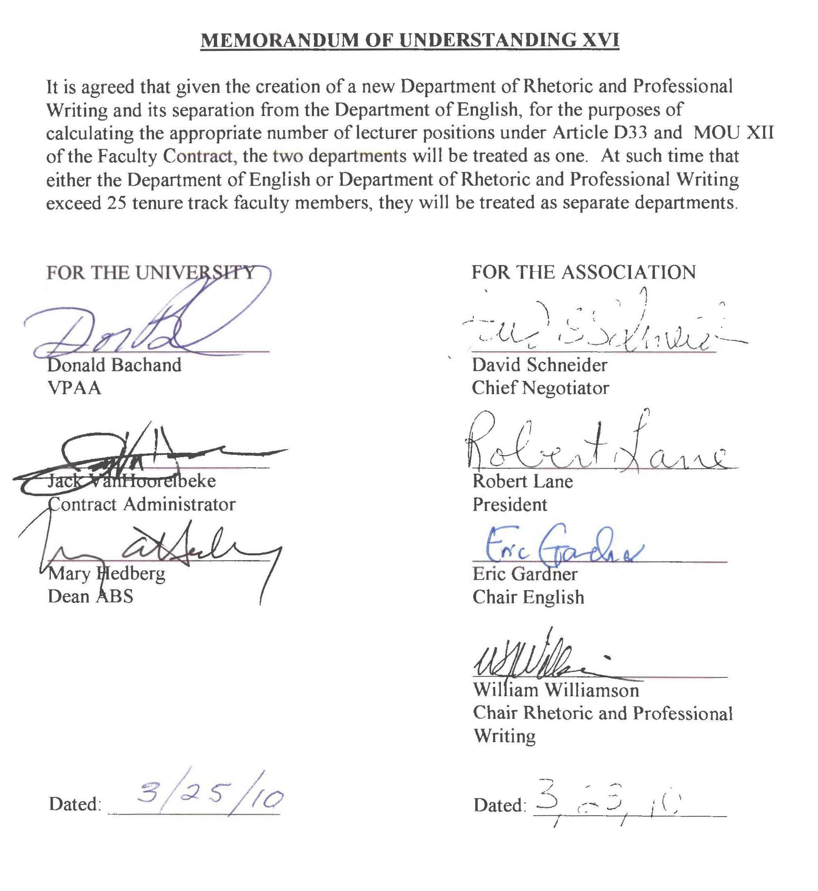
MEMORANDUM OF UNDERSTANDING XVI

CLASS CANCELLATION POLI

CLASS CANCELLATION POLICY
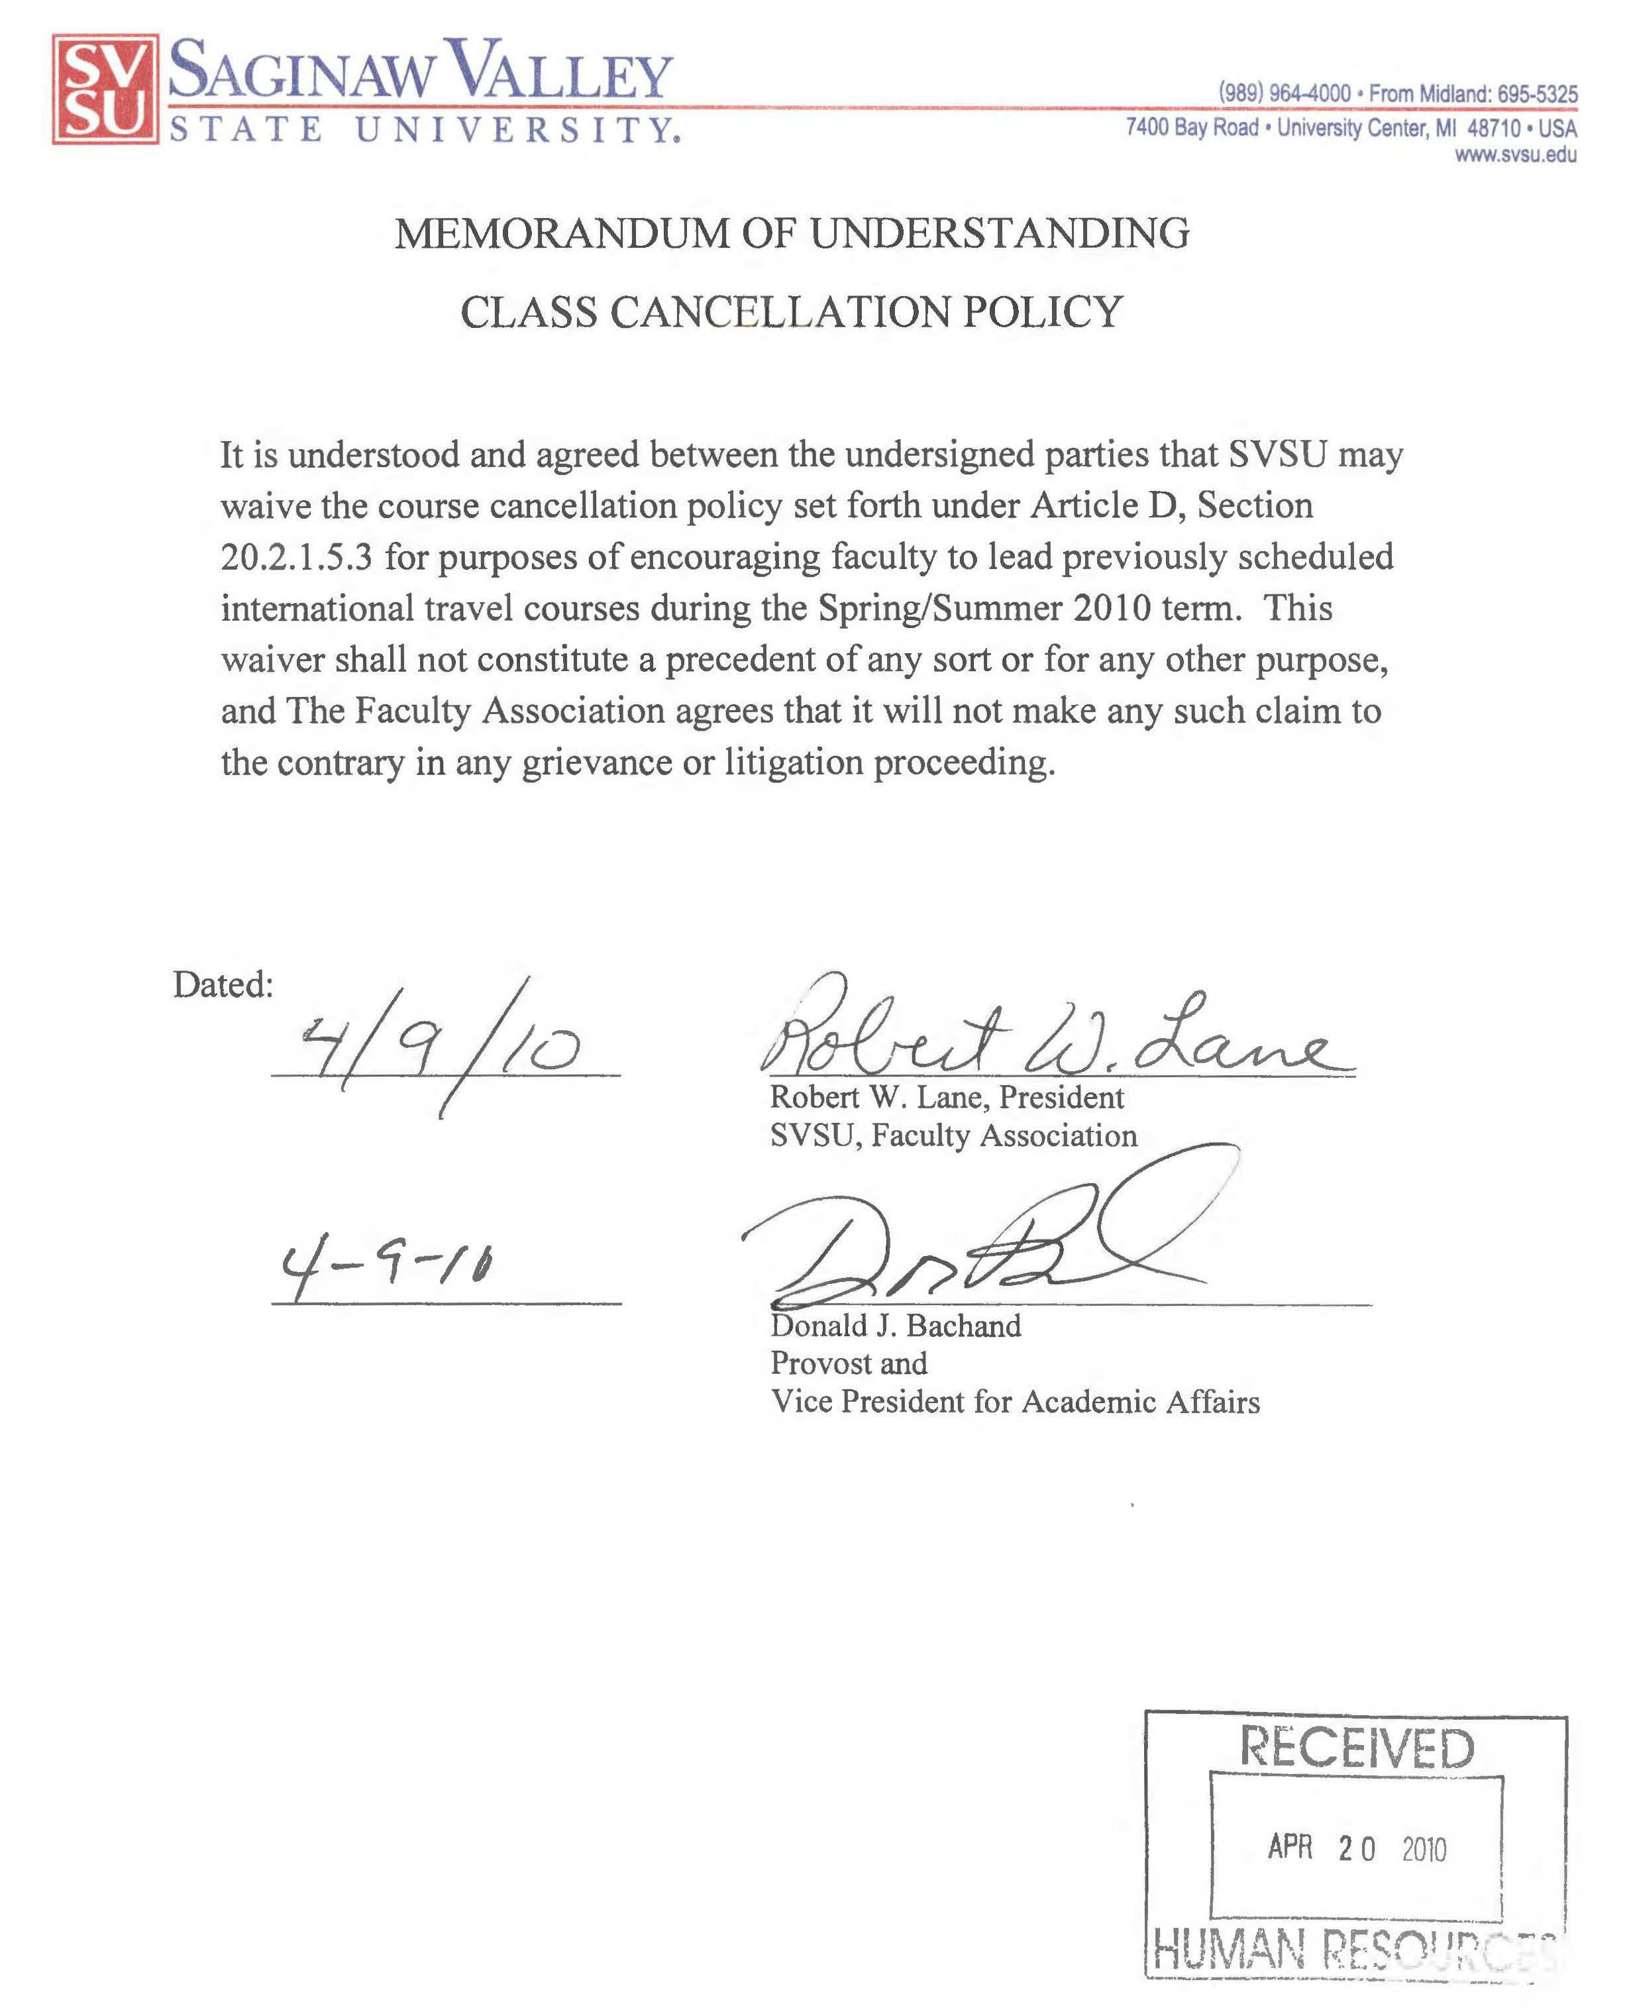

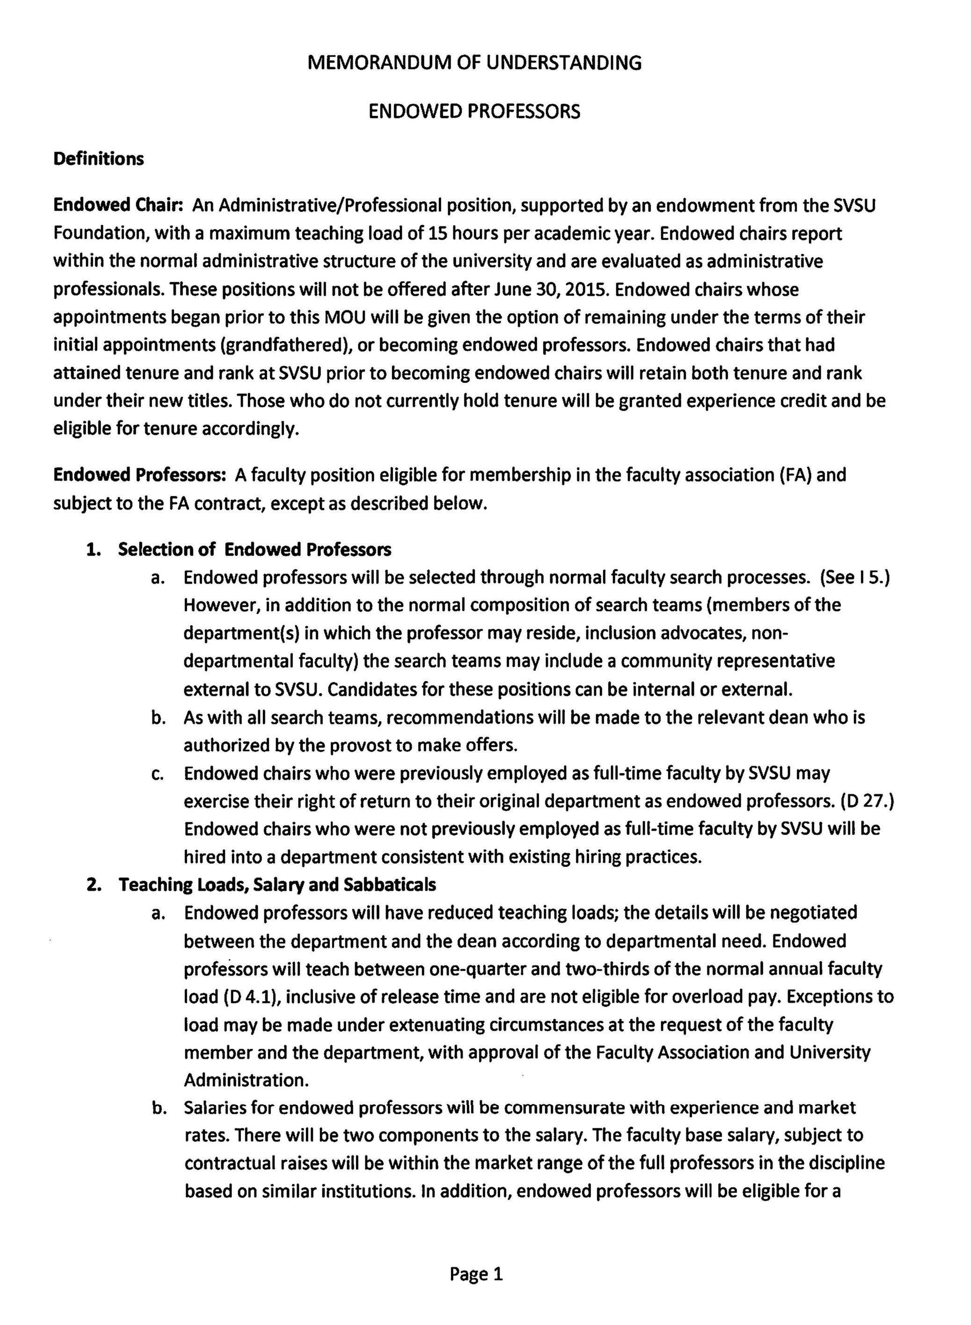
MEMORANDUM OF UNDERSTANDING – ENDOWED PROFESSORS

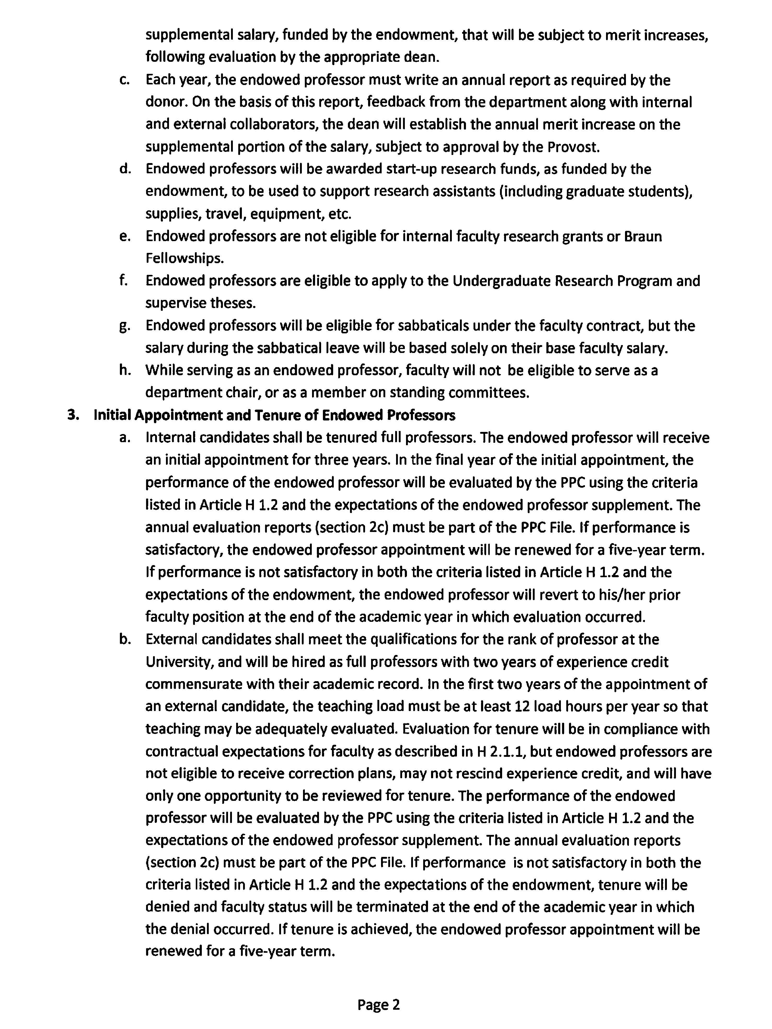

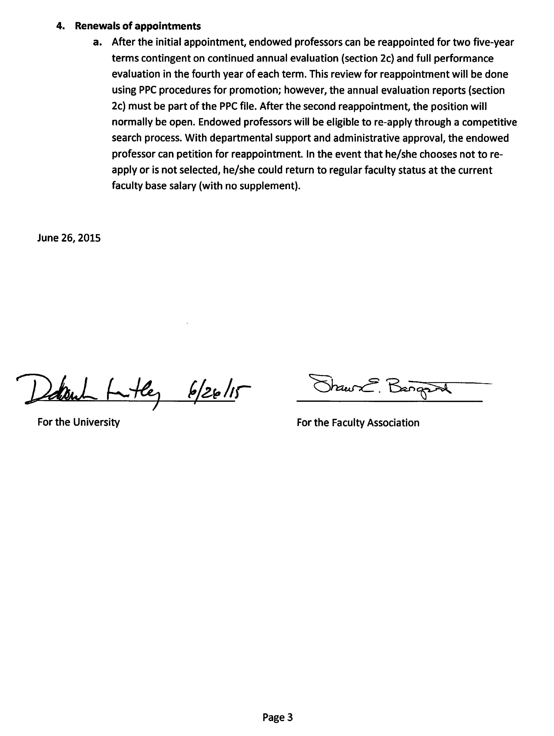

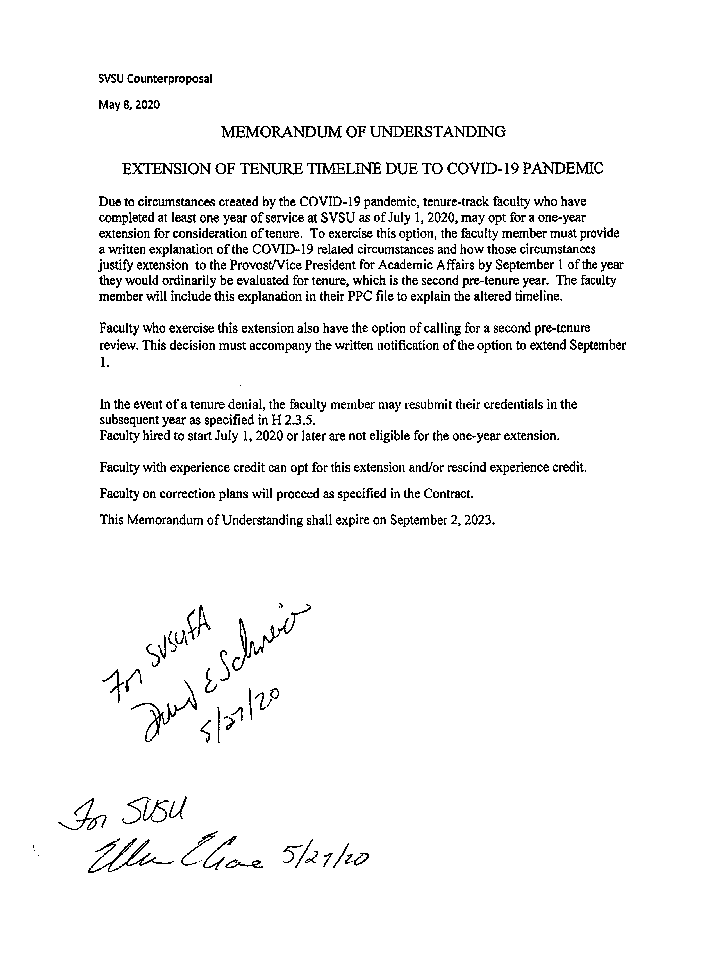
ExtensionMEMORANDUM OF UNDERSTANDING – TENURE TIMELINE DUE TO COVID-19

SVSUFA
May 19, 2020

MEMORANDUM OF UNDERSTANDING TEMPORARY REDUCED LOAD FOR FACULTY

Due to circumstances caused by the COVID-19 pandemic, the University and Faculty Association agree to establish temporary reduced load for faculty.
For the academic year 2020-2021 (D 1 August 25, 2020 - August 24, 2021) a faculty member may request to reduce their regular teaching load while continuing to be treated as a member of the faculty for all other purposes. In such cases salary will be proportionate to load and fringe benefits will be continued. (Fringe benefits based upon a percentage of compensation, such as FICA and retirement contributions, will be reduced in accordance with the amount of salary reduction.) The following requirements will apply to the foregoing:

- Such load reduction cannot be to less than a fifty percent (50%) load.

- It is understood that members who request temporary reduced load will revise their current teaching schedule for 2020-2021. Temporary reduced load shall be conditioned upon the feasibility of departmental arrangements, which will preclude any loss of efficiency in the
. department, any substantial deviation from the announced program of instruction or administrative services, or any addition to the University budget. Specifically, requests must be supported by the department and include a staffing plan that considers all requests for temporary reduced load. Any restructuring of the teaching load shall not mandate another full-time faculty member in the department to change their schedule for 2020-2021. Load adjustments can be covered by voluntary schedule changes, voluntary overload, or the use of part-time faculty. It ls understood that reduced load may need to be spread over the fall and winter semesters. The faculty member involved must initiate the conversation with their department chair by June 15, 2020 in order to explore department arrangements. All schedule adjustments need to be arranged with the department and the dean as set forth in Section I 3 and VPAA as in Section 14 by July 1, 2020.

- This temporary reduction in load cannot be elected by faculty members who have already requested reduced load beginning in Fall 2020 or are already on reduced load through the contract provisions outlined in section M 4.5.3.

- Electing temporary reduced load for the 2020-2021 academic year will not affect the ability of faculty to elect reduced load according to the provisions in M 4.5.3 in the future.

- To accommodate the impact of temporary reduced load, the restrictions on full-time to part-time ratios (D 13, 13) will be exempted for the 2020-2021 academic year in departments where temporary reduced load occurs.
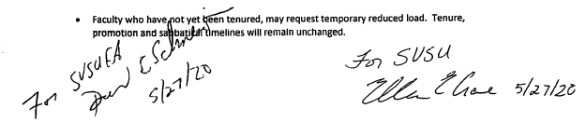

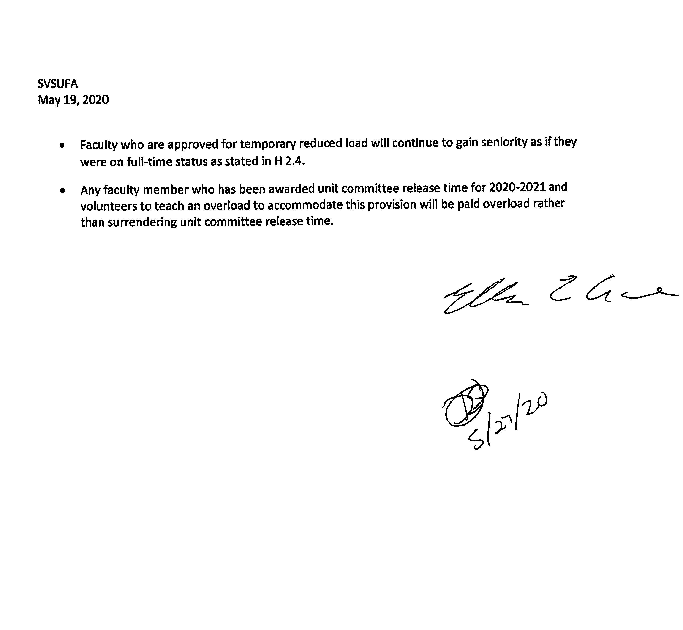

August 13, 2020
Memorandum of Understanding
Working Conditions Changes for AY 2020-2021 Due to Covid-19
In order to accommodate circumstances generated due to the Covid-19 pandemic, both parties agree to make temporary changes to faculty working conditions for the 2020-2021 academic year:
University-wide, the last two weeks of instruction will be entirely remote for the fall semester of 2020.
Faculty still retain the option of providing supplemental online instruction as stipulated in D 29.2.3 (in addition to the last two weeks of fall 2020 and or any online instruction prompted by Covid-19 circumstance).
If a faculty member is not able to report to campus to teach due to Covid-19 symptoms or circumstances (e.g. required quarantine) but is able to provide timely online instruction, sick leave will not be debited.
Faculty may choose to hold office hours remotely for the entire academic year. Evaluation Team charge meetings and team meetings may be conducted remotely.
Standing committee meetings may be conducted remotely; a virtual presence (theability to actively interact with all participants and view and discuss all shared documents synchronously) is required to achieve quorum (F1.3.1).
PPC files will be made available for viewing in secured appropriately social distanced environments.
It is understood that changes to the winter 2021, spring 2021 and summer 2021 semester calendars require a submission to CAPC (as per article F4.1.1).
This MOU expires on August 24, 2021.

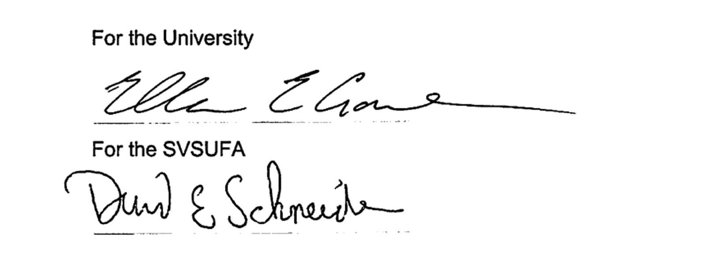
Signatures:

For the University
For the SVSUFA

MEMORANDUM OF UNDERSTANDING – 2020-21 PROFESSIONAL IMPROVEMENT

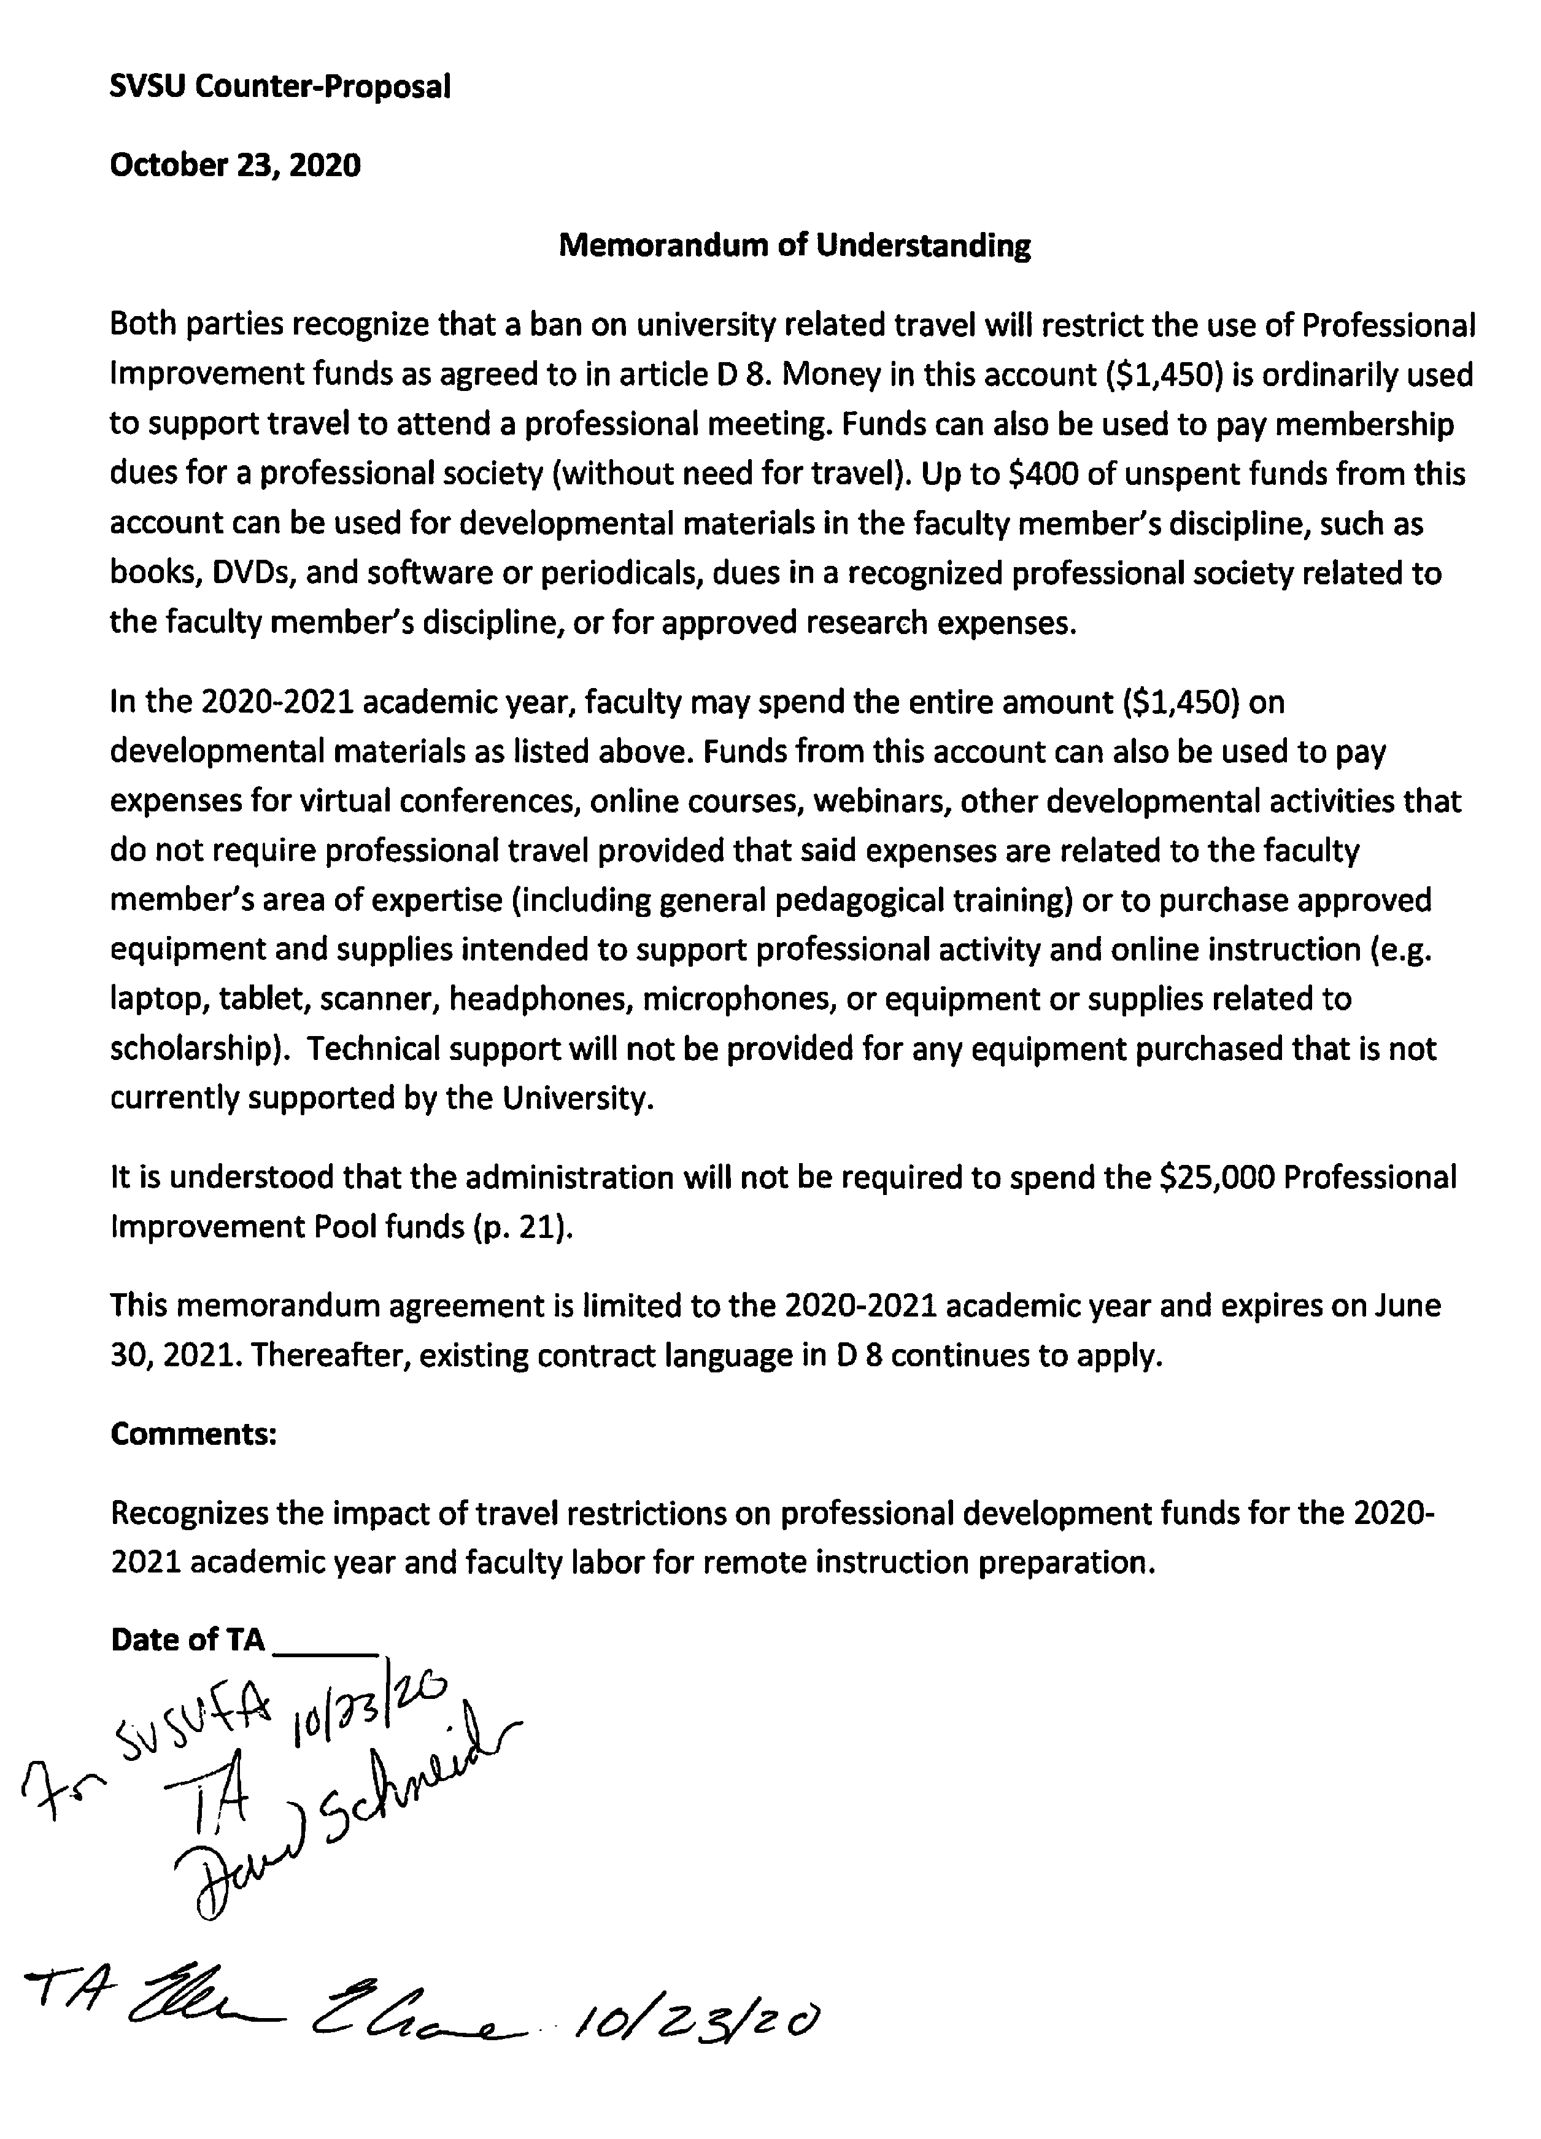
MEMORANDUM OF UNDERSTANDING – PRESCENCE OF FACULTY ASSOCIATION

REPRESENTATIVE

MOU (Proposed)- Presence of Faculty Association Representative - 04-16-2021.docx

MEMORANDUM OF UNDERSTANDING

PRESENCE OF FACULTY ASSOCIATION REPRESENTATIVE

Prior to issuing a reprimand, warning or discipline for any alleged infraction of rules or delinquency in professional performance, the administrator shall inform the faculty member that they are entitled to have present a representative of the Faculty Association at such meetings.

June 4, 2021


For the University For the Faculty Association

INDEX
SUBJECT PAGE
ACADEMIC CONDITIONS (ARTICLE D) 14–35
ACADEMIC DAY 14
ACADEMIC FREEDOM 23
ACADEMIC POLICIES 43
ACADEMIC REGALIA 38
ACADEMIC WEEK 14
ACADEMIC YEAR 14
ADDITIONAL COMMITTEES 49
ADJUNCT FACULTY 33
ADMINISTRATION CONSULTATION 64
ADMINISTRATIVE ASSIGNMENTS 16, 29
ADMINISTRATIVE ATTENDANCE 13
ADMINISTRATIVE TEACHING 22
AMENDMENT 9
ANCILLARY FACULTY 33
APPOINTMENT CRITERIA 54
APPOINTMENT LETTERS See Memorandum of Appointments
APPOINTMENT PROCEDURES AND CONDITIONS: ISSUANCE, EVALUATION, DISCHARGE, TERMINATION AND TENURE 55
APPOINTMENT, LECTURERS 33
ASSOCIATION BUSINESS 13
ASSOCIATION MEMBERSHIP 10
ASSOCIATION REPRESENTATIVE AT BOARD 13
ATTENDANCE AT UNIVERSITY FUNCTIONS 26
BANKED LOAD 18–19
BASE SALARY RAISES 81
BASIC APPOINTMENTS 24
BENEFICIARY RIGHTS 80
BOARD CONSULTATION 12
BUDGET CHANGES 66
BUDGET REQUEST 65
BUDGET, FACULTY-ADMINISTRATION JOINT COMMITTEE 90
CALENDAR, ACADEMIC 14, 24
CANCELLATION OF CLASSES 16, 25
CHAIRPERSON RELEASE TIME 17
CHAIRPERSON RESPONSIBILITIES 64
CHAIRPERSON SELECTION 64
CHANGES IN CURRENT POLICIES 9
CLASS CANCELLATION POLICY. 97
COLLEGE (UNIT) RESEARCH AND DEVELOPMENT COMMITTEES 48
COMMITTEE MEMBER RELEASE TIME 49
COMMITTEES (ARTICLE F) 38–49
COMMITTEES, ADDITIONAL 49
COMPENSATION, SPRING/SUMMER 26
COMPLAINT (ARTICLE J) 67

STUDENT 67
COMPUTER AND ELECTRONICALLY STORED DATA 52
CONFLICT RESOLUTION 65
CONSULTATION (ARTICLE B) 12–13
CONTINUATION OF BENEFITS 80
CORRECTION PLAN 59
COVID-19 WORKING CONDITIONS 104
CREDIT HOUR ALLOCATION 15–16
CREDIT HOUR TEACHING LOAD AND OVERLOADS 15
CREDIT HOUR UNDERLOAD AND CANCELLATION OF CLASSES 16
CRITERIA FOR FACULTY EVALUATION FOR PURPOSES OF REAPPOINTMENT, TENURE AND PROMOTION54 CRITERIA FOR PROMOTION, TENURE AND APPOINTMENT 52
CURRICULUM AND ACADEMIC POLICIES FACULTY RATIFICATION 47
CURRICULUM/ACADEMIC POLICIES COMMITTEE 43
DENIAL OF TENURE 60
DENTAL INSURANCE 73
DEPARTMENT CHAIRPERSON RELEASE TIME 17
DEPARTMENT ORGANIZATION AND DUTIES (ARTICLE I) 64–67
DEPARTMENT, ESTABLISHING 66
DEPARTMENTAL RECOMMENDATIONS (EVALUATION) 55, 58
DISABILITY 72, 77
DISABILITY INSURANCE 72
DISCHARGE OF FACULTY MEMBERS 60
DISCIPLINE, DISCHARGE AND TERMINATION 60–61
DISTANCE LEARNING 31–32
DISTRIBUTIONS OF COMMUNICATIONS 10
DOCTORATE RAISES 82
DUES DEDUCTION 10–11
ELECTION OF COMMITTEE MEMBERS 38
ENDOWED PROFESSORS 98
EQUAL APPLICATION 13
EQUITY / MARKET COMMITTEE 83
ESTABLISHING A DEPARTMENT 66
EVALUATION CRITERIA 54–55
EVALUATION PROCEDURES (PPC, SABBATICALS) 40–43
EVALUATION RECORD, CONTENTS 58
EVALUATION REPORT 58
EVALUATION TEAM 56
EVALUATION TIMETABLE 57
EVALUATION, LECTURERS 33
EVALUATION, METHODS AND SCHEDULES 57
EVALUATION, TENURE-TRACK/TENURED 56–57
EXPERIENCE CREDIT/RANKINGS 64
FACILITIES 14
FACULTY (ARTICLE H) 52–64
FACULTY FACILITIES 23
FACULTY SECRETARIES 37
FACULTY TRIP 36
FAMILY TUITION GRANT 37

FIELDWORK LOAD 15
FILES (PERSONNEL, PPC, GRIEVANCE) 40–43

FINANCIAL RESPONSIBILITY 10
FORMAL DEGREE QUALIFICATIONS 53–54

FOSTERING CREATIVITY 91
FRINGE BENEFITS (ARTICLE M) 71–81
GENERAL EDUCATION COMMITTEE 39, 45–47
GRADE CHANGES 66
GRADUATE COMMITTEE 44–45

GRADUATE COURSES, APPROVAL TO TEACH (F 5.4.3) 45
GRANT AND RESEARCH/DEVELOPMENT RELEASE TIME 27
GRC PROCEDURE ON GRIEVED PPC DECISIONS OR UNIVERSITY OVERRIDES OF PPC DECISIONS 69
GRC PROCEDURES 69
GRIEVABILITY 67
GRIEVANCE FILE 70
GRIEVANCE PROCEDURE (ARTICLE K) 67–71
GRIEVANCE RESOLUTION COMMISSION (GRC) 43, 48, 60
GRIEVANCE, STEP ONE (1), OFFICE OF THE DEAN (WRITTEN) 68
GRIEVANCE, STEP THREE (3), GRIEVANCE RESOLUTION COMMISSION 69
GRIEVANCE, STEP TWO (2), OFFICE OF THE VICE PRESIDENT FOR ACADEMIC AFFAIRS 68
GRIEVANCES (OTHER) 70
GROUP LIFE INSURANCE 71
HEALTH INSURANCE 72
IDENTIFICATION CARDS 36
INADEQUACY 58

INDEPENDENT STUDY 16

INDIVIDUAL EVALUATION REPORTS (IER'S) 41
INITIAL APPOINTMENT 28
INITIAL RANK 28
INSURANCES. 71–73
INTELLECTUAL PROPERTY 35
INTERACTIVE VIDEO-BASED INSTRUCTION (INTERACTIVE TV) 31
JURY DUTY 80
KEYS & ELECTRONIC ACCESS 36
LABORATORY LOAD 15, 84–87
LAYOFFS 63
LEARNING CONTRACTS 32
LEAVE EXTENSION (M 10.1) 79
LEAVE OF ABSENCE 79
LECTURERS 33–35
LEGISLATIVE ACTION 36
LOAD 33–34, 15–16
MANAGEMENT RIGHTS (ARTICLE L) 71
MARKET COMMITTEE 83
MEMBERS OF BARGAINING UNIT 9
MEMBERSHIP OF COMMITTEES 38
CAPC 43
GENERAL EDUCATION COMMITTEE 46
GRADUATE COMMITTEE 44
PPC 40
MEMORANDUM OF APPOINTMENTS 49
MEMORANDUM OF UNDERSTANDING XII 93
MEMORANDUM OF UNDERSTANDING XIII 94

MERIT BONUSES 82
MILEAGE FOR OFF-CAMPUS TEACHING 29–30
MINIMUM BASE SALARIES 82
NEW PROGRAM AND COURSE DEVELOPMENT 20
NOTIFICATION OF RELEASE TIME 19
NOTIFICATION OF TERMINATION 23, 60–63
NURSING & HEALTH SCIENCES INSTRUCTION 32
OFF-CAMPUS TEACHING 29–30
OFFICE HOURS AND STUDENT ADVISING 26
ONLINE and HYBRID INSTRUCTION 31
ORIENTATION 22
OUTSIDE EMPLOYMENT 22–23
OVERLOAD 15–16
PARENTAL AND FAMILY CARE LEAVE 81
PARKING 36
PART-TIME TEACHING 22
PART-TIME/FULL-TIME RATIO 22, 64
PASSES TO EVENTS 36
PERFORMANCE OF ADMINISTRATIVE WORK 29
PERSONAL LEAVE 77
PERSONAL RIGHTS PROTECTION 10
PERSONNEL AND PPC FILES (ARTICLE G) 40–43
PERSONNEL FILE, ACCESS 51–52
PERSONNEL FILE: CONTENTS 50
PPC FILES
ACCESS 51
CONTENTS 50–51
PPC PROCEDURES 41
PPC REVIEW AND PROCEDURES 41, 61–63
PRESENTING A GRIEVANCE 68
PRESIDENTIAL CONSULTATION 12
PRE-TENURE APPOINTMENTS 55
PRIVILEGE OF FACULTY TO CONTINUE BENEFITS 80
PROBATIONARY APPOINTMENTS 55
PROFESSIONAL DEVELOPMENT 20–21, 27–28
PROFESSIONAL IMPROVEMENT 20–21
PROFESSIONAL LEAVE 77
PROFESSIONAL PRACTICES COMMITTEE 40
PROFESSIONAL PRACTICES COMMITTEE REVIEW AND PROCEDURES 61
PROMOTION CRITERIA 54–55
PROMOTION RAISES 82
PROMOTION TIMETABLE 55
PROTECTION OF THE CLASSROOM ENVIRONMENT 67
QUALIFICATIONS FOR APPOINTMENT 33–35
QUALIFICATIONS, MINIMUM 33–35, 52
QUORUMS FOR STANDING COMMITTEES 40
RAISES 81
RANK AT HIRE 28
RATIFICATION, CURRICULUM AND ACADEMIC POLICY 43–44
REAPPOINTMENT CRITERIA 54
REAPPOINTMENT, LECTURERS 33–35

REASSIGNMENT 59
RECLASSIFICATION OF FULL-TIME STAFF 10
RECOGNITION (ARTICLE A) 9–12
RECRUITMENT OF FACULTY 65
REDUCED LOAD (RETIREMENT) 74
REGISTRATION PERIOD FACULTY MEETINGS 22
RELEASE TIME FOR COMMITTEE MEMBERS 47
RELEASE TIME FOR FACULTY ASSOCIATION 11
RELEASE TIME, CHAIRPERSON 17
RELEASE TIME: COMPUTATION OF STUDENT CREDIT HOURS 18
REQUIRED EXAMINATIONS 36
RETIREMENT (TIAA). 73–75
RETIREMENT, REDUCED LOAD 74
RIGHT TO OUTSIDE EMPLOYMENT 22–23
RIGHTS OF FACULTY 13
SABBATICALS, CRITERIA AND PROCEDURES 77–79
SALARIES (ARTICLE N) 81–83
SALARY 33, 81–83
SALARY PLACEMENT ON RETURN 80
SCH COMPENSATION SEE BANKED LOAD
SCHOLARLY ACTIVITIES (H 1.2.2) 54
SECRETARIAL COORDINATION 37
SERVICES, MATERIALS AND GUARANTEES (ARTICLE E) 36–38
SHORT TERM COURSES 20
SICK LEAVE 75
SOLE AGENT 9
SPECIAL CONFERENCES 12
SPONSORSHIP OF STUDENT ACTIVITIES 22
SPRING-SUMMER CREDIT HOUR ASSIGNMENTS 20

SPRING-SUMMER FORMULA CONTRACTS (D 20.2.2) 26
STAFFING NEEDS AND RECRUITMENT 65
STANDING COMMITTEES AND DISTRIBUTION OF FACULTY MEMBERS 38
STATE AUTOMOBILE INSURANCE 80
STUDENT COMPLAINTS 67
STUDENT CREDIT HOUR LOAD COMPENSATION 18
STUDENT EMPLOYEES 24
STUDENT TEACHING EVALUATIONS 56
SUBSTITUTE PAY 81
SUMMER COMPENSATION 26, 78
SUMMER SCHEDULING 24–26
SUPPLEMENTAL APPOINTMENTS (SUMMER TEACHING) 20, 24–26
TEACHER LOAD AND REQUIREMENTS 15
TEACHING PERFORMANCE (H 1.2.1) 54

TEAM-TEACHING LOAD (D 4.1.2.9) 16
TEMPERATURE AND NOISE 36
TEMPORARY FULL-TIME FACULTY 23
TENURE CRITERIA 54–55
TENURE STATUS AT HIRE 55
TENURE TIMETABLE 54
TENURED APPOINTMENTS 55
TERM OF AGREEMENT (ARTICLE O) 84

TERM OF OFFICE, COMMITTEE MEMBERS 38
TERMINATION OF PRE-TENURE FACULTY 60
TERMINATION OF PROBATIONARY FACULTY 60
TERMINATION OF TENURED FACULTY 61
TEXTBOOKS AND OTHER TEACHING MATERIALS 21
THESIS SUPERVISION LOAD (D 4.1.2.11) 16
TRANSFERS 28
TRAVEL/PROFESSIONAL DEVELOPMENT FUNDS 20–21, 27–28
TRIPS, FACULTY/FIELD 36
TV COURSES 32
UNDERLOAD 16
UNIT COMMITTEE (RESEARCH/DEVELOPMENT) 27, 48–49
UNIVERSITY RECOGNITION 9
UNIVERSITY SERVICE AND LEADERSHIP IN STUDENT ACTIVITIES (H 1.2.3) 54
UNIVERSITY YEAR 24
VACANCIES 28
VISION INSURANCE 73
WAIVERS AND SUBSTITUTIONS 66
WITHDRAWAL OF GRIEVANCE 71
WORKING DAY, DEFINITION 76

